BUDGET BOOKLET

CAPITAL PROGRAMME AND REVENUE BUDGET 2019/20

LANCASHIRE COMBINED FIRE AUTHORITY

CAPITAL PROGRAMME AND REVENUE BUDGET 2018/19

TABLE OF CONTENTS

 |  | PAGE
SECTION 1 | EXECUTIVE SUMMARY | 1
SECTION 2 | REVENUE BUDGET | 3
SECTION 3 | CAPITAL BUDGET | 17
SECTION 4 | RESERVES AND BALANCES | 27
SECTION 5 | TREASURY MANAGEMENT | 36

SECTION 1

EXECUTIVE SUMMARY

The booklet sets out the agreed revenue and capital budget set by the Combined Fire Authority at its meeting in February 2019.

The annual budget is the means by which the Authority expresses, in financial terms, its plans for service provision during the forthcoming year.

Revenue Budget

In considering its council tax requirements the Authority aims to balance the public’s requirement for and expectations of our services with the cost of providing this. As such the revenue budget focuses on the need to:-

- deliver services as outlined in the Risk Management Plan and other plans
- maintain future council tax increases at reasonable levels
- continue to deliver efficiencies in line with targets
- continue to invest in improvements in service delivery and facilities
- set a robust budget that takes account of known and anticipated pressures
- maintain an adequate level of reserves

The final proposed gross revenue budget for 2019/20 is £56.5m, an increase of 3.2%. This majority of the increase in costs relate to forecast pay awards and revised pension contributions all of which is partly offset by the identification of £1.2m of efficiency savings/budget reductions. As highlighted the budget allows for a 2% pay award for grey book personnel in 19/20, whilst the current pay claim from the FBU is for 17%, clearly the outcome of pay discussions will have a significant impact on this, and future yeas budgets.

The Local Government Finance Settlement confirmed funding was in line with the 4 year settlement figures, at £23.8m a reduction of £0.5m (2.0%), and that the council tax referendum level remains at 3.0%.

Based on the council tax referendum limit the Authority has a funding gap of £0.5m and will need to either identify additional savings or utilise reserves to set a balanced budget. Doing so will result in a net budget of £56.0m, and a council tax requirement of £69.48 per Band D property, an increase of 2.99% (£2.02 per annum, 4p per week). It is proposed that an unidentified saving target of £0.2m is agreed and that £0.3m of reserves are utilised to deliver a balanced budget in 19/20.

Until such time as the outcome of next year’s Spending review is published it is impossible to provide any meaningful funding forecast, however for the purpose of medium term financial planning we have assumed that funding is frozen in subsequent years. Assuming council tax is increased in line with current referendum principle of 3% in future years the Authority is still faced with a recurring funding gap of approx. £0.3m-£0.5m, if the referendum principle is set at 2% in future years the gap varies between. £0.9m in 20/21 increasing to £1.7m in 23/24.

Looking at the medium-term plans it is clear that the key variables remain pay awards, pension costs and funding. Any significant increase in pay award over and above the 2%-2.5% built into the budget or in the increase in pension costs over and above the £0.7m budgeted (net of additional grant) will add in significant financial pressures. Similarly should the settlement in 2020/21 and beyond be worse than the cash freeze budgeted for then the level of deficit will increase accordingly.

Currently the Authority remains in a good financial position with reserves able to offset the financial challenges next year. The position becomes more challenging thereafter however by that time the Authority should have greater certainty on future funding, pay awards and future referendum limits, which will enable it to deliver a more reliable medium term financial plan in order to address any funding gap that exists.

Capital Strategy/Budget

In terms of the Authority’s Capital Programme our capital strategy is designed to ensure that the Authorities capital investment: -

- assists in delivering the corporate objectives
- provides the framework for capital funding and expenditure decisions, ensuring that capital investment is in line with priorities identified in asset management plans
- ensures statutory requirements are met, i.e. Health and Safety issues
- supports the Medium Term Financial Strategy by ensuring all capital investment decisions consider the future impact on revenue budgets
- demonstrates value for money in ensuring the Authority’s assets are enhanced/preserved
- describes the sources of capital funding available for the medium term and how these might be used to achieve a prudent and sustainable capital programme.

In light of this the capital budget continues to invest in our asset base, in particular vehicle replacement, refurbishment/replacement of stations, new IT requirements and new operational equipment. This gives rise to a capital program of £27m over the next five years.

This can be funded from a combination of revenue contributions, and capital reserves and receipts, without the need for any new borrowing. As such the capital programme is affordable, sustainable and prudent. However it should be noted that no allowance has been made for the potential relocation of Service Headquarters (SHQ), and should this take place further borrowing would be required.

Reserves and Balances

In terms of reserves and balances, the Authority has identified a minimum target of £3.2m and a maximum target of £10.0m. After allowing for the anticipated usage the Authority estimates it will hold £8.0m of uncommitted reserves by the end of 2018/19, but this will potentially fall to £7.7m by the end of 2019/20. This is within its target range, hence at the current level the Treasurer considers these are adequate to meet our requirements. Medium term financial plans show a requirement to continue to utilise reserves in future years in order to deliver a balanced budget, based on forecast funding reductions, and this position may not be sustainable in 2023/24, dependent upon future council tax decisions.

Treasury Management

The Treasury Management strategy shows the Authority holding surplus cash, which is available for investment or to pay off existing debt. However given the penalty associated with debt repayment, and uncertainty around the potential relocation of Service Headquarters, it is not considered appropriate to pay off debt at this point in time.
SECTION 2

REVENUE BUDGET 2019/20-2023/24

In line with the Authority’s objective to deliver affordable, value for money services the Authority’s Budget Strategy remains one of:-

- Maintaining future council tax increases at reasonable levels, reducing if possible;
- Continuing to deliver efficiencies in line with targets;
- Continuing to invest in improvements in service delivery;
- Continuing to invest in improving facilities;
- Setting a robust budget;
- Maintaining an adequate level of reserves.

Draft Budget

In order to determine the future budget requirement, the Authority has used the approved 2018/19 budget as a starting point, and has uplifted this for inflation and other known changes and pressures, to arrive at a draft budgetary requirement, prior to utilising any reserves, as set out below:-

 | 2019/20 | 2020/21 | 2021/22 | 2022/23 | 2023/24
 | £m | £m | £m | £m | £m
Preceding Years Draft Net Budget Requirement | 54.8 | 56.5 | 58.0 | 59.5 | 61.0
Add back previous years unidentified savings target | 0.3 | - | - | - | -
Add back previous years Vacancy Factors | 1.8 | 1.0 | 1.2 | 1.2 | 1.1
Inflation | 0.9 | 1.5 | 1.5 | 1.5 | 1.5
Other Pay Pressures | 0.4 | 0.5 | 0.2 | - | (0.1)
Committed Variations | 0.1 | (0.1) | - | (0.1) | -
Growth | 0.4 | (0.2) | - | - | -
Efficiency Savings | (1.2) | (0.1) | (0.2) | - | 0.1
Gross Budget Requirement | 57.5 | 59.2 | 60.6 | 62.1 | 63.6
Vacancy Factors | (1.0) | (1.2) | (1.2) | (1.1) | (1.1)
Net Budget Requirement | 56.5 | 58.0 | 59.4 | 61.0 | 62.5

Inflation

The following amounts have been added to the budget in respect of inflationary pressures, in line with current estimates:-

 | 2019/20 | 2020/21 | 2021/22 | 2022/23 | 2023/24
 | £m | £m | £m | £m | £m
Removal of over-provision relating to July 17 pay award budgeted at 2% but agreed at 1% | (0.3) | - | - | - | -
A 2% allowance has been built in for all pay-awards for 2019/20  Future budget assume a 2.5% pay award each year. | 0.9 | 1.2 | 1.2 | 1.2 | 1.2
Non-pay inflation, average of 2.5% each year | 0.3 | 0.3 | 0.3 | 0.3 | 0.3
 | 0.9 | 1.5 | 1.5 | 1.5 | 1.5

Each 1% pay award in excess of the above assumptions equates to an additional cost of £340k per year for grey book personnel, and if this is mirrored for green book personnel and additional £70k. The current FBU pay claim is for a 17% increase, significantly higher than the budgeted allowance, and in order to give a flavour for the potential impact of this, a 5% pay award would add in a further £1.0m on an annual basis year compared with the budgeted allowance.

Other Pay Pressure

 | 2019/20 | 2020/21 | 2021/22 | 2022/23 | 2023/24
 | £m | £m | £m | £m | £m
Pay has been recosted taking account of the impact of recruits on numbers of personnel in development rates of pay, the number of personnel in receipt of CPD payments, and the mix of personnel in the old and new FF pension scheme. | (0.3) | 0.3 | 0.2 | - | (0.1)
The latest valuation of the FF pension’s scheme has identified an average increase of 12.6% in employer contribution rate (moving from 17.6% to 30.2%), this is due to combination of changing factors, the most significant of which is the revised discount rate used in unfunded public sector pension schemes will change. It should be noted that the split by individual pension scheme has not been provided, only the average, and hence the actual additional cost will vary according to the mix of personnel in each pension scheme. This equates to an additional cost of £3.3m  However the Government has allowed an additional £2.6m of funding in 19/20 to offset some of this pressure (hence the net additional cost of £0.7m shown). The additional cost pressure in future years will be considered as part of the next Spending Review, hence for medium term planning we have assumed that the additional £2.6m grant will continue. | 0.7 | - | - | - | -
The next actuarial review of the LGPS scheme is due in 12 months’ time, which will result in updated contribution rates being applicable in 2020/21.  The latest indications are that employer contribution in respect of future service are likely to increase but that the funding position of the scheme will have improved since its last review and hence, in our case, it should remain in surplus.  As such the future budget has been adjusted to allow for a 3% increase in employer contribution but with the on-going £325k drawdown of our surplus continuing for the duration of this budget period. (It must be noted that this is only indicative at this point in time, actual figures will not be known until the next valuation is completed.) | - | 0.2 | - | - | -
 | 0.4 | 0.5 | 0.2 | - | (0.1)

Committed Variations

Committed variations are those items which are unavoidable, or which arise from previously agreed policy decisions.

 | 2019/20 | 2020/21 | 2021/22 | 2022/23 | 2023/24
 | £m | £m | £m | £m | £m
The budget for pension costs has been increased to reflect the increased number of ill health retirements forecast for 18/19. Whereby the costs are spread over a three year period, hence the offsetting reduction in 21/22. | 0.1 | - | (0.1) | - | -
Last year’s PPE budget was increased to reflect the roll out of new Helmets and Gloves. Hence this additional funding has been removed in 19/20. | (0.1) | - | - | - | -
The budget assumes that the grant in respect of New Dimensions will continue to fall in 19/20, in line with previous years reductions, although it should be noted that the actual grant is not announced until after the start of the financial year. | 0.1 | - | - | - | -
The budget for interest receivable has been amended to reflect the increase in interest rates, and the level of fixed term investments held. | (0.1) | - | - | - | -
The budget for operational equipment needs to be increased in 21/22 reflecting the anticipated replacement cycle, and particularly the cost of replacing PPV fans in year. (The one off funding being removed the following year | - | - | 0.1 | (0.1) | -
As members are aware Lancashire successfully bid to be a pilot authority for 75% business rate retention. We currently anticipate retaining an additional £213k of business rate growth in 19/20 (which is reflected in the funding forecasts set out later in the report). However of this £11k will be held back as a contribution towards a Lancashire wide risk reserve and £53k towards a Lancashire wide growth fund. It is assumed that the additional growth, and hence the contributions, are both one offs, hence no allowance has been built in to the budget in subsequent years. | 0.1 | (0.1)
 | 0.1 | (0.1) | - | (0.1) | -

No allowance has been made for any increased costs associated with the DCP crewing system and in particular any changes to the pension ability of the allowance. It should be noted that moving to a 30% pensionable allowance is likely to increase costs by £150k.

Growth
 | 2019/20 | 2020/21 | 2021/22 | 2022/23 | 2023/24
 | £m | £m | £m | £m | £m
The budget allows for an increase in the number of Home Fire Safety Checks/Safe & Well Visits and associated costs | 0.1 | - | - | - | -
Fleet and Engineering Services have identified a need for an ‘R&D’ budget to facilitate the introduction of new equipment. Whilst there is an earmarked innovation reserve of £500k this is to cover significant new investment, such as the roll out of new duty rig. Hence an additional £100k has been allowed for in the budget to provide a recurring R&D budget. | 0.1 | - | - | - | -
The budget also includes a one off allowance in 19/20 for the introduction of new duty rig | 0.2 | (0.2) | - | - | -
 | 0.4 | (0.2) | - | - | -

Efficiency Savings

The Authority has a good track record of delivering efficiency savings, with the following savings identified below:-

 | 2019/20 | 2020/21 | 2021/22 | 2022/23 | 2023/24
 | £m | £m | £m | £m | £m
The budget for whole-time recruitment/apprentices has been amended to reflect anticipated number of recruits in each of the next 5 years:-  - 19/20 – 18 apprentices  - 20/21 – 24 apprentices  - 21/22 – 24 apprentices  - 22/23 – 30 apprentices  - 23/24 – 42 apprentices | (0.8) | - | - | - | 0.1
Reduction in Associate Trainer budget, reflecting reduction in number of trainer days | (0.1) | - | - | - | -
Removal of temporary posts | (0.2) | (0.1) | (0.2) | - | -
Reduction in various non-pay budgets | (0.1) | - | - | - | -
 | (1.2) | (0.1) | (0.2) | - | 0.1

Gross Net Budget Requirement

As set out above the overall net budget requirement for each year is as follows:-

 | 2019/20 | 2020/21 | 2021/22 | 2022/23 | 2023/24
 | £m | £m | £m | £m | £m
Draft Gross Budget Requirement | 57.5 | 59.2 | 60.6 | 62.1 | 63.6

Vacancy Factors
The budget needs to take account of forecast vacancy factors arising from retirement and recruitment profiles:-

 | 2019/20 | 2020/21 | 2021/22 | 2022/23 | 2023/24
 | £m | £m | £m | £m | £m
The vacancy factor for whole-time has also been updated based on current staffing profiles and anticipated recruitment numbers as referred to above. This shows a broadly balanced position but with marginal overprovision in 19/20, 22/23 and 23/24. | 0.1 | - | - | 0.2 | 0.2
RDS vacancy factors has been reduced to 18% reflecting the current level of staffing | (1.0) | (1.0) | (1.0) | (1.0) | (1.0)
Support staff vacancy factor has remained at 2.5%. The current vacancy factor over the last 2 years has been in excess of 5% but this is due to one or two problem areas such as ICT and Service Development, the successful recruitment into these two areas would have a significant impact on the overall vacancy factor, bringing this down to 2.5%, hence the decision to leave at this level. | (0.2) | (0.2) | (0.2) | (0.2) | (0.2)
 | (1.0) | (1.2) | (1.2) | (1.1) | (1.1)

Net Budget Requirement

As set out above the overall net budget requirement for each year is as follows:-

 | 2019/20 | 2020/21 | 2021/22 | 2022/23 | 2023/24
 | £m | £m | £m | £m | £m
Draft Budget Requirement | 56.5 | 58.0 | 59.4 | 61.0 | 62.5
Budget (Decrease)/Increase | 3.2% | 2.5% | 2.5% | 2.6% | 2.5%

Analysis of Budget by Service Area

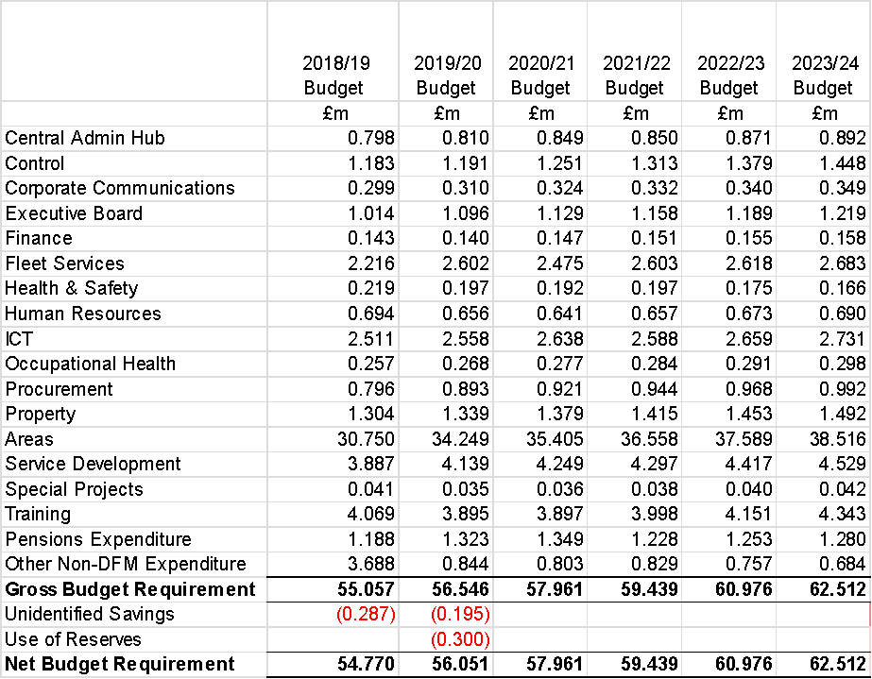

Analysis of Budget by Type of Expenditure

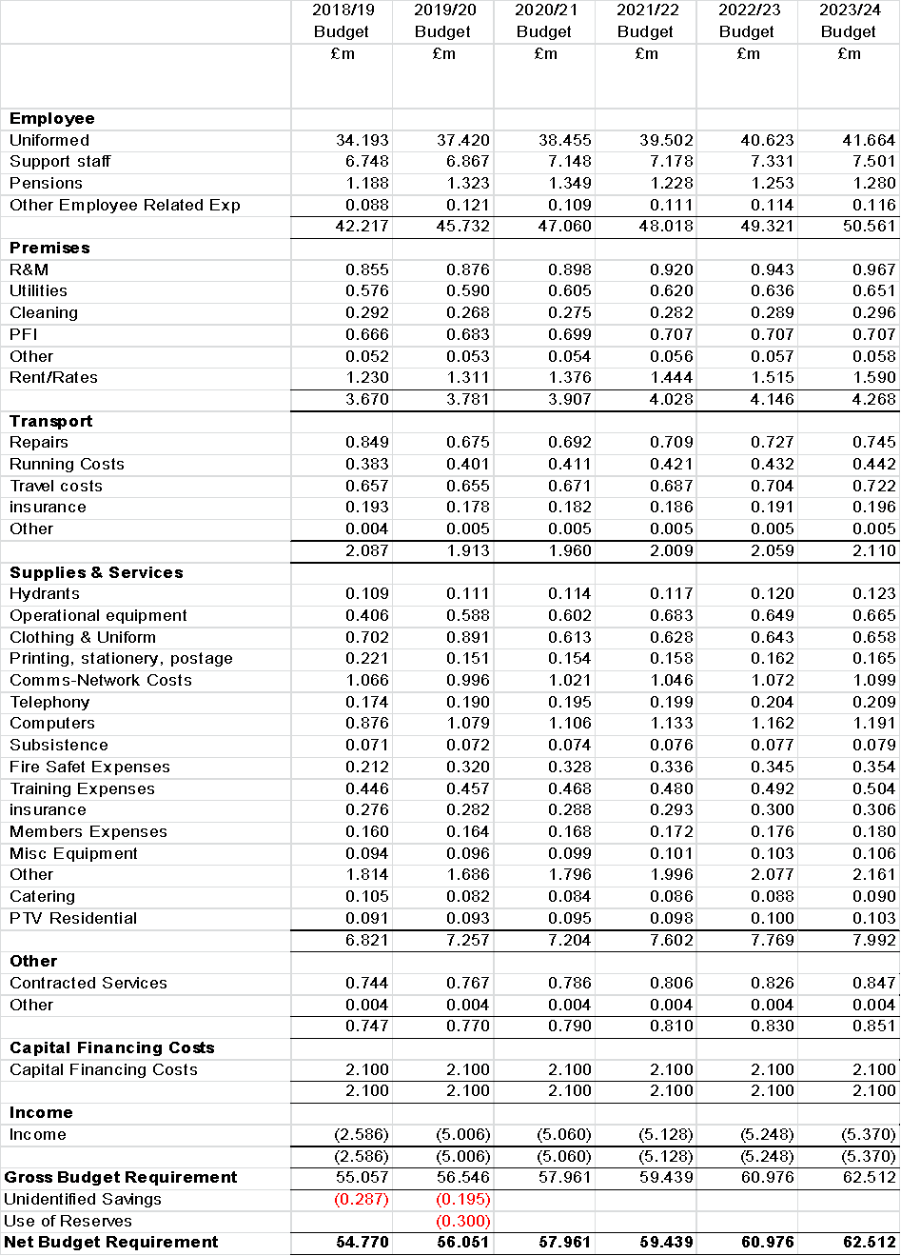

Revenue Funding 2019/20-2023/24

Grant Funding

2019/20 is the final year of the four year settlement, hence next year’s funding is based on figures previously identified, and confirmed in the 2019/20 Local Government Finance Settlement resulted in a £0.5m reduction in funding (£5.5m/19% over the four year period). Given we are now part of the 75% business rate retention pilot pool this funding is now comprised of Locally Retained Business Rates - £6.0m and Top Up Grant - £17.7m.

This does not include the additional £2.6m of one off funding in respect of the increase in employer pension contributions, as highlighted earlier, as we have allowed for this in the net budget requirement reported above.

Funding in 2020 and beyond will be determined by the Governments overall budget and the 2019 Spending Review. The Budget will set overall total for public sector spending which will then be allocated out to departments as part of the Spending Review. Until such time as the outcome of this is known it is impossible to accurately predict future funding levels, however the recent budget included some indictors of Governments current thinking:-

- The Chancellor said that austerity was coming to an end
- The Chancellor told the Today programme that:-
  - Public spending will go up by 1.2%, but most of that will go to the health service
  - Once you take out the commitment made to health it gives a flat real spending available for all other departments
  - He did not deny that some departments could face cuts but that the other option was that everybody would get a 0% increase in funding once inflation was taken into account

From a Fire perspective the two big pressures are pay-awards and pensions contributions. If the government is to meet the increase in employer pension contributions and potential pay awards in future years, then it appears unlikely they will fund any other pressures.

In addition to this uncertainty there are also questions as to how the Fair Funding review will impact the Authority and what, if any, impact the move to 75% retention of business rates in April 2020 will have (The Government has indicated that this change should be cost neutral). There is also a possibility of a further change with the potential to move to 100% business rate retention (again we would expect this to be cost neutral).

Hence taking account of the above we have assumed that the settlement will be frozen throughout the 4 year period. This is reflective of the uncertainty in terms of any distribution of funding.

Business Rate Adjustments

Funding as set out above is adjusted to reflect Section 31 Grants in respect of business rate reliefs, £1.6m and the surplus/deficit on the business rate collection fund, which stands at £8k surplus. Future planning assumptions have been updated to reflect this.

As members are aware Lancashire successfully submitted a bid to be a pilot authority for 75% business rate retention. We currently anticipate retaining an additional £213k of business rate growth in 19/20, which is reflected in the overall funding figures. (As referred to earlier £11k will be held back as a contribution towards a Lancashire wide risk reserve and £53k towards a Lancashire wide growth fund, hence giving net additional growth of £149k retained by the Authority.) It is assumed that this is a one-off increase, hence this has been removed in subsequent years.

Council Tax

In setting the council tax, the Authority aims to balance the public’s requirement for our services with the cost of providing this. As such the underlying principle of any increase in council tax is that this must be seen as reasonable within the context of service provision.

The 2019/20 Local Government Finance Settlement maintains the council tax referendum principle of any increase in excess of 3% triggering a referendum. Last year’s settlement included provision for the council tax referendum principle to be maintained at 3% for two years (18/19 and 19/20) as such we assume that this will return to 2% in future years (although given the uncertainty we have also shown figures based on 3% increases for completeness).

Council Tax-Base

Billing authorities have also provided final council tax base figures and the council tax collection fund figures. The tax base has increased by 1.3%, which is the lowest increase since 2014/15 and considerably lower than the 1.8% averaged over the last 4 years. However this increase still generates an additional £0.4m of precept.

Billing Authorities have also confirmed a final council tax collection fund surplus of £0.3m, which is also the lowest surplus since 2014/15.

Future planning assumptions have been updated to reflect a rolling 5 year average, giving future council tax-base growth of 1.7% and maintaining a collection fund surplus of £0.4m.

Draft Council Tax Requirements

Based on the assumptions outlined the budget requirement would result in a council tax increase of 4.7%, exceeding the referendum limit, and as such the Authority will need to reduce the budget requirement. A reduction of £0.5m being required if council tax is increased by 3% and £1.4m if council tax is frozen:-

 | Raw Budget | Budget based on Referendum Limit | Budget based on Council Tax Freeze
 | £m | £m | £m
Raw Budget Requirement | 56.5 | 56.5 | 56.5
Budget Reduction | - | (0.5) | (1.4)
Net Budget Requirement | 56.5 | 56.0 | 55.1
Less Business Rates | (6.0) | (6.0) | (6.0)
Less Top Up | (17.7) | (17.7) | (17.7)
Less Section 31 Grant re Business Rates Reliefs etc. | (1.6) | (1.6) | (1.6)
Less Business Rates Collection Surplus | - | - | -
Less Council Tax Collection Surplus | (0.3) | (0.3) | (0.3)
Equals Precept | 30.9 | 30.4 | 29.6
Estimated Number of Band D equivalent properties | 438,138 | 438,138 | 438,138
Equates to Council Tax Band D Property | £70.61 | £69.48 | £67.46
Increase in Council Tax | 4.67% | 2.99% | Freeze

Each 1% increase in council tax in 19/20 generates an additional £0.3m of precept, and equates to a £0.67 increase in the annual council tax figure:-
- 3% increase equates to £2.02 per annum, less than 4p per week but generates approx. £0.9m of additional precept
- 2% increase equates to £1.34 per annum, less than 3p per week, and generates approx. £0.6m of additional precept
- 1% increase equates to £0.67 per annum, just over 1p per week, and generates approx. £0.3m of additional precept

It is worth re-iterating that our budget increases have been constrained by capping/referendum principles as well as the Authorities desire to deliver value for money services, hence our current council tax of £67.46 is below the national average of £75.15.

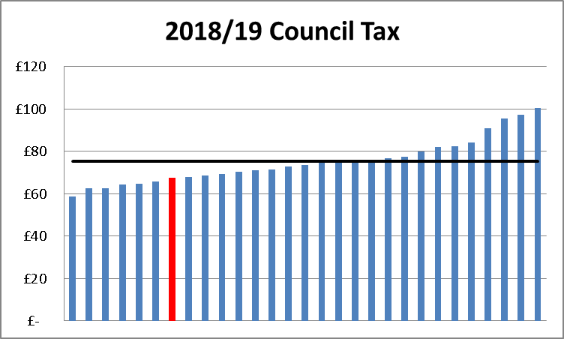

Furthermore, our increase of just 6.0% since 2010/11 compares with an average increase of 13.5% over the same period and is the joint lowest of any Fire Authority.

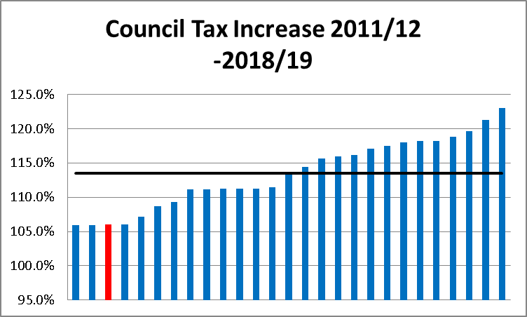

It is also worth noting that Fire accounts for less than 5% of the overall council tax charged in Lancashire.

Further Savings Opportunities

As highlighted earlier the Authority has been extremely successful at delivering efficiency savings, delivering £19m between April 2011 and March 2019. This budget has identified further savings of £1.2m in 19/20 and £0.2m in future years. However it is clear that the scope to deliver further savings is extremely limited, with the majority of departments struggling to balance demands against capacity.

As such it may be possible to deliver further in year savings in future years by delaying expenditure and targeting an in-year underspend offsetting some of the funding shortfall, but the scope to utilise this to balance future budgets appears limited.

Reserves and Balances

As set out in the Reserves and Balances Policy reported elsewhere on this agenda, a reasonable level of reserves is needed to provide an overall safety net against unforeseen circumstances, such as levels of inflation/pay awards in excess of budget provision, unanticipated expenditure on major incidents, and other “demand led” pressures, such as increased pension costs, additional costs associated with national projects, industrial dispute etc. which cannot be contained within the base budget. In addition, they also enable the Authority to provide for expenditure, which was not planned at the time the budget was approved, but which the Authority now wishes to implement and to smooth out large fluctuations in spending requirements and/or funding available.

In line with guidance issued by CIPFA a review of the strategic, operational and financial risk facing the Authority is undertaken each year to identify an appropriate level of reserves to hold, this includes an assessment of the financial assumptions underpinning the budget, the adequacy of insurance arrangements and consideration of the Authority’s financial management arrangements. The assessment focuses on both medium and long-term requirements, taking account of the Medium Term Financial Strategy and the draft budgets.

This has identified:-

- A minimum target reserve level of £3.2m, 5.7% of the 2019/20 net revenue budget, higher than last year which reflects an increasing level of uncertainty, particularly as this is the last year of the four year finding settlement, the grey book pay claim significantly exceeds budget provision and there remains a great deal of uncertainty around additional funding to support the increase in pension costs, and general economic uncertainty that exists at the moment
- the maximum reserve limit is maintained at £10.0m

At 31 March 2019 we anticipate holding £8.0m, providing scope to utilise approx. £4.8m of reserves. As such reserves could be used to deliver a balanced budget in 2019/20, as well as offset some of the gap in future years. It should be noted that utilising reserves in this way means they are being used to fund recurring expenditure and hence this can only be a short term solution, with recurring savings being required in the longer term to offset the shortfall. However having reviewed the level of general reserves required and the anticipated utilisation of these, the Treasurer considers these are at an appropriate level to meet future expenditure requirements in 2019/20. The level of these will be reviewed again as part of the year end outturn process and reported on to the Resources Committee.

In addition to the general reserves the Authority also holds earmarked reserves, created for specific purposes to meet known or anticipated future liabilities, capital reserves and receipts, to provide additional funding to support the capital programme in future years, and provisions for outstanding insurance claims and potential business rate appeals. Further details relating to these are included in the reserves policy and based on the professional opinion of the Treasurer these are adequate to meet future requirements in the medium term.

Council tax 2020/21 and beyond

As highlighted earlier funding up to and including 2019/20 forms part of the multi-year. Funding beyond this period is unknown, but is assumed to be frozen, with any increase in Local Business Rates being offset by a reduction in Top Up grant. Based on this the draft budget as presented, and allowing for a 3% increase in council tax in 19/20, delivers the following council tax increases in future years:-

 | 2020/21 | 2021/22 | 2022/23 | 2023/24
 | £m | £m | £m | £m
Draft Budget Requirement | 58.0 | 59.4 | 61.0 | 62.5
Less Business Rates/Top Up & Section 31 Grant | (25.1) | (25.1) | (25.1) | (25.1)
Less Business Rates Collection Surplus | - | - | - | -
Less Council Tax Collection Surplus | (0.4) | (0.4) | (0.4) | (0.4)
Equals Precept | 32.5 | 33.9 | 35.5 | 37.0
Estimated Number of Band D equivalent properties | 445,709 | 453,412 | 461,247 | 469,218
Equates to Council Tax Band D Property | £72.79 | £74.81 | £76.87 | £78.84
Increase in Council Tax | 4.8% | 2.8% | 2.8% | 2.6%

As previously advised holding a referendum is extremely expensive, costing in excess of £1m, and is unlikely to deliver an increase in excess of the referendum threshold. As such we will need to either deliver additional savings or utilise reserves in order to balance the budget in future years, the extent of which is dependent upon current and future council tax decisions, and the accuracy of expenditure and funding forecasts.

As in previous years we have modelled the funding gap based on different council tax scenarios in future years:-

 | 2020/21 | 2021/22 | 2022/23 | 2023/24
 | £m | £m | £m | £m
3% increase in council tax each year | (0.5) | (0.5) | (0.4) | (0.3)
2% increase in council tax each year | (0.9) | (1.2) | (1.5) | (1.7)
1% increase in council tax each year | (1.2) | (1.8) | (2.4) | (3.1)
Council tax freeze each year | (1.5) | (2.4) | (3.4) | (4.4)

It must be stressed that there are a whole host of assumptions underpinning these projections, particularly around vacancy profiles, pension costs, future inflation, pay awards and funding beyond March 2020. Assuming reserves were used to balance the overall position results in the following impact on general reserves:-
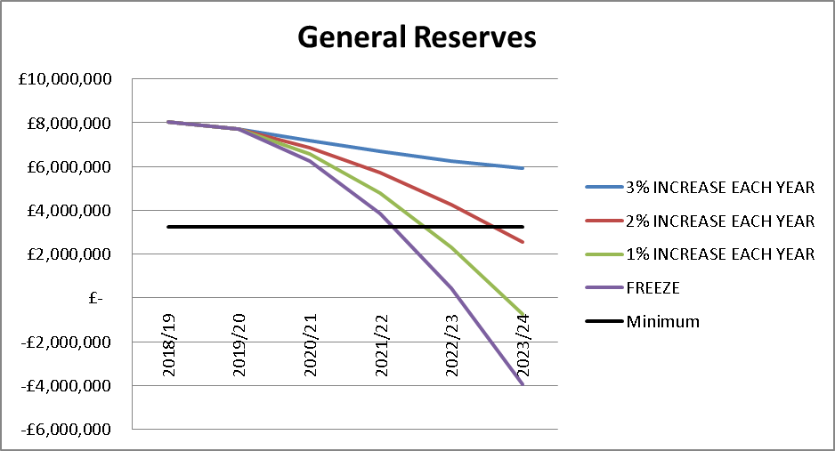

As can be seen general reserves are sufficient to balance the budget next year. However they are only a short term solution, and based on the current assumptions included in the budget, even allowing for a 2% council tax increase each year, they will fall below our minimum level during 2023/24. Furthermore the utilisation of reserves will still leave a recurring funding gap that will need to be offset by savings at a future point in time, and as highlighted earlier the scope to do so is limited.

Robustness of the Revenue Budget 2019/20

Under Section 25 of the Local Government Act 2003, the Chief Finance Officer is required to make a statement about the robustness of the budget.

The professional opinion of the Treasurer is that the budget has been prepared on a robust basis for the following reasons:

- The budget is reflective of existing service plans;
- The budget takes account of the anticipated on-going revenue impact of current and future capital programmes;
- The allowances included for inflation and pay awards represent a best estimate of the likely cost of this, at

 | 2019/20 | 2020/21-2023/24
Uniformed Pay Award | 2.0% | 2.5%
Non Uniformed Pay Award | 2.0% | 2.5%
Non Pay Inflation | 2.5% | 2.5%

- As part of the budget setting process all estimates, including savings and income forecast, are assessed for reasonableness;
- The situation in respect of future funding, and in particular the outcome of m=next year’s Spending Review will be kept under review and reported to the Authority in due course.
- The level of and appropriateness of reserves has been reviewed by the Treasurer, based on the potential risks faced by the Authority (note the real challenge in terms of the level of reserves comes in years 2022/23 and beyond, by which time we should have greater certainty in terms of funding , inflation and pay awards);
- The following significant financial risks have all been assessed and the Treasurer feels that these are adequately covered within the budget estimates presented or within the level of reserves currently held:-
- Reductions in funding levels over and above those forecast;
- Reduction in funding via Business Rates retention scheme;
- Reduction in council tax funding due to changes in localisation of council tax support, reducing tax base and/or council tax referendum limits;
- Higher than anticipated inflation;
- Larger increases in future pension costs/contributions;
- Increase in costs arising from demand led pressures, i.e. increasing staff numbers, overtime due to spate conditions or major equipment replacement requirements;
- Increased cost of partnership arrangements;
- Inadequacy of insurance arrangements

Summary and Conclusions

In considering its council tax requirements for 2019/20 the Authority aims to balance the public’s requirement for and expectations of our services with the cost of providing this. As such the revenue budget focuses on the need to:-

- deliver services as outlined in the Risk Management Plan and other plans;
- maintain future council tax increases at reasonable levels;
- continue to deliver efficiencies in line with targets;
- continue to invest in improvements in service delivery and facilities;
- set a robust budget that takes account of known and anticipated pressures;
- maintain an adequate level of reserves.

The draft budget as set out in this report achieves these objectives, but shows a budget reduction required of £0.5m in order to deliver a balanced budget based on a 3% increase in council tax. This can be achieved by delivering £0.2m more savings and drawing down £0.3m of general reserves to offset the shortfall in 19/20:-

 | 2019/20
 | £m
Raw Budget Requirement | 56.5
Unidentified Savings Target | (0.2)
Draw down of Reserves | (0.3)
Net Budget Requirement | 56.0
Less Locally Retained Business Rates | (6.0)
Less Top Up | (17.7)
Less Section 31 Grant re Business Rates Reliefs etc. | (1.6)
Less Business Rates Collection Surplus | -
Less Council Tax Collection Surplus | (0.3)
Equals Precept | 30.4
Estimated Number of Band D equivalent properties | 438,138
Equates to Council Tax Band D Property | £69.48
Increase in Council Tax | 2.99%

The council tax of £69.48, represents a 2.99% increase (£2.02 per annum, 4p per week).

Whilst the council tax is expressed as a Band D equivalent figure, there are actually 8 property bandings, each of which has a council tax set in proportion to the band D figure (i.e. a band A property is 2/3rds that of a band D charge, and band H is twice that of a band D charge). The individual Council Tax bandings are set out below: -

Council Tax band | A | B | C | D | E | F | G | H
Precept | £46.32 | £54.04 | £61.76 | £69.48 | £84.92 | £100.36 | £115.80 | £138.96

The overall precept is then apportioned between the 14 District & Unitary Authorities pro-rata to their Council Tax base, and they are responsible for billing and collection of this, which they will pay over to the Fire Authority on a pre-determined instalment basis. The precept for each Authority is:-

Blackburn With Darwen Borough Council | £2,420,651
Blackpool Borough Council | £2,537,480
Burnley Borough Council | £1,611,311
Chorley Borough Council | £2,580,098
Fylde Borough Council | £2,089,125
Hyndburn Borough Council | £1,454,495
Lancaster City Council | £2,876,472
Pendle Borough Council | £1,671,780
Preston City Council | £2,673,730
Ribble Valley Borough Council | £1,612,562
Rossendale Borough Council | £1,417,115
South Ribble Borough Council | £2,486,509
West Lancashire District Council | £2,449,610
Wyre Borough Council | £2,560,876
TOTAL | £30,441,814

If any of the assumptions outlined in the report prove to be inaccurate further review will be required, which may include both the use of reserves and the identification of additional savings in order to deliver a sustainable budget.

Until such time as the outcome of next year’s Spending Review is published it is impossible to provide any meaningful funding forecast, however for the purpose of medium term financial planning we have assumed that funding is frozen in subsequent years, based on this, and assuming council tax is increased in line with 2% council tax increase referendum principles in future years the Authority is still faced with a funding gap of £0.9m in 20/21 increasing to £1.7m in 23/24 (or higher if council tax is not increased by the maximum amount permissible).

Looking at the medium-term plans it is clear that the key variables remain pay awards, pension costs and funding. As such additional scenarios are presented in appendix 4 showing the potential impact of the full cost of the employer’s pension contributions falling on the Authority, increased pay awards, and future funding falling as opposed to freezing. These range from a £2.6m increase relating to the pension contributions up to £5m for a 15% pay award. As can be seen all of these have a significant impact on 19/20 budget and the remainder of the medium term strategy.

Currently the Authority remains in a good financial position with reserves able to offset the financial challenges next year. The position becomes more challenging thereafter however by that time the Authority should have greater certainty on future funding, pay awards and future referendum limits, which will enable it to deliver more reliable medium term financial plans in order to address any gap that exists.
SECTION 3

CAPITAL STRATEGY/BUDGET 2019/20-2023/24

The Authority’s capital strategy is designed to ensure that the Authority’s capital investment:

- assists in delivering the corporate objectives
- provides the framework for capital funding and expenditure decisions, ensuring that capital investment is in line with priorities identified in asset management plans
- ensures statutory requirements are met, i.e. Health and Safety issues
- supports the Medium Term Financial Strategy by ensuring all capital investment decisions consider the future impact on revenue budgets
- demonstrates value for money in ensuring the Authority’s assets are enhanced/preserved
- describes the sources of capital funding available for the medium term and how these might be used to achieve a prudent and sustainable capital programme.

Managing capital expenditure

The Capital Programme is prepared annually through the budget setting process, and is reported to the Authority for approval each February. The programme sets out the capital projects taking place in the financial years 2019/20 to 2023/24, and is updated in June to reflect the effects of any slippage from the current financial year (2018/19).

The majority of projects originate from approved asset management plans, subject to assessments of ongoing requirements. Bids for new capital projects are evaluated and prioritised by Executive Board prior to seeking Authority approval.

A budget manager is responsible for the effective financial control and monitoring of their elements of the capital programme. Quarterly returns are submitted to the Director of Corporate Services on progress to date and estimated final costs. Any variations are dealt with in accordance with the Financial Regulations (Section 4.71). Where expenditure is required or anticipated which has not been included in the capital programme, a revision to the Capital Programme must be approved by Resources Committee before that spending can proceed.

Proposed Capital Budget

Capital expenditure is expenditure on major assets such as new buildings, significant building modifications and major pieces of equipment/vehicles.

The Service has developed asset management plans which assist in identifying the long-term capital requirements. These plans, together with the operational equipment register have been used to assist in identifying total requirements and the relevant priorities.

The 2019/20 & 2020/21 programmes include various items of slippage that have been removed from the 2018/19 programme as they are not expected to be incurred within the year – £12.6m of these have already been approved by Resources Committee, and following a further review anticipated slippage has increased to £13.3m, these are as follows:-

Preston Fire Station | £7.000m
Fleet Garage | £2.400m
Pumping appliances | £1.076m
Command Units (Mobile Fire Stations) | £0.580m
CCTV on pumping appliances | £0.100m
Future fire-fighting innovations | £0.050m
IRS/MIS | £0.050m
GIS Risk Info | £0.050m
Performance Management | £0.100m
Wide Area Network | £0.200m
Dynamic Mobilising Tool | £0.150m
Storage area network | £0.120m
Station end mobilising system | £0.400m
ESMCP (Airwave replacement) | £1.000m
Total | £13.276m

A summary of all capital requirements is set out in the table below:

 | 2019/20 | 2020/21 | 2021/22 | 2022/23 | 2023/24 | TOTAL
 | £m | £m | £m | £m | £m | £m
Vehicles | 2.672 | 1.861 | 1.066 | 1.037 | 1.147 | 7.783
Operational Equipment | 0.150 | 1.000 | 0.195 | 0.800 | 0.250 | 2.395
Buildings (timing) | 6.145 | 6.190 | 0.930 | 0.200 | - | 13.465
IT Equipment | 2.470 | 0.425 | 0.500 | 0.100 | - | 3.495
Total | 11.437 | 9.476 | 2.691 | 2.137 | 1.397 | 27.138

Vehicles

The Fleet Asset Management plan has been used as a basis to identify the following vehicle replacement programme, which is based on current approved lives:-

 | No of Vehicles
Type of Vehicle | 2019/20 | 2020/21 | 2021/22 | 2022/23 | 2023/24
Pumping Appliance | 10 | 4 | 3 | 3 | 3
Command Unit | 2 | - | - | - | -
Water Tower | - | - | - | - | -
Aerial Ladder Platform (ALP) | - | 1 | - | - | -
All-Terrain Vehicle | - | 1 | - | 1 | -
Prime mover | - | - | 2 | - | -
Pod | 1 | 1 | - | - | -
Operational Support Vehicles | 18 | 12 | 10 | 17 | 18
 | 22 | 19 | 15 | 21 | 21

 | Budget £m
Type of Vehicle | 2019/20 | 2020/21 | 2021/22 | 2022/23 | 2023/24
Pumping Appliance* | 1.706 | 0.861 | 0.662 | 0.678 | 0.695
Command Unit | 0.580 | - | - | - | -
Water Tower | - | - | - | - | -
Aerial Ladder Platform (ALP) | - | 0.605 | - | - | -
All-Terrain Vehicle | - | 0.085 | - | 0.015 | -
Prime mover | - | - | 0.210 | - | -
Pod | 0.028 | 0.028 | - | - | -
Operational Support Vehicles | 0.358 | 0.282 | 0.194 | 0.344 | 0.452
 | 2.672 | 1.861 | 1.066 | 1.037 | 1.147

* The pumping appliance budget includes the majority of the stage payments for the 7 appliances slipped forwards from the 2018/19 programme, in addition to the full cost of the 3 to be purchased in 2019/20.

LFRS currently has several vehicles provided and maintained by CLG under New Dimensions (5 Prime Movers and 1 Incident Response Unit), which under LFRS replacement schedules would be due for replacement during the period of the programme. However our understanding is that CLG will issue replacement vehicles if they are beyond economic repair, or if the national provision requirement changes. Should LFRS be required to purchase replacement vehicles, grant from CLG may be available to fund them. Based on the current position, we have not included these vehicles (or any potential grant) in our replacement plan.

In addition, Fleet Services continue to review future requirements for the replacement of all vehicles in the portfolio, hence there may be some scope to modify requirements as these reviews are completed, and future replacement programmes will be adjusted accordingly.

A number of vehicles have protracted lead times in excess of 12 months. Therefore in order to deliver vehicles in line with their replacement timeframes it is necessary to order pumping appliances, water towers and ALP’s at least 12 months prior to their planned replacement. As such orders in respect of 4 pumping appliances and 1 ALP scheduled for replacement in 2020/21 will need to be ordered in the new financial year.

Operational Equipment

The following plan allows for the replacement of items at the end of their current asset lives, based on current replacement cost:

 | 2019/20 | 2020/21 | 2021/22 | 2022/23 | 2023/24
 | £m | £m | £m | £m | £m
Breathing Apparatus (BA) and Telemetry equipment | - | - | - | 0.800 | -
Cutting and extrication equipment | - | 1.000 | - | - | -
Light Portable Pumps | - | - | 0.130 | - | -
Defibrillators | - | - | 0.065 | - | -
Thermal Imaging Cameras | - | - | - | - | 0.250
CCTV on Pumping appliances | 0.100 | - | - | - | -
Future Fire-fighting – innovations | 0.050 | - | - | - | -
 | 0.150 | 1.000 | 0.195 | 0.800 | 0.250

Each of these groups of assets is subject to review prior to replacement, which may result in a change of requirements or the asset life.

Buildings

In terms of all the building proposals it must be noted that we are still developing requirements/designs hence costings are to provide some context for decision making.

The two most significant building projects are both carried forward from last year:-
- Preston Fire Station where plans are being refined, following NWAS’ decision not to pursue a joint facility.
- Fleet workshop facility, where plans have been refined and a revised total budget cost of £3.9m was presented and agreed at Novembers Resources Committee.

The plan also incorporates amendments to the PFI facility at Morecambe to provide an enhanced training facility for use by stations within the Northern Area and station modifications to enable site sharing with NWAS. Designs for this are still being refined, whilst discussions are on-going with the PFI provider to agree on how best to facilitate these changes. NWAS have proposed that the Authority funds the capital investment but that they would enter into a long term lease covering both running and the recovery of capital costs over the life of the lease, with suitable break causes included to allow for a recovery of outstanding capital in the event of early termination of the lease.

Details relating to other STC works were considered at Novembers Resources Committee.

Based on the latest stock condition survey, several stations have had identified upgrades to dormitory, drill tower, community room and shower facilities, as listed below – the actual timing of which may be varied to match the capacity to deliver the works.

 | 2019/20 | 2020/21 | 2021/22 | 2022/23 | 2023/24
 | £m | £m | £m | £m | £m
Fleet workshop/trainer facilities/etc | 3.900 | - | - | - | -
Preston fire station rebuild | 1.100 | 5.900 | - | - | -
NWAS co-location – Morecambe* | 0.120 | - | - | - | -
Area training hub – Morecambe | 0.400 | - | - | - | -
STC works:
Fire House | 0.350 | - | - | - | -
Lancaster House/conference facilities | - | - | 0.360 | - | -
Astley House | - | - | 0.370 | - | -
Enhanced station facilities:
Blackpool | 0.135 | - | - | - | -
South Shore | 0.090 | - | - | - | -
Hyndburn | 0.050 | - | - | - | -
Bacup | - | 0.090 | - | - | -
Drill tower replacements, assumed 2 per year | - | 0.200 | 0.200 | 0.200 | -
 | 6.145 | 6.190 | 0.930 | 0.200 | -

ICT

The sums identified for the replacement of various ICT systems are in line with the software replacement lifecycle schedule incorporated into the ICT Asset Management Plan. All replacements identified in the programme will be subject to review, with both the requirement for the potential upgrade/replacement and the cost of such being revisited prior to any expenditure being incurred.

 | 2019/20 | 2020/21 | 2021/22 | 2022/23 | 2023/24
Replace Existing Systems | £m | £m | £m | £m | £m
IRS/MIS | 0.050 | - | - | - | -
GIS | 0.050 | - | - | - | -
Performance management | 0.100 | - | - | - | -
Wide Area Network | 0.200 | - | - | - | -
Dynamic mobilising tool | 0.150 | - | - | - | -
Storage area network | 0.120
Hydrant Management system | - | 0.020 | - | - | -
Vehicle specification crash recovery software | - | 0.020 | - | - | -
Pooled PPE system | - | 0.080 | - | - | -
Finance system | - | - | 0.250 | - | -
Incident Command system | - | 0.060 | - | - | -
Asset Management system | - | - | 0.100 | - | -
HR & Payroll system | - | - | 0.150 | - | -
Community Fire Risk Management Information System (CFRMIS) | - | - | - | 0.100 | -
 | 0.670 | 0.180 | 0.500 | 0.100 | -

 | 2019/20 | 2020/21 | 2021/22 | 2022/23 | 2023/24
Operational Communications | £m | £m | £m | £m | £m
ESMCP (Airwave replacement – assumed fully funded by government grant) | 1.000 | - | - | - | -
Station end mobilising system | 0.400
Vehicle Mounted Data Systems (VMDS) hardware replacement | 0.400 | - | - | - | -
Alerters for RDS/DCP staff | - | 0.065 | - | - | -
Incident Ground Radios | - | 0.180 | - | - | -
 | 1.800 | 0.245 | - | - | -
Total ICT Programme | 2.470 | 0.425 | 0.500 | 0.100 | -

Capital Funding

Capital expenditure can be funded from the following sources:

Prudential Borrowing

The Prudential Code gives the Authority increased flexibility over its level of capital investment and much greater freedom to borrow, should this be necessary, to finance planned expenditure. However any future borrowing will incur a financing charge against the revenue budget for the period of the borrowing.

Given the financial position of the Authority we have not needed to borrow since 2007, and repaid a large proportion of our borrowing in October 2017. Based on the draft capital programme presented this position will not change.

As presented previously no allowance has been made of the potential relocation of Service Headquarters, as this project is due to be reviewed. The programme as presented will clearly need updating if the Authority decides to pursue the relocation in the future.

Capital Grant

Capital grants are received from other bodies, typically the Government, in order to facilitate the purchase/replacement of capital items.

The ESMCP project carried forwards from 2018/19 is anticipated to receive £1.0m grant funding which is included in the programme. To date no other capital grant funding has been made available for 2019/20, nor has any indication been given that capital grant will be available in future years, and hence no allowance has been included in the budget.

Capital Receipts

Capital receipts are generated from the sale of surplus land and buildings, with any monies generated being utilised to fund additional capital expenditure either in-year or carried forward to fund the programme in future years. We do not hold any surplus property assets, therefore no further capital receipts are planned during the capital programme.

As at 31 December 2018 the Authority holds £1.6m of capital receipts. At the end of the 5 year programme we anticipate holding £1.4m of capital receipts, which will be available to meet future costs.

Capital Reserves

Capital Reserves have been created from under spends on the revenue budget in order to provide additional funding to support the capital programme in future years. Following completion of the 2018/19 capital programme, and allowing for the transfer of the year end underspends the Authority expects to hold £16.5m of capital reserves. Over the life of the programme we anticipate utilising £15.9m, leaving a balance of £0.6m by the end of 2023/24.

Revenue Contribution to Capital Outlay (RCCO)

Any revenue surpluses may be transferred to a Capital Reserve in order to fund additional capital expenditure either in-year or carried forward to fund the programme in future years.

The revenue contribution remains the same over the life of the programme, at £2.0m

Drawdown of Earmarked Reserves

The programme does not require the drawdown of any earmarked reserves.

Drawdown of General Reserves

The programme does not require the drawdown of any of the general reserve.

Total Capital Funding

The following table details available capital funding over the five year period:

 | 2019/20 | 2020/21 | 2021/22 | 2022/23 | 2023/24 | TOTAL
 | £m | £m | £m | £m | £m | £m
Capital Grant | 1.000 | - | - | - | - | 1.000
Capital Receipts | - | - | 0.088 | 0.137 | - | 0.225
Capital Reserves | 8.437 | 7.476 | 0.603 | - | (0.603) | 15.914
Revenue Contributions | 2.000 | 2.000 | 2.000 | 2.000 | 2.000 | 10.000
 | 11.437 | 9.476 | 2.691 | 2.137 | 1.397 | 27.138

As highlighted earlier no allowance has been made for the potential relocation of SHQ. If this or any other major capital project is identified subsequently the above position will change significantly. Dependent upon the extent of any new project we will utilise all of the above reserves and may have to take out additional borrowing to deliver a balanced programme, with any such borrowing impacting directly on the revenue budget.

Summary Programme

Therefore the summary of the programme, in terms of requirements and available funding, is set out below:

 | 2019/20 | 2020/21 | 2021/22 | 2022/23 | 2023/24 | TOTAL
 | £m | £m | £m | £m | £m | £m
Capital Requirements | 11.437 | 9.476 | 2.691 | 2.137 | 1.397 | 27.138
Capital Funding | 11.437 | 9.476 | 2.691 | 2.137 | 1.397 | 27.138
Surplus/(Shortfall) | - | - | - | - | - | -

Over the next five years the capital programme is currently balanced, however it should be noted that the following assumptions could change:-
- No allowance has been made for the potential relocation of SHQ, clearly we would need to take out significant additional borrowing if that project was pursued in the 5 year timeframe
- Operational Communications replacements (ESMCP) are subject to a great deal of uncertainty in terms of both timing and costs as they are related to a national replacement project, in addition there may be grant funding available for this which is also unknown at this time;
- Capital grant may be made available in future years, in order to assist service transformation and greater collaboration;
- New Dimensions vehicle replacements are expected to be carried out by CLG, however this position may change;
- All operational equipment item replacements are at estimated costs, and would be subject to proper costings nearer the time;
- ICT software replacements are based largely on the ICT asset management plan, and are subject to review prior to replacement, which has led in the past to significant slippage;
- Property project timings are estimated and as such are expected to vary between years;

The programme is balanced, and as such can be considered prudent, sustainable and affordable. Although it must be recognised that future funding levels, both in terms of revenue and capital, will inevitably impact upon the achievability of the programme as identified.

However as noted above, should any of the funding assumptions or expenditure items within the programme change, this will have an impact on the overall affordability of the programme.

A further report will be presented to the Resources Committee in June, confirming the final year end capital outturn for 2018/19 and the impact of slippage from this on the programme outlined above.

Impact on the Revenue budget

It is worth noting that the capital programme and its funding directly impacts on the revenue budget in terms of capital financing charges and in terms of the revenue contribution to capital outlay. Dependent upon future funding position the revenue contribution to capital (RCCO) could come under increasing pressure, which may mean that the Authority needs to borrow to meet future capital requirements which will impact the revenue budget as capital financing (interest payable and Minimum Revenue Provision (MRP)) charges, the scale of which will depend upon the type of asset the borrowing is charged against, as it is linked to the life of assets.

It is also worth noting that the capital programme shows the Authority utilising the majority of its capital reserves and receipts by the end of the 5 year period, meaning that any longer term capital requirements would need to be met from either capital grant, revenue contributions or from new borrowing. Potentially this could leave a problem in some future years where the on-going revenue contribution of £2.0m is insufficient to meet the current vehicle replacement programme and operational equipment capital replacements.

If a potential relocation of SHQ were to go ahead, it would have a long term impact on the revenue budget, for each £1m borrowed, the annual MRP charges would be £20k (based on an allocated 50 year asset life in accordance with current accounting policy), and the annual interest payable would be in the region of £28k (based on the same 50 year asset life at a current 50 year borrowing rate of 2.8%). For example, borrowing £5m would result in an additional £240k per year charge to the revenue budget.

Prudential Indicators

The Prudential Code gives the Authority increased flexibility over its level of capital investment and much greater freedom to borrow, should this be necessary, to finance planned expenditure. However, in determining the level of borrowing, the Authority must prepare and take account of a number of Prudential Indicators aimed at demonstrating that the level and method of financing capital expenditure is affordable, prudent and sustainable. These Indicators are set out at Appendix 1, along with a brief commentary on each. The Prudential Indicators are based on the programme set out above. These indicators will be updated to reflect the final capital outturn position, and reported to the Resources Committee at the June meeting.

The main emphasis of these Indicators is to enable the Authority to assess whether its proposed spending and its financing is affordable, prudent and sustainable and in this context, the Treasurer's assessment is that, based on the Indicators, this is the case for the following reasons: -

- In terms of prudence, the level of capital expenditure, in absolute terms, is considered to be prudent and sustainable at an annual average of £7.6m over the 3-year period. The trend in the capital financing requirement and the level of external debt are both considered to be within prudent and sustainable levels. No new borrowing is currently planned during the three years.
- In terms of affordability, the negative ratio of financing costs arising from borrowing reflects interest receivable exceeding interest payable and Minimum Revenue Provision payments in each of the three years. This reflects the effect of the previous decision to set aside monies to repay debt.

Capital Expenditure and Financing

The objective in consideration of the affordability of the Authority’s capital plans is to ensure that total capital expenditure remains within sustainable limits.

Capital expenditure 2017/18 to 2021/22

The actual and forecast expenditure for 2017/18 and 2018/19, and estimates of capital expenditure to be incurred in future years, as per the proposed capital programme and allowing for slippage from the 2019/20 programme, are:

 | 2017/18  Actual | 2018/19  Forecast | 2019/20  Estimate | 2020/21  Estimate | 2021/22  Estimate
 | £m | £m | £m | £m | £m
Capital Expenditure | 4.638 | 3.274 | 11.437 | 9.476 | 2.691

This indicator for 2018/19 will also be applied at the year-end to reflect actual capital expenditure incurred.

Capital financing 2017/18 to 2021/22

All capital expenditure must be financed, either from external resources (government grants and other contributions), the Authority’s own resources (revenue contributions, reserves and capital receipts) or debt (borrowing, leasing and Private Finance Initiative). The planned financing of the above expenditure is as follows:

 | 2017/18  Actual | 2018/19  Forecast | 2019/20  Estimate | 2020/21  Estimate | 2021/22  Estimate
 | £m | £m | £m | £m | £m
Grants and Contributions | 0.505 | - | 1.000 | - | -
Own Resources | 4.133 | 3.274 | 10.437 | 9.476 | 2.691
Debt | - | - | - | - | -
Total | 4.638 | 3.274 | 11.437 | 9.476 | 2.691

Borrowing Strategy

Capital Financing Requirement (CFR) 2017/18 to 2021/22

 | 2017/18  Actual | 2018/19  Forecast | 2019/20  Estimate | 2020/21  Estimate | 2021/22  Estimate
 | £m | £m | £m | £m | £m
Capital Financing Requirement (Debt only) | 0.202 | 0.192 | 0.182 | 0.172 | 0.162

The capital financing requirement measures the authority’s underlying need to borrow for a capital purpose, and reflects the effects of previous investment decisions as well as future planned expenditure. In accordance with best professional practice, the Authority does not associate borrowing with particular items or types of expenditure. External borrowing arises as a consequence of all the financial transactions of the Authority and not simply those arising from capital spending, but in the medium term the Treasurer anticipates that borrowing is undertaken for capital purposes only. These capital financing requirements then feed through into the anticipated level of external debt as reported in the Treasury Management Strategy elsewhere on the agenda, but repeated here for completeness. As reported in the Treasury Management Strategy the Authority has made additional MRP provisions since 2010/11 in order to reduce capital financing requirements.

Authorised limit and operational boundary for its total external debt

In respect of its external debt the Authority is required to set two limits over the three-year period: an authorised limit and an operational boundary. Both are based on the planned capital expenditure, estimates of the capital financing requirement and estimates of cash flow requirements for all purposes. It should be noted that these limits have then been uplifted to include potential borrowing associated with a future decision to go ahead with a replacement Headquarters.

The operational boundary is based on the most likely, but not worst case, scenario and represents the maximum level of external debt projected by these estimates. However, unexpected cashflow movements can occur during the year and some provision needs to be made in setting the authorised limit to deal with this.

The two indicators are as follows:

 | 2017/18 Actual | 2018/19  Forecast | 2019/20  Estimate | 2020/21  Estimate | 2021/22  Estimate
 | £m | £m | £m | £m | £m
Authorised Limit for External Debt
Borrowing | 2.000 | 2.000 | 5.000 | 5.000 | 5.000
Other long term liabilities | 14.316 | 14.326 | 14.600 | 14.200 | 13.700
Total | 16.316 | 16.326 | 19.600 | 19.200 | 18.700
Operational Boundary for External Debt
Borrowing | 2.000 | 2.000 | 3.000 | 3.000 | 3.000
Other long term liabilities | 14.316 | 14.326 | 14.000 | 13.600 | 13.100
Total | 16.316 | 16.326 | 17.000 | 16.600 | 16.100

Gross debt and the Capital Financing Requirement

The Prudential Code requires that debt does not exceed the Capital Financing Requirement except in the short term, in order to ensure that over the medium term that debt will only be for capital purposes. This is a key indicator of prudence.

As reported in the Treasury Management Strategy, the Authority has made additional MRP provisions since 2010/11 in order to reduce Capital Financing Requirements and hence the charges associated with this, and in order to set monies aside to pay off debt as it matures. It used these monies to pay off £3.2m of debt in October 2017. As a result of this the level of debt now held, £2.0m, exceeds the capital financing requirement, £0.2m:-

 | 2017/18 Actual | 2018/19  Forecast | 2019/20  Estimate | 2020/21  Estimate | 2021/22  Estimate
 | £m | £m | £m | £m | £m
Debt | 2.000 | 2.000 | 2.000 | 2.000 | 2.000
Capital Financing Requirement | 0.202 | 0.192 | 0.182 | 0.172 | 0.162

Should the Authority decide to repay the remaining £2m of debt, it would need to make additional MRP payments to clear the balance of CFR at that time.

Revenue Budget Implications

Although capital expenditure is not charged directly to the revenue budget, interest payable on loans and Minimum Revenue Provision (MRP, or debt repayments) are charged to revenue, offset by interest receivable. The net annual charge is known as financing costs.

As shown within the Treasury Management Strategy report elsewhere on the agenda, the financing costs are as follows:

 | 2017/18 Actual | 2018/19  Forecast | 2019/20  Estimate | 2020/21  Estimate | 2021/22  Estimate
 | £m | £m | £m | £m | £m
Interest payable | 0.176 | 0.090 | 0.090 | 0.090 | 0.090
MRP | 0.058 | 0.010 | 0.010 | 0.010 | 0.010
Interest receivable | (0.266) | (0.412) | (0.354) | (0.321) | (0.288)
Net financing costs | (0.032) | (0.312) | (0.254) | (0.221) | (0.188)

Proportion of financing costs to net revenue stream

 | 2017/18 Actual | 2018/19  Forecast | 2019/20  Estimate | 2020/21  Estimate | 2021/22  Estimate
Net financing costs | (£0.032m) | (£0.312m) | (£0.254m) | (£0.221m) | (£0.188m)
Ratio of Financing Costs to Net Revenue Stream | (0.06%) | (0.57%) | (0.46%) | (0.39%) | (0.32%)

The negative percentage of this indicator reflects the low level of underlying debt (following the repayment of the majority of our long term loans during 2017/18) for the Authority in comparison to the authority’s level of investment income, i.e. interest receivable is greater than interest payable.

SECTION 4

RESERVES AND BALANCES POLICY 2019/20-2023/24

The National Framework published in December includes a section on reserves. The main components of which are:-

- General reserves should be held by the fire and rescue authority and managed to balance funding and spending priorities and to manage risks. This should be established as part of the medium-term financial planning process.
- Each fire and rescue authority should publish their reserves strategy on their website. The reserves strategy should include details of current and future planned reserve levels, setting out a total amount of reserves and the amount of each specific reserve that is held for each year. The reserves strategy should provide information for at least two years ahead.
- Sufficient information should be provided to enable understanding of the purpose for which each reserve is held and how holding each reserve supports the fire and rescue authority’s medium term financial plan.
- Information should be set out in a way that is clear and understandable for members of the public, and should include:
- how the level of the general reserve has been set;
- justification for holding a general reserve larger than five percent of budget;
- whether the funds in each earmarked reserve are legally or contractually committed, and if so what amount is so committed; and
- a summary of what activities or items will be funded by each earmarked reserve, and how these support the fire and rescue authority’s strategy to deliver good quality services to the public.

The reserves policy complies with these requirements.

General Reserves

These are non-specific reserves which are kept to meet short/medium term unforeseeable expenditure and to enable significant changes in resources or expenditure to be properly managed in the medium term.

The Authority needs to hold an adequate level of general reserves in order to provide:-
- A working balance to help cushion the impact of uneven cash flows and avoid unnecessary temporary borrowing;
- A contingency to cushion the impact of unexpected events;
- A means of smoothing out large fluctuations in spending requirements and/or funding available.

The following table sets out the purpose of this reserve, how it is utilised, controlled and reviewed.

Name | General Fund
Purpose | This covers uncertainties in future years budgets, such as:  - future grant settlements being lower than forecast;  - higher levels of inflation than budgeted;  - increasing cost of and changes to pensions;  - service demands increasing, putting additional pressure on demand led budgets;  - changes in legislation impacting on future service provision;  - potential cost of industrial action.
Utilisation | This is utilised to offset any in-year overspend that would occur when comparing budget requirement to the level of funding generated.
Controls | The utilisation of this is agreed as part of the annual budget setting process. Any further utilisation requires the approval of the Resources Committee.
Review | The adequacy of this is reviewed annually, as part of the budget setting process.

Review of Level of Reserves
In determining the appropriate level of general reserves required by the Authority, the Treasurer is required to form a professional judgement on this, taking account of the strategic, operational and financial risk facing the Authority. This is completed based on guidance issued by CIPFA, and includes an assessment of the financial assumptions underpinning the budget, the adequacy of insurance arrangements and consideration of the Authority’s financial management arrangements. In addition the assessment should focus on both medium and long-term requirements, taking account of the Medium Term Financial Strategy (as set out in the draft budget report elsewhere on this agenda).

For Lancashire Combined Fire Authority this covers issues such as: uncertainty surrounding future funding settlements and the potential impact of this on the revenue and capital budget; uncertainty surrounding future pay awards and inflation rates; the impact of changes to pension schemes; demand led pressures; risk of default associated with our investments as set out in the Treasury Management Strategy, cost associated with maintaining operational cover in the event of Industrial Action etc.

2019/20 is the final year of the current four year settlement. This means that funding beyond 2019/20 is subject to the outcome of next year’s Spending Review, as well as the outcome of the fair funding review of relative needs and resources and the Government intention to move to greater retention of Business Rates, as opposed to maintaining Revenue Support Grant. Furthermore the impact of Brexit on the national economy is still unknown. Therefore there is greater degree of uncertainty over long term funding than in recent years.

As such the Treasurer considers it prudent to increase the minimum target reserves level to £3.2m, 5.7% of the 2019/20 net revenue budget, reflecting the increasing level of uncertainty. This is broadly in line with the 5% threshold identified by the Home Office above which the Authority is required to justify why it holds the level of reserves.

Should reserves fall below this minimum level the following financial year's budget will contain options for increasing reserves back up to this level. (Note, this may take several years to achieve.)

Whilst this exercise sets a minimum level of reserves it does not consider what, if any, maximum level of reserves is appropriate. In order to do this the level of reserves held should be compared with the opportunity cost of holding these, which in simple terms means that if you hold reserves that are too high you are foregoing the opportunity to lower council tax or invest in further service improvements.

However, given the limited scope to increase council tax without holding a local referendum the ability to restore depleted reserves in future years is severely limited. Hence any maximum reserve limit must take account of future anticipated financial pressures and must look at the long term impact of these on the budget and hence the reserve requirement. Based on professional judgement, the Treasurer feels that this should be maintained at £10.0m.

Should this be exceeded the following financial year’s budget will contain options for applying the excess balance in the medium term, i.e. over 3-5 years.

Level of General Reserves
The overall level of the general fund balance, i.e. uncommitted reserves, anticipated at the 31 March 2019 is £8.0m, providing scope to utilise approx. £4.8m of reserves.

The proposed drawdown of £0.3m in 19/20 would reduce the general balance to £7.7m and the Treasurer considers these are at an appropriate level to meet future expenditure requirements in 2019/20.

It should be noted that reserves are being used to fund recurring expenditure and hence this can only be a short term solution, with recurring savings being required in the longer term to offset the shortfall.

Future requirements are less clear as multi-year settlements will have ended and the budget forecasts become less accurate as there are a whole host of assumptions underpinning these projections, particularly around funding, vacancy profiles, pension costs, future inflation and pay awards and council tax increases. The following graph showing the point at which general reserves dip below minimum requirements, and the point at which they are exhausted, based on various council tax options.

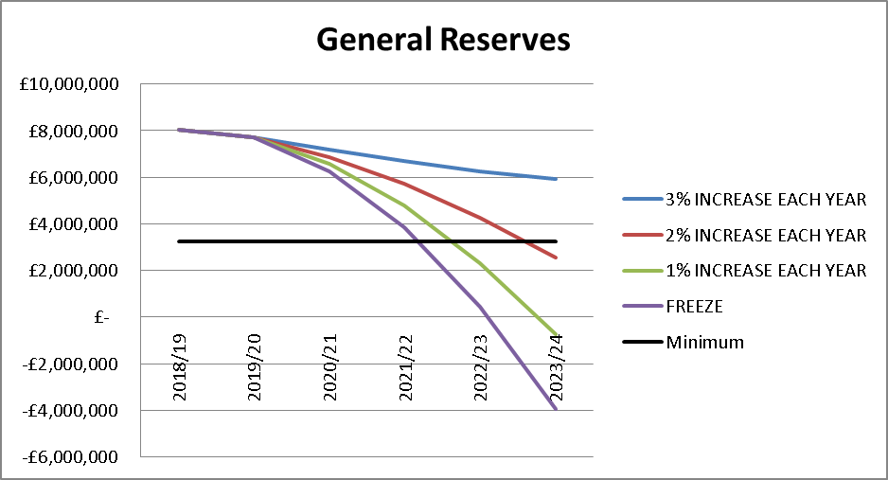

As can be seen general reserves are sufficient to balance the budget next year. However they are only a short term solution, and based on the current assumptions included in the budget, even allowing for a 2% council tax increase each year, they will fall below our minimum level during 2023/24. Hence over the medium term the general reserve will potentially fall below the 5% threshold identified by the Home Office. Furthermore the utilisation of reserves will still leave a recurring funding gap that will need to be offset by savings at a future point in time, and as highlighted earlier the scope to do so is limited.

Earmarked Reserves

These are reserves created for specific purposes to meet known or anticipated future liabilities and as such are not available to meet other budget pressures. They can only be used for that specific purpose, for which they were established, and as such it is not appropriate to set any specific limits on their level, but as part of the annual accounts process their adequacy will be reviewed and reported on.

The following table sets out the purpose of this reserve, how it is utilised, controlled and reviewed.

Name | Earmarked
Purpose | This covers monies set aside for specific purposes.
Utilisation | Once set up these reserves can only be used for the specific purpose for which they were established.
Controls | The utilisation of these are discussed at quarterly DFM meetings between the budget holder, relevant Executive Board member, and the Director of Corporate Services.
Review | The level of earmarked reserves is reviewed each year as part of the revenue outturn/annual accounts process to ensure these are reasonable and remain relevant.

The Director of Corporate Services has delegated authority to create new earmarked reserves valued at up to £100,000; any request which exceeds this must be reported to the Resources Committee for approval.

Specific earmarked reserves will be closed when there is no longer a requirement to hold them, at which point they will either hold a nil balance or when any outstanding balance will be transferred into the general reserve.

Level of Earmarked Reserves
The following table provides a breakdown of the £7.6m of earmarked reserves forecast to be held at 31st March 2019, and a forecast of the anticipated position as at 31 March 2024:-

 | Forecast at 31 March 2019 | Forecast at 31 March 2024
 | £m | £m
DFM Reserve | 0.3 | 0.2 | Devolved Financial Management Reserve enables budget holders to carry forward any surplus or deficit from one financial year to the next, within prescribed limits.  The Service has strong financial management ethos and hence has a track record of managing within individual budget allocations, hence has not previously utilise these reserves to a large degree. However as the Service comes under increasing pressure and departmental budgets are squeezed this provides greater flexibility to individual budget holder and optimises the use of resources.  Examples of areas where these balances have been used previously would be one off replacements of equipment, or enhancement to station facilities etc.  The levels of individual DFM reserves are reviewed each year as part of the revenue outturn/annual accounts process, to ensure that they are reasonable and that budget holders are not building up excessive reserves.  At present there are no contractual or legal obligations against this reserve, as any such commitments would be included in the base revenue budget.
PFI Reserves | 4.3 | 3.9 | Private Finance Initiative Reserve, which is used to smooth out the annual net cost to the Authority of the existing PFI scheme, and will be required to meet future contract payments. The utilisation of this is set out in the budget agreed at the start of the year, any variance in requirements from this are agreed by the Treasurer as part of the revenue outturn/annual accounts process.  Assuming CPI continues at 3% the whole of this reserve is contractually committed over the next 20 years.
Insurance Aggregate Stop Loss (ASL) | 1.0 | 1.0 | The Authority has aggregate stop losses (ASLs) on both it’s combined liability insurance policy (£0.4m) and its motor policy (£0.3m). This means that in any one year the Authority’s maximum liability for insurance claims is capped at the ASL. As such the Authority can either meet these costs direct from its revenue budget or can set up an earmarked reserve to meet these. Within Lancashire we have chosen to meet the potential costs through a combination of the two. Hence the amount included in the revenue budget reflects charges in a typical year, with the reserve being set up to cover any excess over and above this. As such the reserve, combined with amounts within the revenue budget, provides sufficient cover to meet 2 years’ worth of the maximum possible claims, i.e. the ASL. (It is worth noting that the revenue budget allocation has also been reduced in recent years reflecting the claims history. Without holding this reserve to cushion any major claims that may arise this would not have been possible. )  None of this reserve is legally committed at the present time, although as soon as a claim arose this position would change.
PWLB Loan repayment penalty | 0.9 | 0.9 | This reserve was created to meet the potential penalty costs associated with repayment of the remaining PWLB loans.  The Authority still has £2.0m of long term loans, maturing between 2035 and 2037, as set out in the Treasury Management Strategy reported elsewhere on this agenda, and currently incurs £0.1m of interest charges on these loans. We continue to review opportunities to repay these, hence saving any interest payments, however based on the current penalty associated with this, £0.9m, it is not considered prudent to do so at the present time.  There is no legal or contractual commitment against this reserve.  It is worth noting that this is a notional amount as any penalties incurred will depend on both forecast interest rates and the remaining time to maturity, hence the actual penalty will be considered as part of the decision to repay the loans in due course, with any such decision being considered as part of future Treasury Management Strategy.  Should Members decide to relocate SHQ, and hence agree to maintain the existing loans until maturity, the reserve could be used to offset some of the capital costs associated with the relocation.
Prince’s Trust | 0.2 | 0.2 | This reserve has been established to balance short term funding timing differences and also to mitigate the risk of loss of funding and enable short term continuation of team activities, whilst alternative funding is found.  The reserve is equivalent to 25% of the Teams current external funding target.  Without this reserve any significant loss of funding would have an immediate impact on our ability to deliver the PT programme, and hence improve the lives of younger people.  There are no legal or contractual commitments against this.
ESMCP Ring-fenced Funding | 0.1 | - | As part of the Emergency Services Mobile Communication Programme (ESMCP), transitional funding was made available to fund costs associated with the transition to the new national arrangements, with any funds not spent being carried forwards for use in future years.  Whilst there are no contractual or legal commitments against this at the present time, the on-going programme will require this funding to be utilised in the new financial year
Apprentices | 0.1 | - | This reserve was created from previous the in-year underspends relating to the appointment of apprentices, which was delayed awaiting national developments.  As such the reserve was set up to offset some of the pay costs that will be incurred in future years, with the balance being met direct from the revenue budget.  There are no contractual commitments against this.  This clearly contributes to addressing apprenticeship targets, set by the Government, as well as addressing capacity issues within departments.
Fleet & Equipment | 0.2 | - | This reserve was created to meet the cost of replacement projects which were not completed by year end, hence whilst we anticipate carrying some over into 19/20 this will be fully utilised in that year  At the present time £50k of the reserve is contractually committed.
Innovation Fund | 0.5 | - | The Authority created an Innovations Fund to meet costs arising from new initiatives/developments which improve service delivery or fire fighter safety but which are not included in the capital programme.  Any requests to utilise the fund require the approval of the Executive Board.  None of this reserve is contractually or legally committed at the present time.
 | 7.6 | 6.2

It is worth noting that of the anticipated balance of £6.2m at 31 March 2024 over half of this relates to the PFI reserve.

Based on this the Treasurer believes these are adequate to meet future requirements in the medium term.

Capital Reserves and Receipts

Capital Reserves have been created from under spends on the revenue budget in order to provide additional funding to support the capital programme in future years; as such they cannot be used to offset any deficit on the revenue budget, without having a significant impact on the capital programme that the Authority can support.

Capital Receipts are generated from the sale of surplus assets, which have not yet been utilised to fund the capital programme. Under revised regulations receipts generated between April 2016 and March 2019 can be used to meet qualifying revenue costs, i.e. set up and implementation costs of projects/schemes which are forecast to generate on-going savings. The on-going costs of such projects/schemes do not qualify. Whilst the Authority currently holds £1.6m of capital receipts only £140k of this arose in the relevant time period. Given the small amount eligible we do not currently have any plans to use this in line with new regulations and hence for the purpose of planning all capital receipts will be used to meet future capital costs, not qualifying revenue expenditure.

The following table sets out the purpose of this reserve, how it is utilised, controlled and reviewed.

Name | Capital reserves and receipts
Purpose | This covers monies set aside to fund the future capital programme.
Utilisation | Once set up these reserves can only be used to fund capital expenditure
Controls | The proposed utilisation of these is reported to the Authority as part of the capital programme setting and monitoring arrangements.
Review | These are reviewed on an annual basis as part of the year end outturn, reported to Resources Committee and as part of the capital budget setting report to the Authority.

At 31 March 2019 the Authority anticipates holding £18.2m of capital reserves and receipts. Based on the capital programme presented elsewhere on this agenda we anticipate utilising £16.2m by 31 March 2024. This leaves a balance of £2.0m to fund future capital programmes. Of the total reserve £1.8m is contractually committed.

Based on this the Treasurer believes these are adequate to meet future requirements in the medium term.

It should be noted that no allowance has been built in the capital programme for the potential relocation of SHQ. If this was included in the 5 year capital programme then all capital reserves and receipts would be utilised to fund this, as well as requiring additional borrowing.

Provisions

The Authority has two provisions to meet future estimated liabilities:-

Insurance Provision
This covers potential liabilities associated with outstanding insurance claims. Any claims for which we have been notified and where we are at fault will result in a legal commitment, however as the extent of these cannot be accurately assessed at the present time this provision is created to meet any element of cost for which we are liable, i.e. which are not reimbursable from insurers as they fall below individual excess clauses and the annual self-insured limits. This provision fully covers all estimated costs associated with outstanding claims.

The following table sets out the purpose of this provision, how it is utilised, controlled and reviewed.

Name | Insurance Provision
Purpose | This covers monies set aside to meet future insurance claims.
Utilisation | Once set up the provision can only be utilised to meet insurance claims.
Controls | The utilisation of these are reported on an annual basis as part of the year end outturn report presented to Resources Committee.
Review | The level of the provision is reviewed annually based on existing and anticipated outstanding insurance claims to ensure these are reasonable and remain relevant.

This provision stood at £0.5m at 31 March 2018. Given the uncertainty in terms of future insurance claims we have assumed that the provision will be maintained at this level throughout the 5 year period. There are no existing legal obligations associated with this provision, as the legal obligation only arises when settlement of outstanding claims is agreed.

Business Rates Collection Fund Appeals Provision
This covers the Authority’s share of outstanding appeals against business rates collection funds, which is calculated each year end by each billing authority within Lancashire based on their assumptions of outstanding appeal success rates, as part of their year-end accounting for the business rates collection fund.

The following table sets out the purpose of this provision, how it is utilised, controlled and reviewed.

Name | Business Rates Collection Fund Appeals Provision
Purpose | This covers monies set aside to meet the Authority’s share of the cost of successful business rates appeals.
Utilisation | Once set up the provision can only be utilised to meet costs associated with settlement of such appeals.
Controls | The utilisation of these are reported on an annual basis as part of the year end outturn report presented to Resources Committee.
Review | The level of the provision is reviewed annually based on each billing authority’s assumptions regarding success rates to ensure these are reasonable and remain relevant.

At 31 March 2018 this provision stood at £0.6m to cover anticipated costs of outstanding business rates appeals. Whilst a significant element of this will be utilised in the current financial year, reflecting the settlement of outstanding appeals, it is impossible to accurately predict the extent of this usage or the need for any additional provision to meet appeals that arise in year, until such time as a full review is undertaken as part of the financial year end process. Therefore for the purpose of this report we have assumed that the level of business rates appeals provision remains unchanged. Until the outcome of any appeal is known there is no legal obligation arising from the appeal.

The Treasurer feels that the level of provisions are sufficient to meet future requirements in the medium term.

Summary Reserve Position

The following table sets out the summary anticipated position in terms of reserves and balances showing the overall level reducing to approx. £12m by 31 March 2024 (further details are provided in Appendix 1):-

 | General Reserve | Earmarked Reserve | Capital Reserves & Receipts | Provisions | Total Reserves & Balances
 | £m | £m | £m | £m | £m
Balance 31/3/18 | 7.8 | 7.9 | 19.3 | 1.1 | 36.1
Change in year | 0.2 | (0.3) | (1.2) | (0.0) | (1.3)
Balance 31/3/19 | 8.0 | 7.6 | 18.2 | 1.1 | 34.8
Change in year | (0.3) | (0.4) | (8.4) | 0.0 | (9.2)
Balance 31/3/20 | 7.7 | 7.1 | 9.7 | 1.1 | 25.6
Change in year | (0.9) | (0.2) | (7.5) | 0.0 | (8.6)
Balance 31/3/21 | 6.9 | 6.9 | 2.3 | 1.1 | 17.1
Change in year | (1.2) | (0.3) | (0.7) | 0.0 | (2.1)
Balance 31/3/22 | 5.7 | 6.6 | 1.6 | 1.1 | 15.0
Change in year | (1.5) | (0.2) | (0.1) | 0.0 | (1.8)
Balance 31/3/23 | 4.3 | 6.4 | 1.4 | 1.1 | 13.2
Change in year | (1.7) | (0.2) | 0.6 | 0.0 | (1.3)
Balance 31/3/24 | 2.5 | 6.2 | 2.0 | 1.1 | 11.8

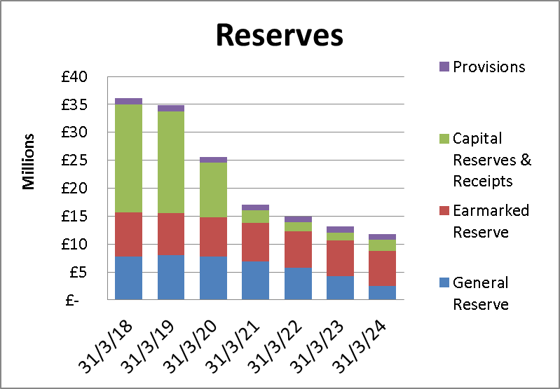

As this shows up to 31/3/2020, the end of the current multi-year settlement period, we remain in a healthy position. The reduction in the level of reserves becomes more of a concern thereafter with general reserves potentially falling below the minimum target level, but this position will be subject to significant change as funding, inflation, pay awards and other pressures all become clearer in future years. The annual refresh of this policy will identify the impact of any changes as they develop.

For comparative purposes the average level of reserves relative to total revenue expenditure across all Fire Authorities as at 31 March 2018 was 42%. Our anticipated position at the end of the current financial year shows reserves equal to 60% our revenue expenditure. However within this are £13m of capital slippage and a further £4m of PFI reserve, if we exclude these total reserves equate to £17m, 30% of our total revenue expenditure which is below the sector average.

It is also worth noting the comparator with other types of Authorities as set out in the Revenue Outturn Summary for 2017/18 comparing Net Revenue Expenditure with Non School Reserves:-

- London Boroughs | 51%
- Metropolitan Districts | 40%
- Unitary Authorities | 39%
- Shire Counties | 28%
- Shire Districts | 144%
- Other (which includes Fire) | 31%
- Overall | 40%

Further details of the year on year change in reserves is shown below

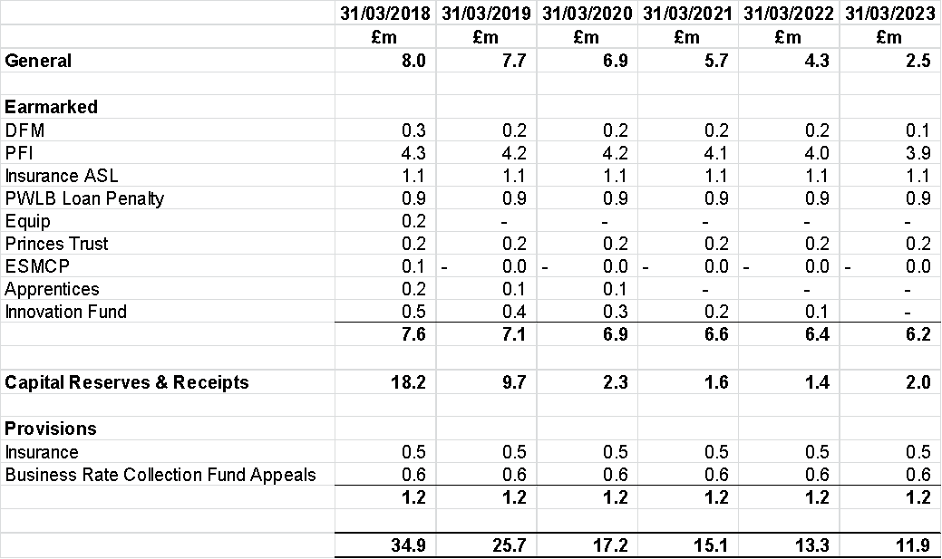

SECTION 5

TREASURY MANAGEMENT STRATEGY 2019/20

Treasury Management is defined as “The management of the Authority’s investments and cash flows, its banking, money market and capital market transactions; the effective control of the risks associated with those activities; and the pursuit of optimum performance consistent with those risks. ”

The Combined Fire Authority adopts the Chartered Institute of Public Finance and Accountancy’s Treasury Management in the Public Services: Code of Practice (the CIPFA Code) which requires the Authority to approve a treasury management strategy before the start of each financial year. The authority also adheres to investment guidance issued by the Ministry of Housing, Communities and Local Government (MHCLG). In 2018 the MHCLG issued new guidance which widens the definition of investments. For treasury management investments the guidance requires authorities to prioritise security, liquidity and yield in that order of importance. This is consistent with previous guidance. In addition, the guidance definition of investments includes financial and non-financial assets which are held primarily or partially to generate a profit.

Where an authority holds non treasury investments it is required to produce a separate investment strategy. The definition of non-treasury investments is wide ranging covering for example loans to third parties and the holding of property to make a profit. However, it is not considered that the Combined Fire Authority hold any such assets and it does not propose to engage in any such investments in 2019/20.

Statutory requirements

The Local Government Act 2003 (the Act) and supporting Regulations requires the Authority to “have regard to” the CIPFA Prudential Code and the CIPFA Treasury Management Code of Practice to set Prudential and Treasury Indicators for the next three years to ensure that the Authority’s capital investment plans are affordable, prudent and sustainable.

This report fulfils the Authority’s legal obligation under the Local Government Act 2003 to have regard to both the CIPFA Code and the MHCLG Guidance.

Treasury Management Strategy for 2019/20

This Strategy Statement has been prepared in accordance with the CIPFA Treasury Management Code of Practice. Accordingly, the Lancashire Combined Fire Authority's Treasury Management Strategy will be approved by the full Authority, and there will also be a mid-year and a year-end outturn report presented to the Resources Committee. In addition there will be monitoring and review reports to members in the event of any changes to Treasury Management policies or practices. The aim of these reporting arrangements is to ensure that those with ultimate responsibility for the treasury management function appreciate fully the implications of treasury management policies and activities, and that those implementing policies and executing transactions have properly fulfilled their responsibilities with regard to delegation and reporting.

This Authority has adopted the following reporting arrangements in accordance with the requirements of the revised Code: -

Area of Responsibility | Committee/ Officer | Frequency
Treasury Management Policy Statement | Resources  Committee/Authority | Annually
Scrutiny and approval of  - Treasury Management Strategy  - Annual Investment Strategy  - MRP policy | Resources Committee/Authority | Annually before the start of the year
Treasury Management mid-year report | Resources  Committee | Mid-year
Updates or revisions at other times of  - Treasury Management Strategy  - Annual Investment Strategy  - MRP policy | Resources  Committee | As required
Annual Treasury Management Outturn Report | Resources Committee/Authority | Annually by 30 September after the end of the year
Treasury Management Monitoring Reports | Director of  Corporate Services | Quarterly
Treasury Management Practices | Director of  Corporate Services | Annually

The Treasury Management Strategy covers the following aspects of the Treasury Management function:-

- Prudential Indicators which will provide a controlling framework for the capital expenditure and treasury management activities of the Authority;
- Current Long-term debt and investments;
- Prospects for interest rates;
- The Borrowing Strategy;
- The Investment Strategy;
- Policy on borrowing in advance of need.

Setting the Treasury Management Strategy for 2019/20

In setting the treasury management strategy the following factors need to be considered as they may have a strong influence over the strategy adopted:

- economic forecasts,
- Interest rate forecasts
- the current structure of the investment and debt portfolio
- future Capital Programme and underlying cash forecasts

Economic Context

The UK’s progress in negotiating its exit from the European Union (EU), together with its future trading arrangements, will continue to be a major influence on the economy in 2019/20. The latest (2018 Quarter 3) GDP growth figures show a year on year growth of 1.5%. It is anticipated that the growth will continue with the Bank of England, in its November Inflation Report, expecting GDP growth to average around 1.75% over the forecast horizon, providing the UK’s exit from the EU is relatively smooth.

The Bank of England remit includes a 2% inflation (CPI) target. It is slightly above this level at 2.1% in December 2018. The latest inflation report projected inflation to remain above the target for 2019/20, before reaching 2% at Q4 2021.

There are signs that there will be a slowing of world economic growth in 2019. There is a continued risk of a developing trade war between US and China while the German economy grew by 1.5 per cent in 2018, the weakest rate since 2013. The World Bank forecast global economic growth would slow to 2.9 per cent with falls in the US, China and the Eurozone.

Following the Bank of England’s decision to increase Bank Rate to 0.75% in August, no changes to monetary policy has been made since. However, the Bank expects that should the economy continue to evolve in line with its November forecast, further increases in Bank Rate will be required to return inflation to the 2% target. The Monetary Policy Committee continues to reiterate that any further increases will be at a gradual pace and limited in extent.

Credit outlook: The big four UK banking groups have now divided their retail and investment banking divisions into separate legal entities under ringfencing legislation. Bank of Scotland, Barclays Bank UK, HSBC UK Bank, Lloyds Bank, National Westminster Bank, Royal Bank of Scotland and Ulster Bank are the ringfenced banks that now only conduct lower risk retail banking activities. Barclays Bank, HSBC Bank, Lloyds Bank Corporate Markets and NatWest Markets are the investment banks. Credit rating agencies have adjusted the ratings of some of these banks with the ringfenced banks generally being better rated than their non-ringfenced counterparts.

Interest Rate Forecast and Prospects for Market Liquidity

Interest rate forecasts are made in the context of the overall economic position outlined above. The Bank of England last changed rates in August 2018 and it has maintained expectations for slow and steady rate rises however with the high level of uncertainty there is the possibility for the next change in interest rates will be a reduction.

The latest forecast provided by Treasury Consultants Arlingclose Ltd is shown in the table below:

 | Bank Rate % | 3 month LIBID % | 12 month LIBID  % | 5 year gilt yield % | 10 year gilt yield % | 20 year gilt yield % | 50 year gilt yield %
March 19 | 0.75 | 0.95 | 1.25 | 1.25 | 1.65 | 2.10 | 1.95
June 19 | 1.00 | 1.10 | 1.35 | 1.35 | 1.70 | 2.20 | 2.00
September 19 | 1.00 | 1.30 | 1.50 | 1.50 | 1.80 | 2.20 | 2.00
December 19 | 1.25 | 1.40 | 1.70 | 1.50 | 1.80 | 2.20 | 2.00
March 20 | 1.25 | 1.40 | 1.60 | 1.40 | 1.75 | 2.20 | 2.00
June 20 | 1.25 | 1.40 | 1.50 | 1.35 | 1.75 | 2.20 | 2.00
September 20 | 1.25 | 1.35 | 1.40 | 1.35 | 1.70 | 2.20 | 2.00
December 20 | 1.25 | 1.35 | 1.35 | 1.30 | 1.70 | 2.20 | 2.00
March 21 | 1.25 | 1.35 | 1.35 | 1.30 | 1.70 | 2.20 | 2.00
June 21 | 1.25 | 1.35 | 1.35 | 1.30 | 1.70 | 2.20 | 2.00
September 21 | 1.25 | 1.35 | 1.35 | 1.30 | 1.70 | 2.20 | 2.00
December 21 | 1.25 | 1.35 | 1.35 | 1.30 | 1.70 | 2.20 | 2.00

In the above table 'bank rate' refers to the policy rate of the Bank of England. 'LIBID' is the London Interbank bid rate and can be used as a proxy for short term market interest rates. PWLB borrowing rates are based on 'Gilt Yield' and so this is a forecast of long term interest rates. The Authority can borrow at 80 basis points above the gilt yield, so for example a fixed interest rate to borrow PWLB money for 10 years would be 2.45%, 1.65% plus 0.80%.

Current Treasury Portfolio Position

At the 31 December 2018 the debt outstanding was £2.0m with investments of £38.1m

Debt
Fixed rate loans from the Public Works Loan Board | £2.000m | 100%
Variable rate loans | - | -
 | £2.000m | 100%
Investment
Variable rate investments with Lancashire County Council | £18.090m | 47.5%
Fixed rate investments | £20.000m | 52.5%
 | £38.090m | 100%

The level of investments represents the Authority’s cumulative surplus on the General Fund, the balances on other cash-backed earmarked reserves and a cash-flow balance generated by a surplus of creditors over debtors and by grant receipts in advance of payments. There is a net investment figure of £36.1m.

Borrowing and Investment Requirement

In the medium term the Authority borrows for capital purposes only. The underlying need to borrow for capital purposes is measured by the Capital Financing Requirement (CFR), while usable reserves and working capital are the underlying resources available for investment. The table below compares the estimated CFR to the debt which currently exists, this gives an indication of the borrowing required. It also shows the estimated resources available for investment. An option is to use these balances to finance the expenditure rather than investing, often referred to as internal borrowing. The table gives an indication of the minimum borrowing or investment requirement through the period.

The CFR forecast includes the impact of the latest forecast of the funding of the Capital Programme which currently assumes that there will be no borrowing.

 | 31/3/2018 | 31/3/2019 | 31/3/2020 | 31/3/2021 | 31/3/2022
 | £m | £m | £m | £m | £m
Capital Financing Requirement | 14.518 | 14.513 | 14.106 | 13.669 | 13.195
Less long term liabilities (PFI & Leases) | (14.316) | (14.321) | (13.925) | (13.497) | (13.033)
Less external borrowing | (2.000) | (2.000) | (2.000) | (2.000) | (2.000)
Borrowing requirement | (1.798) | (1.808) | (1.818) | (1.828) | (1.838)
Reserves and working capital | (35.400) | (22.400) | (17.400) | (13.800) | (11.400)
Borrowing/(investment) need | (37.198) | (24.208) | (19.218) | (15.628) | (13.238)

CIPFA’s Prudential Code for Capital Finance in Local Authorities recommends that the Authority’s total debt should be lower than its highest forecast CFR over the next three years. However, the table above shows that the level of loans was above the CFR at 31/3/18. This was the result of the Authority adopting a policy of setting aside additional Minimum Revenue Provision (MRP) in order to generate the cash to repay loans either on maturity or as an early repayment.

The table above indicates that rather than having a need for borrowing it is estimated that the authority has an underlying need to invest although the available balances are forecast to reduce.

Although the Authority does not have plans for new borrowing it does currently holds £2.000m of loans as part of its strategy for funding previous years' capital programmes.

Borrowing Strategy

Although it is unlikely that borrowing will required in 2019/20 it is still best practice to approve a borrowing strategy and a policy on borrowing in advance of need. In considering a borrowing strategy the Authority needs to make provision to borrow short term to cover unexpected cash flow shortages or to cover any change in the financing of its Capital Programme.

Therefore the approved sources of long-term and short-term borrowing are:

- Public Works Loan Board
- UK local authorities
- any institution approved for investments
- any other bank or building society authorised by the Prudential Regulation Authority to operate in the UK
- UK public and private sector pension funds

In the past the Authority has raised all of its long-term borrowing from the Public Works Loan Board, but it continues to investigate other sources of finance, such as local authority loans, and bank loans, that may be available at more favourable rates.

Policy on Borrowing in Advance of Need

In line with the existing policy the Authority will not borrow more than or in advance of need purely in order to profit from the investment of the extra sums borrowed. However advance borrowing may be taken if it is considered that current rates are more favourable than future rates and that this advantage outweighs the cost of carrying advance borrowing. Any decision to borrow in advance will be considered carefully to ensure value for money can be demonstrated and that the Authority can ensure the security of such funds and relationships.

In determining whether borrowing will be undertaken in advance of need the authority will:-

- Ensure that there is a clear link between the capital programme and the maturity profile of the existing debt portfolio which supports the need to take funding in advance of need.
- Ensure the on-going revenue liabilities created, and the implications for the future plans and budgets have been considered.
- Evaluate the economic and market factors that might influence the manner and timing of any decision to borrow.
- Consider the merits and demerits of alternative forms of funding.
- Consider the alternative interest rate bases available, the most appropriate periods to fund and repayment profiles to use.

Debt Restructuring

The Authorities debt has arisen as a result of prior years' capital investment decisions. It has not taken any new borrowing out since 2007 as it has been utilising cash balances to pay off debt as it matures, or when deemed appropriate with the authority making early payment of debt. The anticipated holding of debt at 31 March 2019 is £2.0m. All the debt is from the Public Works Loans Board (PWLB) and is all at fixed rates of interest and is repayable on maturity. The table below shows the maturity profile and interest rate applicable on these:-

Loan Amount | Maturity Date | Interest rate
£650k | December 2035 | 4.49%
£650k | June 2036 | 4.49%
£700k | June 2037 | 4.48%

This debt was taken out in 2007 when base rate was 5.75% and when the Authority was earning 5.84% return on its investments.

Given the high interest rates payable on these loans, relative to current interest rates, we have again reviewed opportunities for debt repayment/restructuring.

The level of penalty applicable on early repayment of loans now stands at £0.890m. (As previously reported the level of penalty is dependent upon two factors, the difference between the interest chargeable on the loan and current interest rates, the greater this difference the greater the penalty, and the length to maturity, the greater the remaining time of the loan the greater the penalty. Hence as interest rates increase or as loans get closer to maturity the level of penalty will reduce.)

Outstanding interest payable between now and maturity is £1.587m. Giving a gross saving of £0.697m

Penalty incurred | £0.890m
Savings on interest payable | (£1.587m)
Gross Saving | (£0.697m)

However as highlighted as part of the Treasury Management Strategy and the previous reports, any early repayment means that cash balances available for investment will be reduced and hence interest receivable will also be reduced. The extent of which is dependent upon future interest rates. It is estimated that if interest rate on investments are at 1.25% over the remaining period of the loan then repaying the loans now will be broadly neutral.

In essence this means that if returns on investments over the next 20 years exceed 1.25% then it is financially disadvantageous to pay off the loans, if interest rate averages less than 1.25% then it is financially advantageous. It is worth noting that other than during the current financial crisis interest rates have never been at such a low rate. If, as seems likely, interest rates prove to be higher than this then the early repayment of debt results in a worse overall financial position.

It is also worth noting that whilst the capital budget does not show any additional borrowing being required in the next 5 years, it does not include any allowance for relocating SHQ. This project is currently on hold and should the Authority decide to proceed with the relocation it will need to take out additional borrowing to meet the costs.

Investment Strategy

At 31st December 2018 the Authority held £38.1m invested funds, representing income received in advance of expenditure plus existing balances and reserves. In the past 12 months, the Authority’s investment balance has ranged between £28.5m and £48.3m. The variation arises principally due to the timing of the receipt of government grants. It is anticipated that similar levels will be maintained in the forthcoming year.

Both the CIPFA Code and the CLG Guidance require the Authority to invest its funds prudently, and to have regard to the security and liquidity of its investments before seeking the highest rate of return, or yield. The Authority’s objective when investing money is to strike an appropriate balance between risk and return, minimising the risk of incurring losses from defaults and the risk receiving unsuitably low investment income.

Therefore in line with the guidance the Treasury Management Strategy is developed to ensure the Fire Authority will only use very high quality counterparties for investments.

The Authority may invest its surplus funds with any of the counterparties in the table below, subject to the cash and time limits shown.

Counterparty |  | Cash limit | Time limit †
Banks and other organisations and securities whose lowest published long-term credit rating from Fitch, Moody’s and Standard & Poor’s is: | AAA | £5m each | 5 years
 | AA+ |  | 3 years
 | AA |  | 2 years
 | AA- |  | 2 years
Call Accounts with banks and other organisations with minimum AA- credit rating |  | £10m | next day
Call Account with Lancashire County Council |  | unlimited | next day
UK Central Government (irrespective of credit rating) |  | unlimited | 50 years
UK Local Authorities (irrespective of credit rating) |  | £5m each | 10 years
Secured Bond Funds AA rating and WAL not more than 3 yrs |  | £5m each | n/a
Secured Bond Funds AAA rated and WAL not more than 5 yrs |  | £5m each | n/a

Allowable bond funds are defined by credit rating and weighted average life (WAL). Investing in senior secured bonds backed by collateral provides a protection against bail-in. Although the average life of the securities within the fund will be either 3 or 5 years, funds can be redeemed within 2 days of request but in general these should be seen as longer term investments. The fund targets returns of 3 month Libor + 40 basis points which is currently around 1.1% in total.

Regarding the risk of investing with another local authority, only a very few authorities have their own credit rating, but those that do are the same or one notch below the UK Government reflecting the fact that they are quasi-Government institutions. On the whole credit ratings are seen as unnecessary by the sector because the statutory and prudential framework within which the authorities operate is amongst the strongest in the world. In addition any lender to a local authority has protection, under statute, by way of a first charge on the revenues of that authority. No local authority has ever defaulted to date and this also may be an indication of security. However, following the downgrade of the UK credit rating by the rating agencies those local authorities with a rating saw a reduction in their ratings. Therefore, consideration has been given to reducing the risk associated with the investment with other local authorities. Arlingclose, the County Council's Treasury Management advisor, state they are "comfortable with clients making loans to UK local authorities for periods up to two years, subject to this meeting their approved strategy. For periods longer than two years we recommend that additional due diligence is undertaken prior to a loan being made." On this basis it is proposed that the investments to local authorities are limited as follows:

 | Maximum individual investment (£m) | Maximum total investment (£m) | Maximum period
Up to 2 years | 5 | 25 | 2 years
Over 2 years | 5 | 25 | 10 years

The investment in LCC as part of the call account arrangement is excluded from the above limits. The balance on this account is dependent upon short term cash flows and therefore does not have a limit.

Whilst the investment strategy has been amended to allow greater flexibility with investments any decision as to whether to utilise this facility will be made based on an assessment of risk and reward undertaken jointly between the Director of Corporate Services and LCC Treasury Management Team, and consideration of this forms part of the on-going meetings that take place throughout the year.

The legislative context referred to earlier in the report effectively means that, because taxpayers will no longer bail-out failed banks, the required funds will be paid by equity investors and depositors. Local authorities' deposits will be at risk and consequently although currently available within the policy it is unlikely that long term unsecured term deposits will be used at the present time.

Currently all of the Authority's investments are with other local authorities.

The Authority currently has access to a call (instant access) account with a local authority, which pays bank rate, this is currently 0.75%. Each working day the balance on the Authority's current account is invested to ensure that the interest received on surplus balances is maximised.

In addition longer term loans have been placed with an UK local authorities as outlined below.

Start Date | End Date | Principal | Rate | Annual Interest | Interest 2018/19
30/6/14 | 28/6/19 | £5,000,000 | 2.4% | £120,000 | £120,000
18/10/18 | 19/10/20 | £5,000,000 | 1.15% | £57,500 | £25,993
19/11/18 | 18/11/19 | £5,000,000 | 1.00% | £50,000 | £18,219
19/12/18 | 19/6/19 | £5,000,000 | 0.92% | £46,000 | £12,980

Consideration is given fixing further investments if the maturity fits with estimated cash flows and the rate is considered to be attractive. This will continue to be reviewed. Current rates payable by other local authorities are:

3 month investment | 0.75%
6 month investment | 0.95%
12 month investment | 1.09%

The overall combined amount of interest earned on Fixed/Call balances as at 31st December 2018 is £0.260m on an average balance of £38.333m at an annualised rate of 0.90%. This compares favourably with the benchmark 7 day LIBID which averages 0.48% over the same period, and is 0.15% above the current bank rate.

Specified and Non-specified investments

The legislative and regulatory background to treasury management activities requires the Authority to set out its use of “specified” and “non-specified” investments.

Specified Investments: The CLG Guidance defines specified investments as those:-

- denominated in pound sterling,
- due to be repaid within 12 months of arrangement,
- not defined as capital expenditure by legislation, and invested with one of:
  - the UK Government,
  - a UK local authority, parish council or community council, or
  - a body or investment scheme of “high credit quality”.

The Authority defines “high credit quality” organisations as those having a credit rating of A+ or higher that are domiciled in the UK or a foreign country with a sovereign rating of AA+ or higher.

Non-Specified Investments: are any investment not meeting the definition of a specified investment is classed as non-specified. The Authority does not intend to make any investments denominated in foreign currencies, nor any that are defined as capital expenditure by legislation, such as company shares. Non-specified investments will therefore be limited to long-term investments, i.e. those that are due to mature 12 months or longer from the date of arrangement, and investments with bodies and schemes not meeting the definition on high credit quality.

The Authority may lend or invest money using any of the following instruments:-

- interest-bearing bank accounts,
- fixed term deposits and loans,
- callable deposits where the Authority may demand repayment at any time (with or without notice),
- certificates of deposit,
- bonds, notes, bills, commercial paper and other marketable instruments, and

Investments may be made at either a fixed rate of interest, or at a variable rate linked to a market interest rate, such as LIBOR, subject to the limits on interest rate exposures below.

The Authority prepares daily cash flow forecasts to determine the maximum period for which funds may prudently be committed. The forecast is compiled on a pessimistic basis, with receipts under-estimated and payments over-estimated to minimise the risk of the Authority being forced to borrow on unfavourable terms to meet its financial commitments. Limits on long-term investments are set by reference to the Authority’s medium term financial plan and cash flow forecast.

Minimum Revenue Provision (MRP)

Under Local Authority Accounting arrangements the Authority is required to set aside a sum of money each year to reduce the overall level of debt. This sum is known as the Minimum Revenue Provision (MRP).

The Authority will assess their MRP for 2018/19 in accordance with guidance issued by the Secretary of State under section 21(1A) of the Local Government Act 2003.

It is proposed to continue to utilise the Capital Financing Requirement (CFR) Method. This provides for a charge of 4% of the value of fixed assets, as measured on the balance sheet, for which financing provision has not already been made. .

 | 2019/20 | 2020/21 | 2021/22 | 2022/23
 | £m | £m | £m | £m
Statutory charge to revenue 4% MRP | 0.008 | 0.007 | 0.007 | 0.006
Additional voluntary lump sum MRP | 0.002 | 0.003 | 0.003 | 0.004
Total MRP | 0.010 | 0.010 | 0.010 | 0.010

The Authority may make a voluntary MRP depending upon the overall financial position. The Director of Corporate Services will have the authority to authorise a voluntary MRP.

Whilst the Authority has no unsupported borrowing, nor has any plans to take out any unsupported borrowing it needs to approve a policy relating to the MRP that would apply if this were not the case. As such in accordance with the Local Government Act 2003, the MRP on any future unsupported borrowing will be calculated using the Asset Life Method. This will be based on a straightforward straight – line calculation to set an equal charge to revenue over the estimated life of the asset. Estimated life periods will be determined under delegated powers. To the extent that expenditure is not on the creation of an asset and is of a type that is subject to estimated life periods that are referred to in the guidance, these periods will generally be adopted by the Authority. However, the Authority reserves the right to determine useful life periods and prudent MRP in exceptional circumstances where the recommendations of the guidance would not be appropriate.

As some types of capital expenditure incurred by the Authority are not capable of being related to an individual asset, asset lives will be assessed on a basis which most reasonably reflects the anticipated period of benefit that arises from the expenditure. Also, whatever type of expenditure is involved, it will be grouped together in a manner which reflects the nature of the main component of expenditure and will only be divided up in cases where there are two or more major components with substantially different useful economic lives.

Assets held under a PFI contracts and finance leases form part of the Balance Sheet. This has increased the overall capital financing requirement and on a 4% basis the potential charge to revenue. To prevent the increase the guidance permits a prudent MRP to equate to the amount charged to revenue under the contract to repay the liability. In terms of the PFI schemes this charge forms part of the payment due to the PFI contractor.

Revenue Budget Implications

The capital financing budget currently shows that income received exceeds expenditure. This excludes the PFI and Finance lease payments, which are included in other budgets. Based on the Strategy outlined above then the proposed budget for capital financing are:

 | 2019/20 | 2020/21 | 2021/22 | 2022/23
 | £m | £m | £m | £m
Interest payable | 0.090 | 0.090 | 0.090 | 0.090
MRP | 0.010 | 0.010 | 0.010 | 0.010
Interest receivable | (0.352) | (0.322) | (0.297) | (0.322)
Net budget | (0.252) | (0.222) | (0.197) | (0.222)

Prudential Indicators for 2018/19(revised) to 2021/22 in respect of the Combined Fire Authority's Treasury Management Activities.

In accordance with its statutory duty and with the requirements of the Prudential Code for Capital Finance and the CIPFA Code for Treasury Management, the Combined Fire Authority produces each year a set of prudential indicators which regulate and control its treasury management activities.

The following table sets out the debt and investment-related indicators which provide the framework for the Authority’s proposed borrowing and lending activities over the coming three years. These indicators will also be approved by members as part of the Capital Programme approval process along with other capital expenditure-related indicators, but need to be reaffirmed and approved as part of this Treasury Management Strategy.

It should be noted that contained within the external debt limits, there are allowances for outstanding liabilities in respect of the PFI schemes and finance leases for operational vehicles and photocopiers.

 |  | 2018/19 (Revised) | 2019/20 | 2020/21 | 2021/22
 |  | £m | £m | £m | £m
1 | Adoption of the Revised CIPFA Code of Practice on Treasury Management (2011) | Adopted for all years
2 | Authorised limit for external debt - A prudent estimate of external debt, which includes sufficient headroom for unusual cash movements.
 | Borrowing | 5.000 | 5.000 | 5.000 | 5.000
 | Other long-term liabilities | 15.000 | 14.600 | 14.200 | 13.700
 | TOTAL | 20.000 | 19.600 | 19.200 | 18.700
3 | Operational boundary for external debt - A prudent estimate of debt, but no provision for unusual cash movements. It represents the estimated maximum external debt arising as a consequence of the Authority's current plans.
 | Borrowing | 3.000 | 3.000 | 3.000 | 3.000
 | Other long-term liabilities | 14.400 | 14.000 | 13.600 | 13.100
 | TOTAL | 17.100 | 17.000 | 16.600 | 16.100
4 | Upper limit for fixed interest rate exposure
 | Upper limit of borrowing at fixed rates | 100% | 100% | 100% | 100%
 | Upper limit of investments at fixed rates | 100% | 100% | 100% | 100%
5 | Upper limit for variable rate exposure
 | Upper limit of borrowing at variable rates | 25% | 50% | 50% | 50%
 | Upper limit of investments at variable rates | 100% | 100% | 100% | 100%
6 | Upper limit for total principal sums invested for over 364 days (per maturity date) | 25.000 | 25.000 | 25.000 | 25.000
7 | Maturity structure of Debt | Upper Limit % |  | Lower Limit %
 | Under 12 months | 100 |  | -
 | 12 months and within 24 months | 50 |  | -
 | 24 months and within 5 years | 50 |  | -
 | 5 years and within 10 years | 50 |  | -
 | 10 years and above | 100 |  | -

