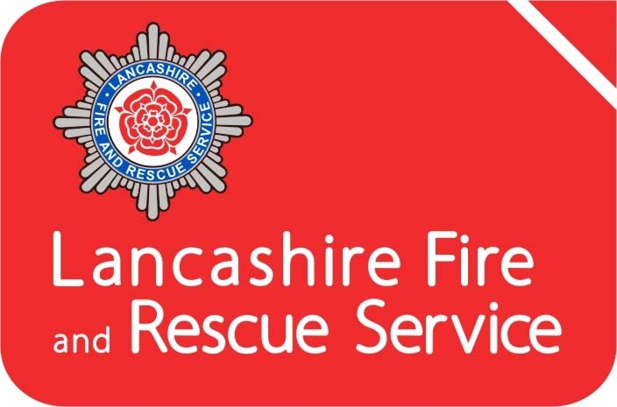

Annual Statement of Assurance 2018-19
1. Introduction 3
Lancashire Combined Fire Authority 3
The County of Lancashire 4
Lancashire Fire and Rescue Service (LFRS) 5
2. Financial Assurance 6
3. Assurance on Governance 7
4. Operational Assurance 8
Integrated Risk Management Plan (IRMP) 9
Planning & Performance 9
Consultation 9
Community Risk Management 10
Prevention, Protection and Response 11
Mutual Aid Agreements 11
National Resilience 11
Business Continuity 12
Safety, Health & Environment 13
Training and Development 14
5. Assurance Declaration 14

Figure 1 - Combined Fire Authority structure 4
Figure 2 - Service Delivery Areas and Fire Station locations 6
Figure 3 - Changes in Fire Risk 2009-2019 10

1. Introduction
The Fire and Rescue National Framework for England (2018) provides overall strategic direction to English Fire and Rescue Authorities (FRA). It sets out the Government’s priorities and objectives and places a requirement on all FRA’s to provide assurance to their communities and to Government on financial, governance and operational matters.
This Statement of Assurance aims to provide the necessary accountability and transparency to the people of Lancashire and evidence that their Fire and Rescue Service continues to deliver under the expectations detailed within both the National Framework and our own Integrated Risk Management Plan (IRMP).
This statement sits alongside our IRMP, Statement of Accounts, the Annual Governance Statement and recently re-designed Annual Service Plan and Annual Service Report. It details what measures are in place to assure that the Combined Fire Authority’s performance is efficient, economic and effective.

Lancashire Combined Fire Authority
Lancashire Combined Fire Authority (CFA) is made up of 25 elected councillors drawn from Lancashire County Council (19) and the unitary authorities of Blackburn-with-Darwen (3) and Blackpool (3). The CFA is responsible under the Fire & Rescue Services Act 2004 for providing a Fire and Rescue Service in Lancashire. This involves the provision, training and equipping our staff to undertake firefighting operations, fire safety work, rescue of persons from road traffic collisions and preparing for our response to other emergency situations. The CFA is the body legally responsible for enforcing the Regulatory Reform (Fire Safety) Order 2005 and is a designated Category 1 responder under the Civil Contingencies Act 2004.
The CFA ensures that the work of the Fire and Rescue Service is efficient, effective and provides best value for money. To achieve this, they operate under a framework of five full meetings each year (Figure 1), which are supplemented by a number of smaller committees focusing upon Planning, Performance, Resources, Audit and Appeals.
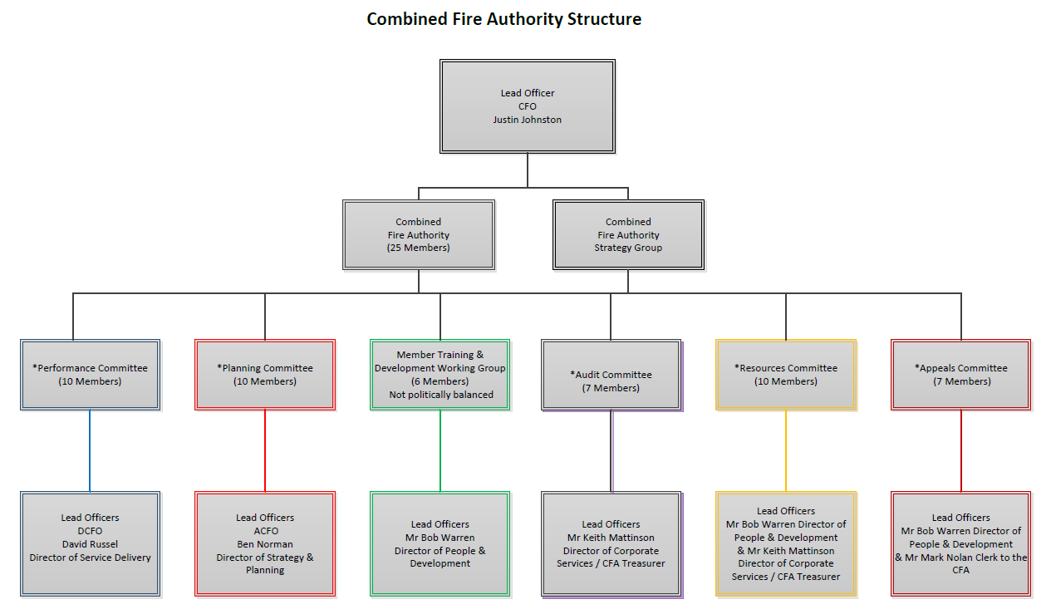
Further information on the afore-mentioned committees is accessible via our website at https://cfa.lancsfirerescue.org.uk/

Figure 1 - Combined Fire Authority structure

The County of Lancashire
Lancashire comprises of 14 districts, 12 of which are within the Lancashire County Council area (Burnley, Chorley, Fylde, Hyndburn, Lancaster, Pendle, Wyre, Ribble Valley, Rossendale, South Ribble, West Lancashire and Preston) and 2 unitary authorities of Blackpool and Blackburn-with-Darwen. The area is home to a resident population of circa 1.46 million people (Census 2011) and is one of the most populated and urbanised shire counties within Great Britain, with a legacy of historical, industrial heritage.

Lancashire covers just over 3,000 square kilometres including 123 kilometres of coastline stretching from Morecambe Bay in the north of the county, down to the sands of West Lancashire in the south. The County has an extensive motorway network, port facilities, nuclear installations and airports and is home to a diverse demographic, with almost 20% of our population being over retirement age and 10% representing Black and Minority Ethnic (BME) communities.
The County is bordered by Cumbria to the north and North Yorkshire, West Yorkshire, Greater Manchester and Merseyside moving from east to south. The major conurbations are Lancaster, Preston, Burnley, Blackburn, Accrington, Chorley and the seasonal town of Blackpool which receives around 16 million visitors per year.

Lancashire Fire and Rescue Service (LFRS)
LFRS is the service provider on behalf of the CFA. We currently operate from 39 locations (with 58 front-line fire engines and a fleet of specialist vehicles), an integrated Urban Search and Rescue capability, Service Headquarters in Fulwood and our Service Training Centre in Euxton, Chorley. LFRS staff deliver an extensive range of prevention, protection and emergency response services throughout Lancashire.
To deliver these services, we employ circa 1000 operational staff in a wide variety of roles using a variety of shift systems; Whole-time, On-Call, Day Crewed, Day Crewing Plus and Day Duty (Figure 2).
Our Mobilising and Control Centre moved to North West Fire Control (NWFC), Warrington in 2014. We work collaboratively with Cumbria, Greater Manchester and Cheshire Fire and Rescue Services.
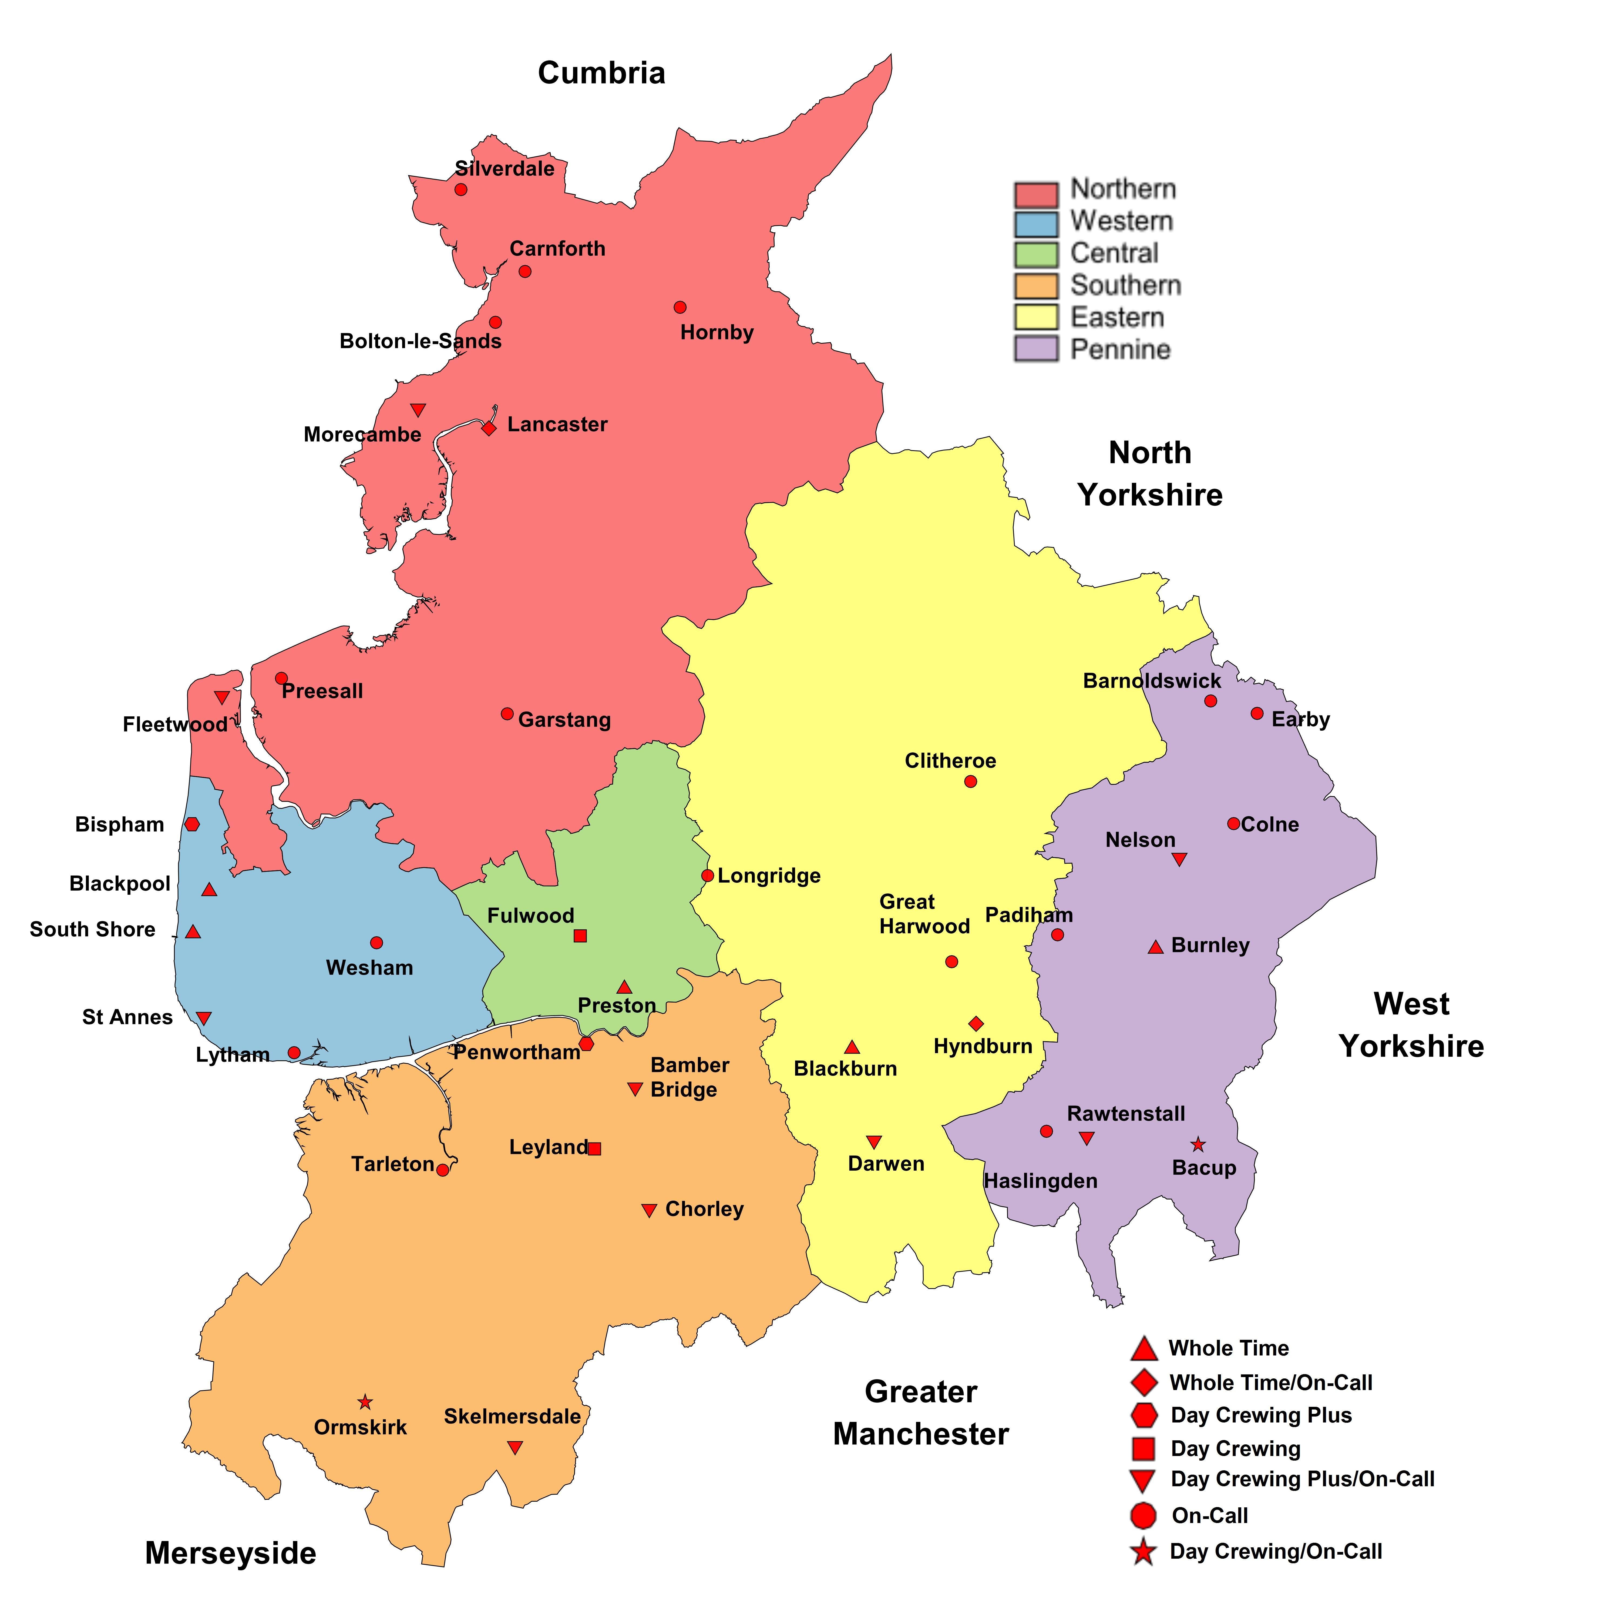
Figure 2 - Service Delivery Areas and Fire Station locations

2. Financial Assurance
All local authority accounts are required to adopt ‘proper accounting practice’ based on either statutory requirements or the code of practice on local authority accounting. These specify the principles and practices of accounting required to prepare a Statement of Accounts that ‘present a true and fair view’.

The Treasurer to the CFA provides publically available annual accounts which are approved by the Resources Committee.

An independent audit of the accounts is undertaken by an external auditing body, Grant Thornton. The external auditor undertakes a review of the accounts and forms an overall opinion which is published in September of each year. The audit for 2018/19 was conducted in accordance with the Local Audit and Accountability Act 2014 and provided the following –
- An unqualified opinion on the accounts which gives a true and fair view of the Authority’s financial position as at 31 March 2019 and its income and expenditure for the year.
- An unqualified conclusion in respect of the Authority’s arrangements for securing economy, efficiency and effectiveness in its use of resources.
A copy of the Statement of Accounts 2018/19 can be found here.
A copy of Robin J Baker’s audit report on behalf of Grant Thornton’s can be found here.

3. Assurance on Governance
The Accounts and Audit Regulations 2015 require the CFA to publish an Annual Governance Statement along with the Authority’s financial statements, following a review of the effectiveness of the internal controls in place. It sets out the key elements of the Authority’s governance framework, how these have been evaluated, the outcome of the assessment of effectiveness and any areas for improvement.

The Audit Committee has approved and adopted an updated Code of Corporate Governance, in line with guidance produced jointly by CIPFA (Chartered Institute of Public Finance Accountants) and SOLACE (Society of Local Authority Chief Executives). The Code defines corporate governance as the way an authority ensures that it is doing the right things, in the right way, for the right people, in a timely, inclusive, open, honest and accountable manner.

Included within the Code are the following core principles:-
- Behaving with integrity, demonstrating strong commitment to ethical values, and respecting the rule of law;
- Ensuring openness and comprehensive stakeholder engagement;
- Defining outcomes in terms of sustainable economic, social, and environmental benefits;
- Determining the interventions necessary to optimise the achievement of the intended outcomes;
- Developing the entity’s capacity, including the capability of its leadership and the individuals within it;
- Managing risks and performance through robust internal control and strong public financial management;
- Implementing good practices in transparency, reporting, and audit to deliver effective accountability.
The code also sets out the principles which support each of these core elements, as well as how the Authority will address each of these.

The Authority has responsibility for conducting, at least annually, a review of the effectiveness of its governance framework including the system of internal control. The 2018/19 review was supported and informed by the work of both internal audit, which is undertaken by Lancashire County Council, and external audit, which is undertaken by Grant Thornton. This self-assessment formed the basis of the Authority’s Annual Governance Statement for 2018/19, which concluded that Lancashire Combined Fire Authority and Lancashire Fire and Rescue Service has in place a satisfactory system of internal control which facilitates the effective exercise of its functions and which includes arrangements for the management of risk, and that no significant governance issues were identified.

4. Operational Assurance
The National Framework outlines the requirement placed upon FRA’s to provide assurance on operational matters which are determined locally by them in partnership with their local communities; citizens, businesses and others.
FRA’s function within a clearly defined statutory and policy framework of which the key legislative documents defining these responsibilities are:
- Fire and Rescue Services Act 2004
- Civil Contingencies Act 2004
- Regulatory Reform (Fire Safety) Order 2005
- Fire and Rescue Services (Emergencies) (England) Order 2007
- Localism Act 2011
- Fire and Rescue National Framework for England.

This section aims to provide assurance that our service is delivered in line with our statutory responsibilities and with due regard to the expectations set out in our IRMP including cross-border, multi-authority and national incident arrangements.

Integrated Risk Management Plan (IRMP)
Our Integrated Risk Management Plan (IRMP) is a public facing document covering the period 2017-22. This plan is in place to provide the opportunity for LFRS to demonstrate how, we as an organisation, identify and assess all foreseeable fire and rescue related risks and challenges that could affect our communities over the 5 year period and how we plan to mitigate such risks or reduce their potential impact.
Key to the successful identification and management of risk is our ability to maintain a clear and current understanding of the present and future threats to Lancashire’s communities. Risk in Lancashire remains dynamic, constantly changing and differs between districts, which requires varying preventative activities. As a result, no single activity to reduce risk is adequate in all circumstances and a mix of prevention, protection and response activities delivered by a range of organisations is needed to reduce the likelihood of the risk event occurring or to lessen its consequences. This depth of understanding underpins everything we do, driving our governance and planning arrangements; our findings are published within the Strategic Assessment of Risk.

Planning & Performance
To meet the requirements of the IRMP the Service reviews its priorities and targets annually, this supports continual improvement and provides the opportunity to ensure that we undertake activities dependent on the requirements of our environment. Our Corporate planning process has been developed to provide a rigorous yet flexible process that allows the Service to assess and respond to opportunities and threats as and when they emerge. Whilst the IRMP is in place to set out the strategic direction of the Service in the medium term, the Service also has in place a forward-looking Annual Service Plan which clearly sets out what we will deliver over the coming 12 months, this is complimented by the Annual Service Report which reflects our achievement against those objectives at the year end.
In addition to this on a quarterly basis, we produce a performance management report known as ‘Measuring Progress’. The content of this report is considered at Senior Management Team meetings and by the Performance Committee of the CFA.

Consultation
External and internal consultation is an essential part of the development of the IRMP and subsequent reviews, and as such we have a clearly defined Consultation Strategy. We use a variety of methods for engaging with community members and for every consultation exercise completed, a summary report is provided to the relevant committee of the CFA. This process ensures that potential stakeholders are consulted, involved and informed of the proposals to ensure that their input is considered within the final plans.
Community Risk Management
Our approach to integrated risk management is supported by the use of modelling. The Office of National Statistics categorises every part of the UK into a small neighbourhood called a Lower Layer Super Output Area (SOA). There are 941 SOA’s in Lancashire, containing an average of 1,500 people. We use information about where fires have taken place in the past and combine this with various social deprivation data to give each area a risk grade.
The information is then used to identify geographic areas at higher risk where a combination of Prevention, Protection and Response activities can have the greatest impact.
This is utilised alongside the provision of a tailored Home Fire Safety Check service (HFSC) which is geared towards occupant risk and importantly, to those in greatest need and at greatest risk of fire.
We update the risk model on a regular basis and use the outcomes to direct and reprioritise our activities. Risk reduction progress over the last 11 years is depicted in the table below.

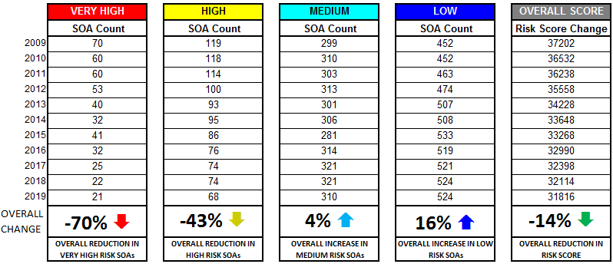

Figure 3 - Changes in Fire Risk 2009-2019

Prevention, Protection and Response
Over the course of our previous IRMP (2013-17) our Prevention and Protection activities and services were reviewed to ensure that we continue to deliver services in line with our changing environment. Prevention activities are now focussed around four key themes helping people to Start Safe, Live Safe, Age Safe and be Safe on our roads with a focus on working collaboratively with other organisations.
To further complement this we have changed our working practices in order to transform our Home Fire Safety Check Service to a Safe & Well Service. Delivery methods for this Service have been improved to provide a more targeted risk based approach for home visits. The service now includes brief intervention and advice to reduce risk, falls risk assessments, alcohol and mental health advice and access to other services. This provides the gateway for further collaboration with colleagues in health and social care with a joint aim to improve the health and quality of life for those most at risk in our communities.
Protection services have been transformed in order to help the businesses of Lancashire in being more compliant with fire safety regulations, by providing information and access to a great range of services through a business support function. Protection activity is undertaken through the utilisation of a Risk Based Inspection Programme (RBIP) ensuring the highest risk premises are effectively targeted for compliance. We have continued to develop and establish Primary Authority schemes with an aim to develop effective partnerships with businesses, in order to provide reliable and consistent regulatory advice in relation to fire safety.

Mutual Aid Agreements
The National Framework states that Fire and Rescue Authorities must make provision to respond to incidents such as fires, road traffic collisions and other emergencies within their area and in other areas in line with mutual aid agreements. LFRS maintain mutual agreements for reinforcements with our five bordering Fire and Rescue Authorities - Cumbria, Greater Manchester, Merseyside, North Yorkshire and West Yorkshire. These agreements are periodically reviewed to maintain currency and provide optimal response arrangements.

National Resilience
For the purposes of this document, National Resilience (NR) is defined as the capacity and capability of Fire and Rescue Authorities to work together and with other Category 1 and 2 responders to deliver a sustained, effective response to major incidents, emergencies and disruptive challenges, such as (but not limited to) those identified in the National Risk Register of Civil Emergencies. It refers to risks that need to be planned for on a strategic, national basis because their impacts and consequences would be of such scale and / or complexity that local resources would be insufficient, even when taking into account mutual aid arrangements.
LFRS is a signatory to the National Mutual Aid protocol and has deployed assets to major incidents outside the region. The costs of such mobilisations are borne by the FRA within whose area the incident occurs and are therefore re-claimed by LFRS.
We remain subject to the National Resilience audit processes which test the various aspects of our NR capabilities. National Resilience has transferred from The Home Office to Merseyside Fire & Rescue Service as the Primary Authority.

Business Continuity
Business Continuity Management (BCM) is an integral part of our corporate risk management process. In relation to BCM processes and procedures, all FRA’s have to satisfy the requirements of both the Civil Contingencies Act 2004 and Fire & Rescue Services Act 2004.
We are required to ‘write and maintain plans for the purpose of ensuring, so far as reasonably practicable, that if an emergency occurs the Authority is able to continue its functions’. This includes periods of industrial action.
In order to ensure that Lancashire Fire and Rescue Service comply with both pieces of legislation, our BCM complies with the Business Continuity Institutes’ Best Practice Guidelines. This provides a framework through which:
- Critical processes are identified
- Assessments of both internal and external risks which may impact on business
continuity are made;
- Strategic and Tactical Plans have been produced to ensure an acceptable level of service can be maintained following disruption;
- Procedures are developed to invoke the BCP;
- Arrangements are made to test the BCP;
- All key personnel are trained to understand their role within the plan;
- Responsibilities are clearly identified and assigned.

Each year the plans are reviewed and tested to ensure our plans are fit for purpose. The protracted Winter Hill incident demonstrated the Service’s ability to deal with a Major Incident, whilst at the same time responding to other emergencies in a timely manner and continuing with business as usual, as much as reasonably practicable.

Safety, Health & Environment
The Combined Fire Authority meets regularly to consider local and national Safety, Health and Environment issues and to provide strategic political leadership to the Service. The Authority has overall responsibility for the effective governance of Safety, Health and Environment (SHE), including:
- Agreeing the SHE Policy which outlines their commitments and ensuring adequate resources is available for the establishment, ongoing implementation and control of a Health and Safety Management System (HSMS) and Environmental Management System (EMS).
- Providing a clear direction for the Executive Board and Senior Management Team to establish policies and manage health and safety performance effectively.
- Monitoring performance through receipt of the Annual SHE Report, to provide governance and assurance that an effective HSMS is operational within LFRS.

Our HSMS is based on the model Plan, Do, Check, Act laid down in the Health and Safety Executive publication HS(G)65 – Successful Health and Safety Management and written and implemented to the International Standard for Health and Safety Management Systems, ISO 45001:2018. The EMS is written and implemented to the International Standard ISO 14001:2015. Certification for both standards has been in place since 2011/12 with re-certification taking place every 3 years followed by annual surveillance audits. The last successful audit took place in 2019, where certification was extended. As part of the audit process, the auditors visit a range of stations and departments and examine the ‘Full provision of fire, rescue and supporting services across Lancashire’ delivered by the Combined Fire Authority from a health and safety and environmental perspective.
Each year a performance review of Safety, Health and Environment is carried out and reported to the Combined Fire Authority in the Annual SHE Report. Part of business-as-usual is the review of all policies, procedures, instructions and guidance to ensure that we continue to meet our legal obligations in respect of safety, health and environment and we validate this by a system of internal and external audits.
To ensure continuous improvement is made in both the HSMS and EMS, we have developed an action plan to assist in delivering future improvements.

Training and Development
Lancashire Fire and Rescue Service Training and Operational Review policy is designed to provide training and development to personnel to enable the organisation to fulfil its vision of 'Making Lancashire Safer'. Training is based on the needs of the organisation with a strong focus on ensuring that personnel are safe and competent in the delivery of the prevention, protection and response services we provide.
The training programme takes into account learning identified through our own operational review processes as well as from reports describing learning from events of national significance. The Training and Operational Review department supports continual learning and organisational development through a wide range of programmes tailored to role and responsibility, as well as managing the selection processes which identify managers for advancement. Ongoing development and maintenance of competence is a key focus and this is facilitated through a robust maintenance of skills programme linked to an e-learning system which is continually updated.

Trainers are selected and developed across an extremely diverse variety of specialisms ranging from the intricacies of boat handling and rope rescue through to the complexities of mounting a successful fire safety prosecution. Where necessary, support is commissioned from specialist providers.

5. Assurance Declaration
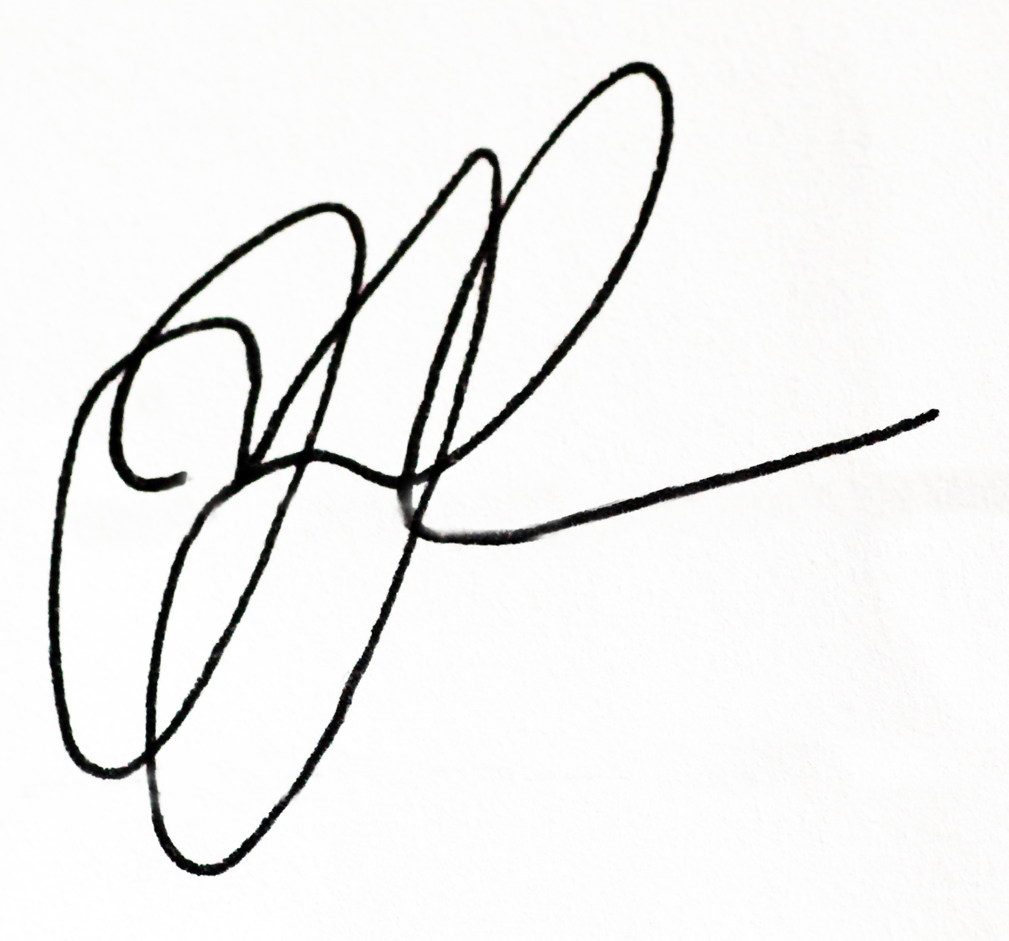
The Chairman of Lancashire Combined Fire Authority and Chief Fire Officer of Lancashire Fire and Rescue Service are satisfied that the Authority’s financial, governance and operational assurance arrangements are adequate and operating effectively and meet the requirements detailed within the Fire and Rescue National Framework.
Justin Johnston - Chief Fire Officer …………………………….
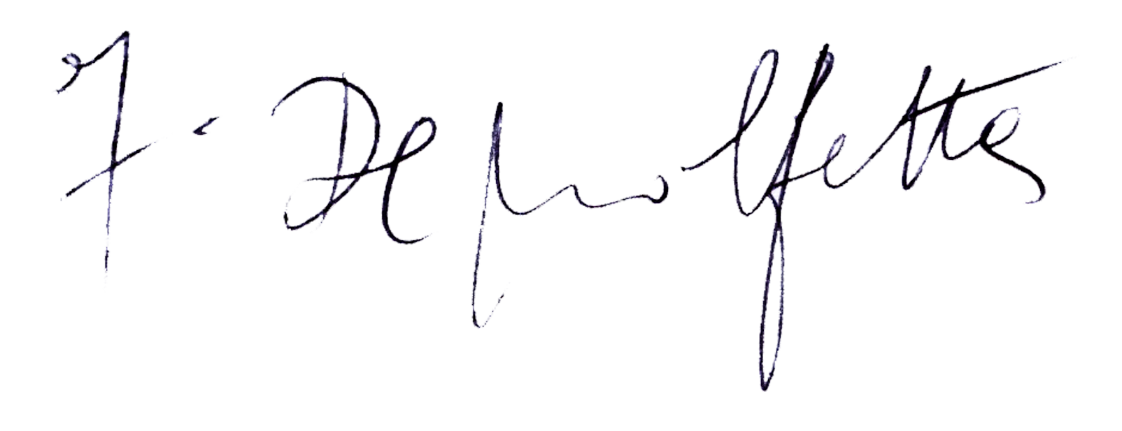
Frank De Molfetta – CFA Chairman …………………………….

Date: 16 December 2019

