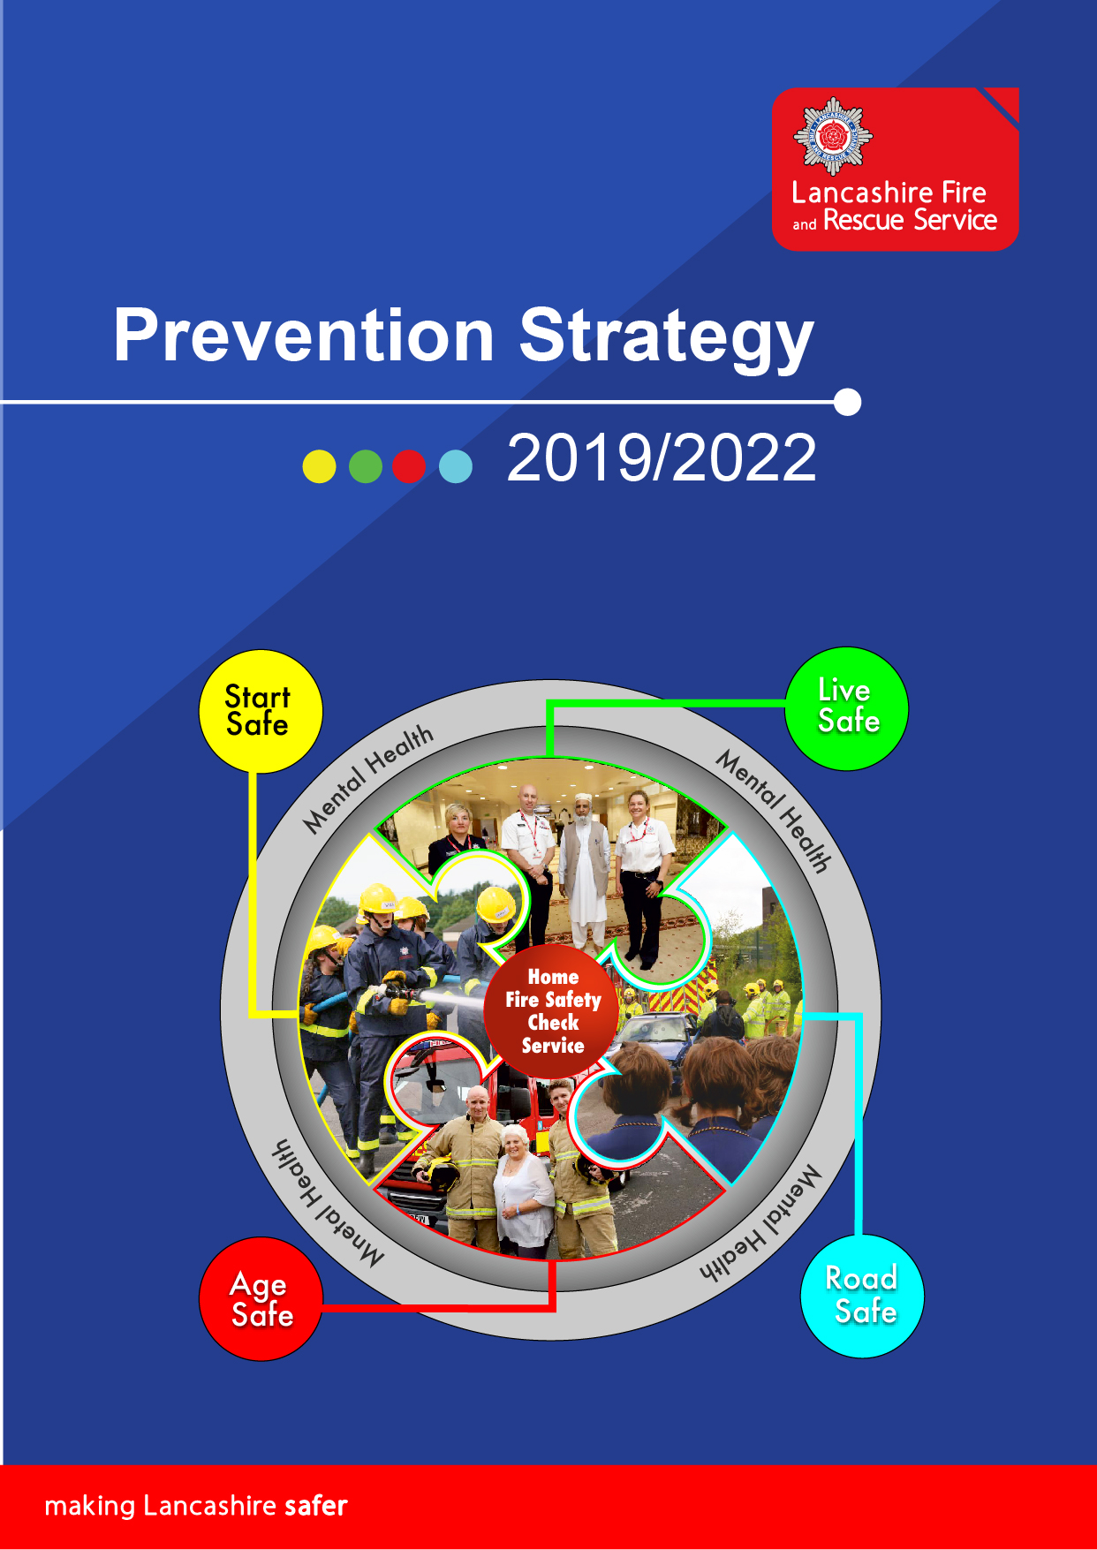

Table of Contents

Prevention Strategy 2019/2022 3
Our commitment to Community Safety 3
How will we achieve our goals? 4
How we structure our prevention activities 4
Campaigns 4
Thematic Groups 4
Start Safe 5
Live Safe 5
Age Safe 5
Road Safety 5
Mental Health 5
Our Prevention Offer 6
Our Home Fire Safety Check Service incorporating our Safe and Well Visits 7
How will we measure success? 7
Who are We? 8

Prevention Strategy 2019/2022

Our commitment to Community Safety
Lancashire Fire and Rescue Service (LFRS) seek to prevent fires and other emergencies such as road traffic collisions, flooding, wildfire and search and rescue activities, from happening in the first place as we believe this is the best way to make Lancashire safer. We focus our efforts on helping people start safe, live safe, age safe and use our roads safely; targeting our resources at those most vulnerable and managing domestic risk.
Risk in Lancashire is anything but uniform in nature, and the time and effort spent in evaluating where and how this risk materialises is absolutely crucial. Our Integrated Risk Management Plan (IRMP) sets out the direction of the Service for the 2017-2022 period and is informed by consideration of our Strategic Assessment of Risk. By carrying out this analysis we are able to target our prevention activities and focus on aiming our work on the groups, individuals and causes which are seen as high risk in terms of vulnerability to fire.
Our Annual Service Plan details the activities we will undertake in the year to deliver the strategy we set in our IRMP and our Local Delivery Plans (departmental and district plans) detail activity which further supports the delivery of our strategy but which is led by local teams. The Prevention Strategy feeds into the Strategic Assessment of Risk and the diagram below confirms how our Corporate Planning documents and plans link to ensure we are utilising information and data appropriately and sharing our priorities with staff
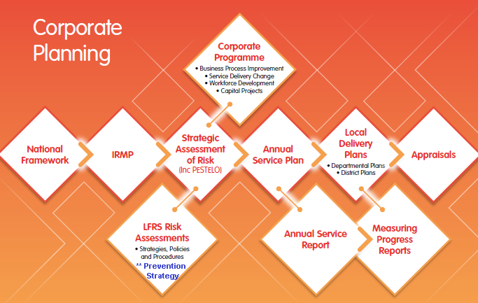
Bringing about positive change in people’s behaviours within their own homes is central to improving their safety and our main method of delivery is the Home Fire Safety Check Service incorporating the Safe and Well Visit. A major project is currently underway to review our Home Fire Safety Check Service which includes assessing the effectiveness of our referral pathways, reviewing our scoring mechanism and considering ICT system changes to streamline the process even further.

The professionalism of our staff and the quality of our prevention activities are paramount to managing domestic risk and providing an efficient service which will help to bring about behavioural changes which in turn prevent fires from occurring in the first place. We regularly monitor and evaluate our prevention activities to ensure they remain effective and we strive to improve our service even further by sharing best practices and learning with other Fire and Rescue Services and considering improvements to our working practices.

How will we achieve our goals?
By using an intelligence-led approach we are able to target our resources to identify those who are at the greatest risk of injury or death from fire or road and this enables us to manage and reduce fire risk in domestic dwellings across Lancashire. By analysing our data from incidents, near misses and serious fires we are able to identify themes and trends which are then presented to the Service Intelligence and Analysis Group (SIAG) for agreement of strategic actions. We also work closely with our partners and key stakeholders and use their data to analyse risk and vulnerability and offer our Safe and Well visit to those people who are identified as high risk.
We also provide representation on a number of strategic boards and groups to share information and intelligence, develop networks and provide a mechanism to highlight areas of concerns and messages about fire risk. This includes the Lancashire, Blackpool and Blackburn with Darwen Safeguarding Boards, the Health and Wellbeing Boards, the Regional North West Groups and various National Fire Chiefs Council (NFCC) Groups including prevention, safeguarding, equality and diversity, safeguarding and mental health.

How we structure our prevention activities
Lancashire is geographically split into 6 areas and our Community Fire Safety Teams and Operational Crews in each of these areas provide a number of prevention activities locally to raise awareness about fire risk and provide fire safety advice. These include:-
- Offering our Home Fire Safety Check Service incorporating a Safe and Well visit to our most vulnerable people
- Providing School/educational talks to Year 2, Year 6, Year 7 and also to Lancashire Colleges and Universities
- Talks to partners and community groups
- Inclusion in multi-agency and Integrated Hub working
- Attendance at events and community forums
- Attendance at partner meetings
- Ad hoc visits and requests

Campaigns
Specific community safety campaigns focus on a particular risk or target audience and are driven by intelligence and support service delivery priorities. Our campaign plan is developed with Area involvement with campaigns being prioritised into 6 levels from Service wide campaigns to Special Events. Level 1 (Service wide) campaigns clearly set out the actions that will be taken by different sections of the Service including activity by service development, service delivery and corporate communications and these are aligned to make best use of resources and deliver effective campaigns. Level 1 campaigns also follow a structured campaign plan and template which is shared on our RADAR system for all staff to access, monitor and update throughout the campaign. This also enables a comprehensive evaluation to be carried out and lessons learned to be included in future campaigns.

Thematic Groups
Our approach in delivering prevention services recognises different life stages and the risks associated to these and to support this the Service has four dedicated thematic groups which are each managed by an assigned Group Manager and supported by a task group which includes representation from operational and community fire safety staff for all the geographical areas. Each thematic group will review current practice, data and results along with identifying new areas of work for improvements which are then shared within the Service and with all staff.
These groups and their priorities are:-

Start Safe
We focus our efforts and resources towards educating, supporting and protecting children and young people so that they are able to start their lives safely and grow up to be safe adults and good citizens. This includes the running of our Cadet and Princes Trust programmes, raising awareness about Adverse Childhood Experiences (ACEs) and the impact these can have, implementation of our TeenSafe Year 7 education package and also reviewing our SENDSafe (Special Educational Needs and Disabilities) programme.
We are also supporting a programme Water Safety Board installations in our highest risk locations working alongside families and local communities to raise awareness about risks and water safety. Alongside this we are considering the development of a multi-agency Lancashire wide Water Safety Partnership.

Live Safe
We focus our efforts and resources towards assisting the people who live and work in our communities to minimise the risk of fire and other related accidents occurring. Work within the group includes the consideration of a Lancashire Fire and Rescue Service Volunteering offer to encourage people to support the Service and become ambassadors to raise awareness about fire risk, our work and services we provide. This group also quality assure our Safe and Well visits to ensure we continue to provide a professional, appropriate, value for money service.

Age Safe
We focus our efforts and resources towards ensuring that our prevention work is delivered in the most effective way to support the individual needs of our older communities. This includes promoting dementia awareness and supporting resources to assist people living with dementia; ensuring we use the most appropriate communication methods when engaging with older people; educating our staff to be able to identify more complex needs of older people and the ability to signpost these to appropriate partner organisations who can provide continued and specific support to meet these needs.

Road Safety
Road safety affects everyone in Lancashire and is not just about the mechanics of roads, vehicles and street design, but as much about attitudes, perceptions and the way that we value and share our roads. 'Towards Zero Lancashire' is the Lancashire Partnership for Road Safety joint response approach to road safety and Lancashire Fire and Rescue Service is a member of this and various other Road Safety Partnerships to support and deliver activities to achieve these outcomes.

Mental Health
Mental Health is overarching across all the 4 theme groups and our Community Mental Health Task Group consider how we can support people living in the local community who are experiencing mental health issues and are seeking support. We have produced a signposting directory so that we are aware where and how to refer people for help and we have also developed a number of products for our staff to raise awareness about hoarding and the actions that we need to take. The group also supports mental health campaigns.

Our Prevention Offer
Lancashire Fire and Rescue Service recognise that we can contribute to the wider community safety agenda and further work towards Making Lancashire Safer by engaging with local communities and partner organisations to raise awareness about fire risk. The flyer below captures some of these prevention activities under the four themes
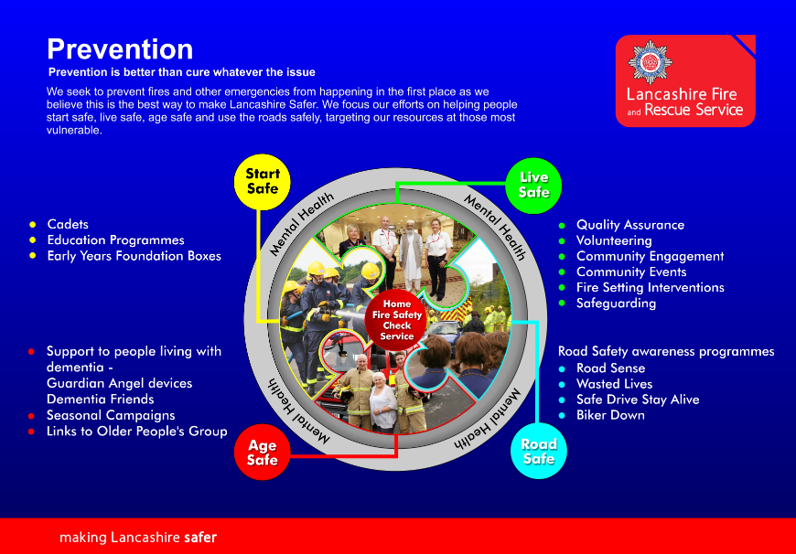

Our Home Fire Safety Check Service incorporating our Safe and Well Visits
Our Home Fire Safety Check Service includes the assessment of fire risk with information and advice provided to low risk referrals and our Safe and Well visit provided to people identified as high risk. The visit provides a more targeted, risk based approach to fire safety advice and applies an holistic approach to household/domestic risk. At the point of contact with LFRS, either by telephone, our website or via our partner organisations we collect information which is analysed to provide a score against set risk criteria questions. This enables us to offer a Safe and Well visit to anyone who scores 22 or above.
Within the Fire Service we identify high risk people as, “a person who is or may be in need of community care services by reason of mental or other disability, age or illness; and is or may be unable to take care of themselves, or unable to protect themselves from the risk of fire and its consequences”. Advice is still provided to low risk scoring households in the form of our literature and resources and is aimed specifically at the areas identified in the questionnaire for the HFSC Service.
Our HFSC Service ensures a consistent offer and service across the whole of Lancashire with the additional functionality to be able to make an automated referral to a partner organisation, whilst actually completing the visit, to request additional support and services if required. Our Safe and Well visit continues to deliver fire prevention advice and safety information but also includes the identification of additional risk factors and vulnerabilities that may have an adverse impact on an individual’s health and well-being. This enables us to provide brief interventions and referrals as part of our offer. The seven determinants of the Safe and Well Visit are:-
- Falls prevention
- Social isolation
- Dementia
- Diabetes
- Healthy Homes/Winter pressures
- Home Security
- Mental Health

How will we measure success?
Our prevention activities are reported via Key Performance Indicators which are reported to the Combined Fire Authority (CFA) and are also publicised in our Annual Service Plan. This information is also captured in the individual District Profiles and plans which are then utilised to forward plan activities, prioritise local focus and set our Campaign calendar. By evaluating our prevention activities we can measure the difference we have made in the local community to reducing fires and raising awareness about fire risks in domestic dwellings.
We also carry out quality assurance of our Safe and Well visits and record our findings centrally so that we can identify any training needs or changes required to our processes or systems. All data and information collated is compliant with General Data Protection Regulations (GDPR).

Who are We?
The Prevention Support Team is based at the Service Headquarters in Preston and our role is to shape and develop new strategic prevention activities and ensure these are implemented across the whole Service. Each of the 4 Prevention Support Officers have responsibility to support the work of their theme groups and we also provide the strategic lead on a number of themes including Safeguarding, Community Mental Health and Dementia. We also work closely with the Community Safety Teams in each Area to strengthen the link on community safety across all areas of Lancashire. The Prevention Support Team are:-
Prevention Support Manager
Prevention Support Officer – Start Safe
Prevention Support Officer – Live Safe
Prevention Support Officer – Age Safe
Prevention Support Officer – Road Safe
Community Fire Safety Training Manager
Each of our 6 geographical Areas across Lancashire are led by a Community Safety Team Leader and a team of Community Safety Advisors who carry out partnership engagement, complete Safe and Well visits and support all the prevention activities for the Service. The following map confirms the geographical splits for each area.
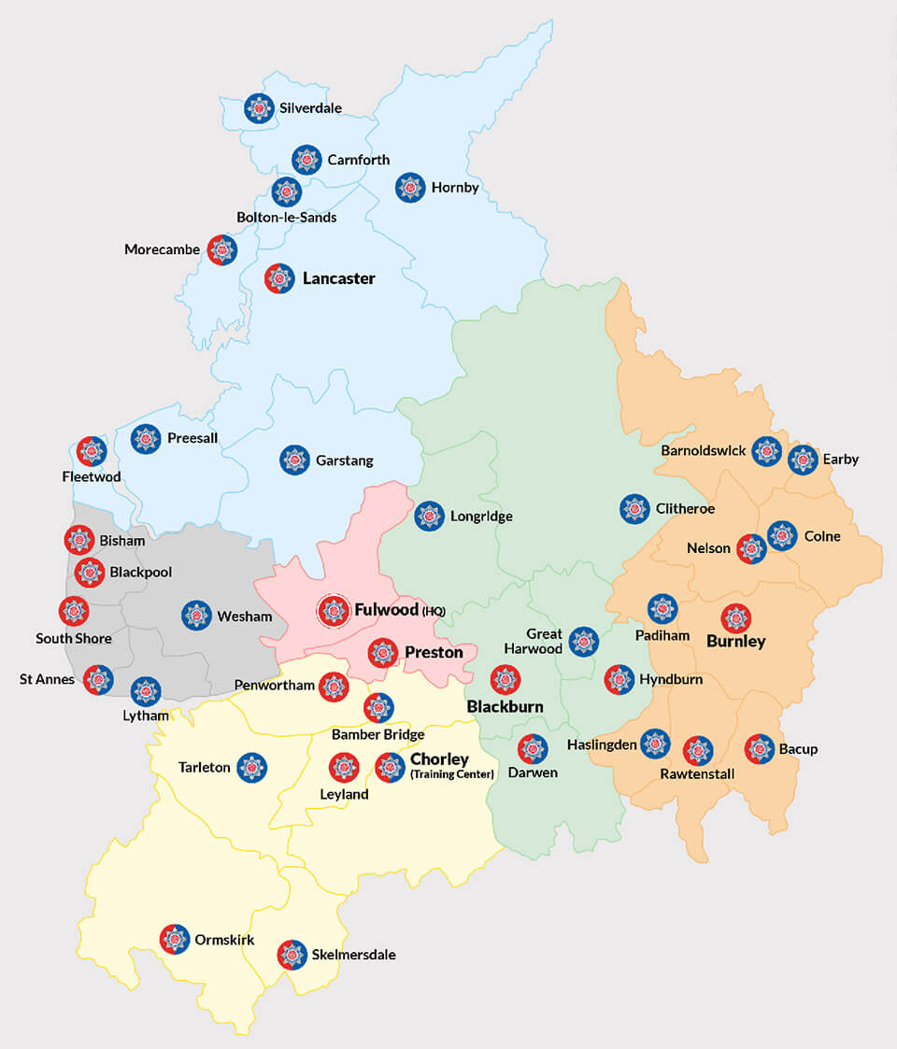
- Blue = Northern
- Grey = Western
- Green = Eastern
- Orange = Pennine
- Pink = Central
- Yellow = Southern

If you would like any further information please visit www.lancsfirerescue.org.uk or telephone 0800 169 1125

If you would like any further Information about the Prevention Strategy or any prevention activities please contact:
Jane Williams,
Prevention Support Manager
Tel: 01772 886950, ext 26950
Email: janewilliams@lancsfirerescue.org.uk

