

RESERVES AND BALANCES STRATEGY

2020/21 – 2023/24

**Reserves and Balances Policy**

The National Framework includes a section on reserves. The main components of which are:-

* General reserves should be held by the fire and rescue authority and managed to balance funding and spending priorities and to manage risks. This should be established as part of the medium-term financial planning process.
* Each fire and rescue authority should publish their reserves strategy on their website. The reserves strategy should include details of current and future planned reserve levels, setting out a total amount of reserves and the amount of each specific reserve that is held for each year. The reserves strategy should provide information for at least two years ahead.
* Sufficient information should be provided to enable understanding of the purpose for which each reserve is held and how holding each reserve supports the fire and rescue authority’s medium term financial plan.
* Information should be set out in a way that is clear and understandable for members of the public, and should include:
* how the level of the general reserve has been set;
* justification for holding a general reserve larger than five percent of budget;
* whether the funds in each earmarked reserve are legally or contractually committed, and if so what amount is so committed; and
* a summary of what activities or items will be funded by each earmarked reserve, and how these support the fire and rescue authority’s strategy to deliver good quality services to the public.

The reserves policy complies with these requirements.

**General Reserves**

These are non-specific reserves which are kept to meet short/medium term unforeseeable expenditure and to enable significant changes in resources or expenditure to be properly managed in the medium term.

The Authority needs to hold an adequate level of general reserves in order to provide:-

* A working balance to help cushion the impact of uneven cash flows and avoid unnecessary temporary borrowing;
* A contingency to cushion the impact of unexpected events;
* A means of smoothing out large fluctuations in spending requirements and/or funding available.

The following table sets out the purpose of this reserve, how it is utilised, controlled and reviewed.

|  |  |
| --- | --- |
| Name | General Fund |
| Purpose | This covers uncertainties in future years budgets, such as:   * future grant settlements being lower than forecast; * higher levels of inflation than budgeted; * increasing cost of and changes to pensions; * service demands increasing, putting additional pressure on demand led budgets; * changes in legislation impacting on future service provision; * potential cost of industrial action. |
| Utilisation | This is utilised to offset any in-year overspend that would occur when comparing budget requirement to the level of funding generated. |
| Controls | The utilisation of this is agreed as part of the annual budget setting process. Any further utilisation requires the approval of the Resources Committee. |
| Review | The adequacy of this is reviewed annually, as part of the budget setting process. |

Review of Level of Reserves

In determining the appropriate level of general reserves required by the Authority, the Treasurer is required to form a professional judgement on this, taking account of the strategic, operational and financial risk facing the Authority. This is completed based on guidance issued by CIPFA, and includes an assessment of the financial assumptions underpinning the budget, the adequacy of insurance arrangements and consideration of the Authority’s financial management arrangements. In addition the assessment should focus on both medium and long-term requirements, taking account of the Medium Term Financial Strategy (as set out in the draft budget report elsewhere on this agenda).

For Lancashire Combined Fire Authority this covers issues such as: uncertainty surrounding future funding settlements and the potential impact of this on the revenue and capital budget; uncertainty surrounding future pay awards and inflation rates; the impact of changes to pension schemes, both in terms of pensionability of allowances and the remedy for the McCloud judgement; demand led pressures; risk of default associated with our investments as set out in the Treasury Management Strategy, cost associated with maintaining operational cover in the event of Industrial Action etc.

2019/20 was the final year of a four year settlement. This means that funding for 2020/21 is subject to a one year settlement, with a further four year Spending Review planned for 2021/22. As per the Local Government Finance Settlement we will receive a 1.6% inflationary increase for 2020/21.

There is greater degree of uncertainty over long term funding than in recent years as the outcome of the fair funding review of relative needs and resources and the Government intention to move to greater retention of Business Rates will take effect. Furthermore the impact of Brexit on the national economy is still unknown.

As such the Treasurer considers it prudent to maintain the minimum target reserves level at £3.0m, 5.2% of the 2020/21 net revenue budget, reflecting the increasing level of uncertainty. This is broadly in line with the 5% threshold identified by the Home Office above which the Authority is required to justify why it holds the level of reserves.

Should reserves fall below this minimum level the following financial year's budget will contain options for increasing reserves back up to this level. (Note, this may take several years to achieve.)

Whilst this exercise sets a minimum level of reserves it does not consider what, if any, maximum level of reserves is appropriate. In order to do this the level of reserves held should be compared with the opportunity cost of holding these, which in simple terms means that if you hold reserves that are too high you are foregoing the opportunity to lower council tax or invest in further service improvements.

However, given the limited scope to increase council tax without holding a local referendum the ability to restore depleted reserves in future years is severely limited. Hence any maximum reserve limit must take account of future anticipated financial pressures and must look at the long term impact of these on the budget and hence the reserve requirement. Based on professional judgement, the Treasurer feels that this should be maintained at £10.0m.

Should this be exceeded the following financial year’s budget will contain options for applying the excess balance in the medium term, i.e. over 3-5 years.

Level of General Reserves

The overall level of the general fund balance, i.e. uncommitted reserves, anticipated at the 31 March 2020 is £8.2m, providing scope to utilise approx. £5.2m of reserves.

The proposed drawdown of £0.4m in 20/21 would reduce the general balance to £7.8m. Discussions are on-going both locally and nationally in respect of Fire-fighter pensions and until such time as these conclude it is not clear whether any backdating costs will be incurred, hence at the present time no allowance has been made for these. Based on this the Treasurer considers these are at an appropriate level to meet expenditure requirements in 2020/21.

It should be noted that reserves are being used to fund recurring expenditure and hence this can only be a short term solution, with recurring savings being required to offset the shortfall.

Future requirements are less clear as multi-year settlements will have ended and the budget forecasts become less accurate as there are a whole host of assumptions underpinning these projections, particularly around pension costs, funding, vacancy profiles, future inflation and pay awards and council tax increases.

The following graph shows the general reserve position based on the draft revenue budget presented elsewhere on the agenda, allowing for some of the scenarios presented in that report:

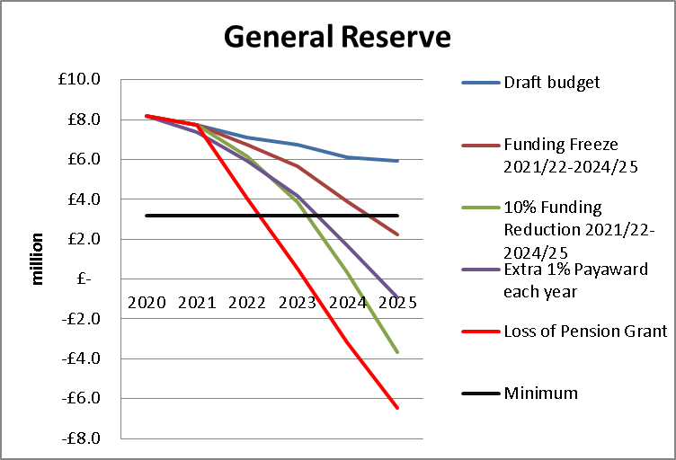

As can be seen under our existing draft revenue budget general reserves are sufficient to balance the budget throughout the period. Dependent upon which scenario is considered reserves will not be sufficient to meet the current anticipated funding gap over the next 5 years and hence significant additional savings would be required.

**Earmarked Reserves**

These are reserves created for specific purposes to meet known or anticipated future liabilities and as such are not available to meet other budget pressures. They can only be used for that specific purpose, for which they were established, and as such it is not appropriate to set any specific limits on their level, but as part of the annual accounts process their adequacy will be reviewed and reported on.

The following table sets out the purpose of this reserve, how it is utilised, controlled and reviewed.

|  |  |
| --- | --- |
| Name | Earmarked |
| Purpose | This covers monies set aside for specific purposes. |
| Utilisation | Once set up these reserves can only be used for the specific purpose for which they were established. |
| Controls | The utilisation of these are discussed at quarterly DFM meetings between the budget holder, relevant Executive Board member, and the Director of Corporate Services. |
| Review | The level of earmarked reserves is reviewed each year as part of the revenue outturn/annual accounts process to ensure these are reasonable and remain relevant. |

The Director of Corporate Services has delegated authority to create new earmarked reserves valued at up to £100,000; any request which exceeds this must be reported to the Resources Committee for approval.

Specific earmarked reserves will be closed when there is no longer a requirement to hold them, at which point they will either hold a nil balance or when any outstanding balance will be transferred into the general reserve.

Level of Earmarked Reserves

The following table provides a breakdown of the £7.2m of earmarked reserves forecast to be held at 31st March 2020, and a forecast of the anticipated position as at 31 March 2025:-

|  |  |  |  |
| --- | --- | --- | --- |
|  | Forecast at 31 March 2020 | Forecast at 31 March 2025 |  |
|  | £m | £m |  |
| DFM Reserve | 0.3 | 0.1 | Devolved Financial Management Reserve enables budget holders to carry forward any surplus or deficit from one financial year to the next, within prescribed limits.  The Service has strong financial management ethos and hence has a track record of managing within individual budget allocations, hence has not previously utilised these reserves to a large degree. However as the Service comes under increasing pressure and departmental budgets are squeezed this provides greater flexibility to individual budget holder and optimises the use of resources.  Examples of areas where these balances have been used previously would be one off replacements of equipment, or enhancement to station facilities etc.  The levels of individual DFM reserves are reviewed each year as part of the revenue outturn/annual accounts process, to ensure that they are reasonable and that budget holders are not building up excessive reserves.  At present there are no contractual or legal obligations against this reserve, as any such commitments would be included in the base revenue budget. |
| PFI Reserves | 4.4 | 3.9 | Private Finance Initiative Reserve, which is used to smooth out the annual net cost to the Authority of the existing PFI scheme, and will be required to meet future contract payments. The utilisation of this is set out in the budget agreed at the start of the year, any variance in requirements from this are agreed by the Treasurer as part of the revenue outturn/annual accounts process.  Assuming CPI continues at 2% the whole of this reserve is contractually committed over the next 20 years. |
| Insurance Aggregate Stop Loss (ASL) | 1.1 | 1.1 | The Authority has aggregate stop losses (ASLs) on both its combined liability insurance policy (£0.4m) and its motor policy (£0.3m). This means that in any one year the Authority’s maximum liability for insurance claims is capped at the ASL. As such the Authority can either meet these costs direct from its revenue budget or can set up an earmarked reserve to meet these. Within Lancashire we have chosen to meet the potential costs through a combination of the two. Hence the amount included in the revenue budget reflects charges in a typical year, with the reserve being set up to cover any excess over and above this. As such the reserve, combined with amounts within the revenue budget, provides sufficient cover to meet 2 years’ worth of the maximum possible claims, i.e. the ASL. (It is worth noting that the revenue budget allocation has also been reduced in recent years reflecting the claims history. Without holding this reserve to cushion any major claims that may arise this would not have been possible. )  None of this reserve is legally committed at the present time, although as soon as a claim arose this position would change. |
| Prince’s Trust | 0.3 | 0.3 | This reserve has been established to balance short term funding timing differences and also to mitigate the risk of loss of funding and enable short term continuation of team activities, whilst alternative funding is found.  Without this reserve any significant loss of funding would have an immediate impact on our ability to deliver the PT programme, and hence improve the lives of younger people.  There are no legal or contractual commitments against this. |
| ESMCP Ring-fenced Funding | 0.2 | - | As part of the Emergency Services Mobile Communication Programme (ESMCP), transitional funding was made available to fund costs associated with the transition to the new national arrangements, with any funds not spent being carried forwards for use in future years.  Whilst there are no contractual or legal commitments against this at the present time, the on-going programme will require this funding to be utilised in the new financial year |
| Apprentices | 0.1 | - | This reserve was created from previous in-year underspends relating to the appointment of apprentices, which was delayed awaiting national developments.  This reserve is being used to fund an additional post to support apprenticeships within the service, with a particular emphasis on Fire-Fighter apprenticeships.  This clearly contributes to addressing apprenticeship targets, set by the Government, as well as addressing capacity issues within departments. There are no contractual commitments against this. |
| Fleet & Equipment | 0.4 | - | This reserve was created to meet the cost of replacement projects which were not completed by year end, hence whilst we anticipate carrying this over into 20/21 this will be fully utilised in subsequent years.  There are no contractual or legal commitments against this at the present time. |
| Innovation Fund | 0.5 | - | The Authority created an Innovations Fund to meet costs arising from new initiatives/developments which improve service delivery or fire fighter safety but which are not included in the capital programme.  Any requests to utilise the fund require the approval of the Executive Board.  This is being used to fund the establishment of the Building Environment Assessment Team (BEAT) which was created following the release of the Grenfell Phase 1 report and associated recommendations, and in light of a number of significant / protracted fires wherein the building has failed or not behaved in the manner anticipated. Terms of Reference for the team are being developed which will give the service a greater understanding of the risk that exists across the building stock in Lancashire. Specifically in relation to the more complex built environment, that incorporates modern methods of construction, which warrants a more focussed and detailed assessment, that will subsequently enhance the operational service delivery and protection services that we offer.  In addition it is being utilised to fund the delivery of high rise training, as well as the initial purchase of escape hoods and smoke curtains, both of which are currently on trial, and, subject to the outcome of the trial, will be utilised to fund their roll out across the Service.  It is anticipated that any further changes required following Grenfell could potentially be met from this reserve.  None of this reserve is contractually or legally committed at the present time. |
|  | **7.2** | **5.4** |  |

Note – As at 31 March 2019 we held £0.9m to meet the potential penalty costs associated with the repayment of the remaining PWLB loans. Given the reducing likelihood of repaying the loans with such a large penalty, it is proposed that this balance is transferred into the Capital Funding Reserve to meet the costs of the future capital programme, referred to below.

It is worth noting that of the anticipated balance of £5.4m at 31 March 2025, almost £4m of this relates to the PFI reserve.

Based on this the Treasurer believes these are adequate to meet future requirements in the medium term.

**Capital Reserves and Receipts**

Capital Reserves have been created from under spends on the revenue budget in order to provide additional funding to support the capital programme in future years; as such they cannot be used to offset any deficit on the revenue budget, without having a significant impact on the capital programme that the Authority can support.

Capital Receipts are generated from the sale of surplus assets, which have not yet been utilised to fund the capital programme. Under revised regulations receipts generated between April 2016 and March 2020 can be used to meet qualifying revenue costs, i.e. set up and implementation costs of projects/schemes which are forecast to generate on-going savings. The on-going costs of such projects/schemes do not qualify. Whilst the Authority currently holds £1.6m of capital receipts only £0.2m of this arose in the relevant time period. Given the small amount eligible we do not currently have any plans to use this in line with new regulations and hence for the purpose of planning all capital receipts will be used to meet future capital costs, not qualifying revenue expenditure.

The following table sets out the purpose of this reserve, how it is utilised, controlled and reviewed.

|  |  |
| --- | --- |
| Name | Capital reserves and receipts |
| Purpose | This covers monies set aside to fund the future capital programme. |
| Utilisation | Once set up these reserves can only be used to fund capital expenditure |
| Controls | The proposed utilisation of these is reported to the Authority as part of the capital programme setting and monitoring arrangements. |
| Review | These are reviewed on an annual basis as part of the year end outturn, reported to Resources Committee and as part of the capital budget setting report to the Authority. |

At 31 March 2020 the Authority anticipates holding £18.7m of capital reserves and receipts. Based on the capital programme presented elsewhere on this agenda we anticipate fully utilising these by 31 March 2025. Of the total reserve £0.6m is contractually committed.

Based on this the Treasurer believes these are adequate to meet future requirements in the medium term.

**Provisions**

The Authority has two provisions to meet future estimated liabilities:-

Insurance Provision

This covers potential liabilities associated with outstanding insurance claims. Any claims for which we have been notified and where we are at fault will result in a legal commitment, however as the extent of these cannot be accurately assessed at the present time this provision is created to meet any element of cost for which we are liable, i.e. which are not reimbursable from insurers as they fall below individual excess clauses and the annual self-insured limits. This provision fully covers all estimated costs associated with outstanding claims.

The following table sets out the purpose of this provision, how it is utilised, controlled and reviewed.

|  |  |
| --- | --- |
| Name | Insurance Provision |
| Purpose | This covers monies set aside to meet future insurance claims. |
| Utilisation | Once set up the provision can only be utilised to meet insurance claims. |
| Controls | The utilisation of these are reported on an annual basis as part of the year end outturn report presented to Resources Committee. |
| Review | The level of the provision is reviewed annually based on existing and anticipated outstanding insurance claims to ensure these are reasonable and remain relevant. |

This provision stood at £0.5m at 31 March 2019. Given the uncertainty in terms of future insurance claims we have assumed that the provision will be maintained at this level throughout the 5 year period. There are no existing legal obligations associated with this provision, as the legal obligation only arises when settlement of outstanding claims is agreed.

Business Rates Collection Fund Appeals Provision

This covers the Authority’s share of outstanding appeals against business rates collection funds, which is calculated each year end by each billing authority within Lancashire based on their assumptions of outstanding appeal success rates, as part of their year-end accounting for the business rates collection fund.

The following table sets out the purpose of this provision, how it is utilised, controlled and reviewed.

|  |  |
| --- | --- |
| Name | Business Rates Collection Fund Appeals Provision |
| Purpose | This covers monies set aside to meet the Authority’s share of the cost of successful business rates appeals. |
| Utilisation | Once set up the provision can only be utilised to meet costs associated with settlement of such appeals. |
| Controls | The utilisation of these are reported on an annual basis as part of the year end outturn report presented to Resources Committee. |
| Review | The level of the provision is reviewed annually based on each billing authority’s assumptions regarding success rates to ensure these are reasonable and remain relevant. |

At 31 March 2019 this provision stood at £0.8m to cover anticipated costs of outstanding business rates appeals. Whilst a significant element of this will be utilised in the current financial year, reflecting the settlement of outstanding appeals, it is impossible to accurately predict the extent of this usage or the need for any additional provision to meet appeals that arise in year, until such time as a full review is undertaken as part of the financial year end process. Therefore for the purpose of this report we have assumed that the level of business rates appeals provision remains unchanged. Until the outcome of any appeal is known there is no legal obligation arising from the appeal.

The Treasurer feels that the levels of provisions are sufficient to meet future requirements in the medium term.

**Summary Reserve Position**

The following table sets out the summary anticipated position in terms of reserves and balances showing the overall level reducing to approx. £13m by 31 March 2025, after allowing for potential backdating of pensionability of allowances:-

|  |  |  |  |  |  |
| --- | --- | --- | --- | --- | --- |
|  | General Reserve | Earmarked Reserve | Capital Reserves & Receipts | Provisions | Total Reserves & Balances |
|  | £m | £m | £m | £m | £m |
| Balance 31/3/19 | 8.2 | 8.0 | 19.0 | 1.3 | 36.5 |
| Change in year | 0.0 | (0.8) | (0.3) | 0.0 | (1.1) |
| Balance 31/3/20 | 8.2 | 7.3 | 18.7 | 1.3 | 35.4 |
| Change in year | (0.4) | (0.7) | (7.6) | 0.0 | (8.7) |
| Balance 31/3/21 | 7.7 | 6.6 | 11.1 | 1.3 | 26.7 |
| Change in year | (0.6) | (0.4) | (4.8) | 0.0 | (5.9) |
| Balance 31/3/22 | 7.1 | 6.2 | 6.3 | 1.3 | 20.9 |
| Change in year | (0.4) | (0.3) | (6.2) | 0.0 | (6.9) |
| Balance 31/3/23 | 6.7 | 5.9 | 0.1 | 1.3 | 14.0 |
| Change in year | (0.6) | (0.2) | (0.0) | 0.0 | (0.9) |
| Balance 31/3/24 | 6.1 | 5.6 | 0.1 | 1.3 | 13.1 |
| Change in year | (0.2) | (0.2) | (0.1) | 0.0 | (0.4) |
| Balance 31/3/25 | 5.9 | 5.5 | 0.0 | 1.3 | 12.7 |

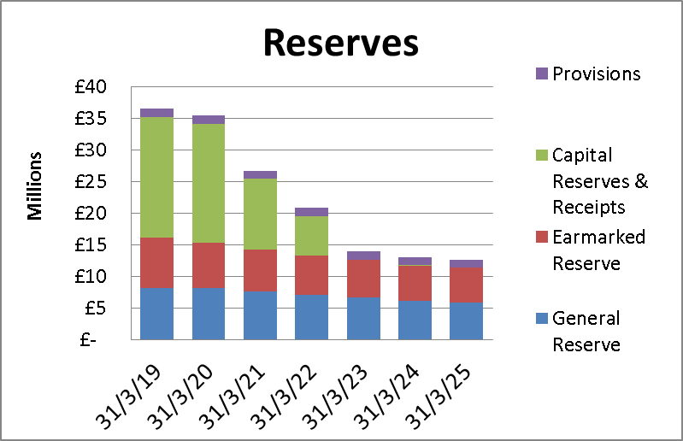

As can be seen reserves fall dramatically over the programme reflecting the scale of the draft capital programme. Furthermore this position will be subject to significant change as pension costs, funding, inflation, pay awards and other pressures all become clearer in future years. The annual refresh of this policy will identify the impact of any changes as they develop.

##### For comparative purposes the average level of reserves relative to total revenue expenditure across all Fire Authorities as at 31 March 2019 was 42%. Our anticipated position at the end of the current financial year shows reserves equal to 62% our revenue expenditure. However within this are £8m of capital slippage and a further £4m of PFI reserve, if we exclude these total reserves equate to £23m, 41% of our total revenue expenditure which is in line with the sector average.

It is also worth noting the comparator with other types of Authorities as set out in the Revenue Outturn Summary for 2018/19 comparing Net Revenue Expenditure with Non School Reserves:-

|  |  |
| --- | --- |
| * London Boroughs | 49% |
| * Metropolitan Districts | 40% |
| * Unitary Authorities | 39% |
| * Shire Counties | 28% |
| * Shire Districts | 133% |
| * Other (which includes Fire) | 32% |
| * Overall | 40% |

Further details of the year on change in reserves is shown below:

