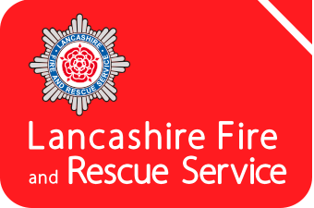
Fire Cadets
Application Form

Please complete this form neatly and accurately, with as much information as possible. Please complete this form electronically and return to: gerryhellier@lancsfirerescue.org.uk
Personal Details
Full Name |  |  |  |  |  |  | Date of Birth
 |  |  |  |  |  |  | Current Age
Address
 |  |  |  |  |  |  | Postcode
Contacts | Home Tel. |  |  |  |  | Mobile
 | Email
 | Parent / Guardian Contact
 | School Attending
Ethnic  Origin | Please indicate which of the following best describes your ethnic group or background:
 | White British |  |  |  | Black African |  |  |  |  |  | Asian British
 | European |  |  |  | Black Caribbean |  |  |  |  |  | Asian Indian
 | Mixed / Multiple ethnic |  |  |  | Asian Chinese |  |  |  |  |  | Asian Pakistani
 | Other (please specify)
Gender | Female |  |  |  | Male |  |  |  | (Tick as appropriate)

Which Fire Cadet Unit are you applying to?

Hobbies and Interests
What are your hobbies and interests?
Are you a member of any other club?
If yes, please provide details.

You may wish to refer to our Fire Cadet web page (https://www.lancsfirerescue.org.uk/education/cadets/) to help you complete this section of the application form.
Why do you want to be a Fire Cadet?
List the reasons why you want to become a Fire Cadet with Lancashire Fire and Rescue Service.

Tell us why you would make a good Fire Cadet

What skills are you looking to gain from becoming a Fire Cadet?

General
Do you consider that you have a learning difficulty, disability or health problem that may affect you on the programme?
If so, please explain.

(*Please note, electronic signatures are accepted)
Applicant | *Signature |  | Date
 | Print Name

Consent
As parent/guardian of the above named, I consent to his / her application. I also understand that completion of this form does not guarantee placement onto the Fire Cadet programme. | *Signature |  | Date
 | Print Name

