Evidence Evaluation
“The programme should be regularly evaluated with feedback from students, parents, teachers and employers as part of evaluation process”
Data Collection Sources:
- Key Event Feedback from a Range of Stakeholders
- Programme Evaluation (Implementation & Impact) from a Range of Stakeholders
- Outcomes Data (i.e. Destination Data, Attainment, Progress 8, etc.)
- Skills, Knowledge and Attitudes Evidence
How to use this tool:
The questions below are suggestions only and you should review these in line with your strategic priorities and context before completion.
There are gaps for you to add relevant questions and questions can be removed if they are not suitable for your context
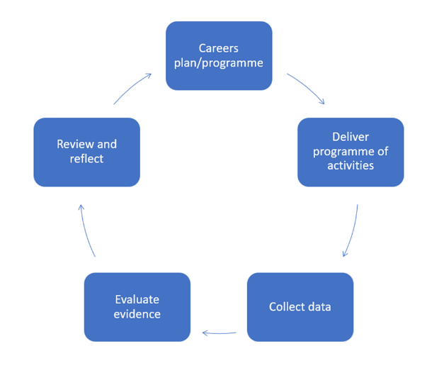
Intent
What are the key strategic objectives of the Careers Plan?
Were learning outcomes set for each key stage/year group?
Delivery
Which aspects of the careers programme were delivered as intended? Which weren’t?
From stakeholder ‘key event’ feedback’ what went well?
From stakeholder ‘key event’ feedback’ what improvements could be made to careers programme?
What was the quality of the employer engagement activities? How could you improve the quality of employer engagement?
Which employers might you re-engage next year?
How well was BM8 delivered? What was the qualification level of the Careers Advisers? What does stakeholder voice tell you about BM8 provision?
To what extent has careers been integrated within the curriculum?
Outcomes
What were the career management skills, knowledge and attitudes of Year 11 and Year 13 leavers? (i.e. via Future Skills)
What were the destinations of Year 11 and Year 13 leavers last year?
i.e. What proportion went on to one of their intended destinations?
What proportion have sustained their destination for 6 months?
What proportion of Year 11 went on to A-Levels, T-Levels, L3 Apprenticeships or other L3 destinations?
What proportion were NEET?
What were the attainment outcomes for Year 11 and Year 13 last year?
i.e. What was the average Progress 8 score for PP/NPP?
How did Progress8 and attainment scores compare to last year or to other schools?
What was the pass rate for A-Levels?
Were there ‘gaps’ in attainment/progress outcomes for specific groups? (i.e. SEND, gender, EAL, PP)
What was the gender split in STEM subjects/ How does this compare to last year?
What were the positive / negatives from key stakeholders including parents/carers, employers, staff, etc?
To what extent did outcomes improve overall and for specific / target groups of students?
How are vulnerable / disadvantaged students engaging / achieving compared to others?
Review & Reflect
What progress have we made on the Gatsby Benchmarks this year?
From current LMI updates, are there any sectors/employers you would like to engage in your programme?
Which aspects of the careers programme went well / could be improved?
Which aspects of the careers programme should we repeat next year? Which aspects should we change?
Did we set the right Strategic Objectives?
Did we set the right Learning Outcomes?
What should targets be for career management skills, knowledge and attitudes of students?
What are our priorities for next year?
How will you share impact and successes of plan/programme with students, parents/carers, employers and SLT/Governors?
What staff CPD needs are emerging?
What are key areas of strength/for development from ‘support and review’* with EA/EC/SLT/Governor?

*

