Beach Detectives Worksheets

On a visit to the beach, you found each of these plastic items. Discuss in your group where these could have come from, and answer the questions below.

1. Where could each of these plastic objects have come from? Match the number off each piece of plastic pollution to one of the sources below. Some plastics could be from multiple sources. 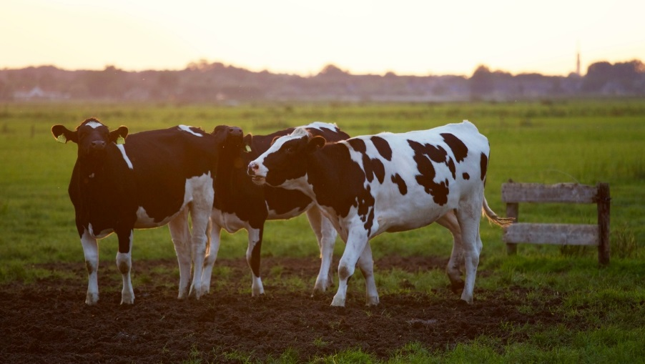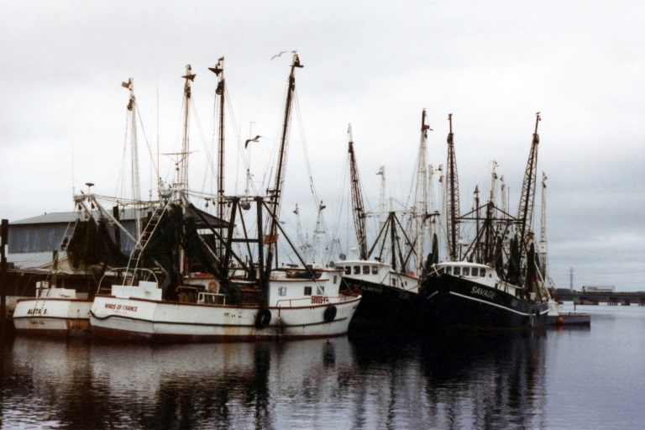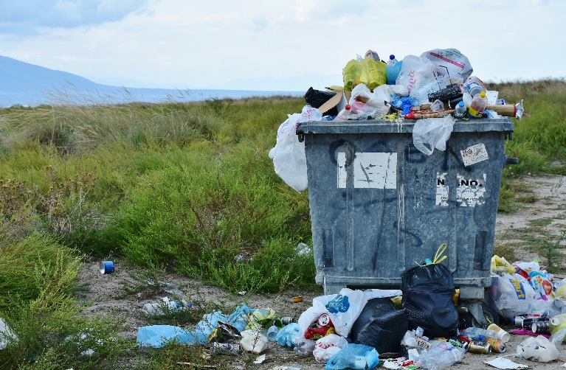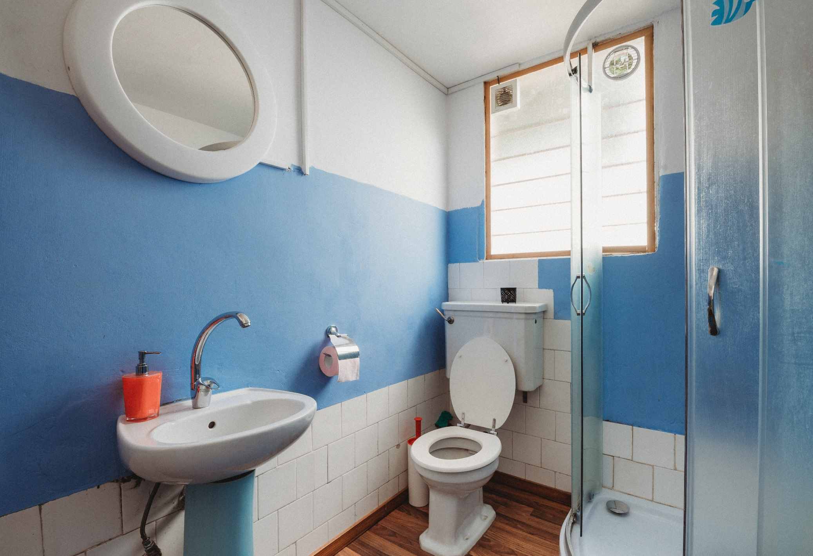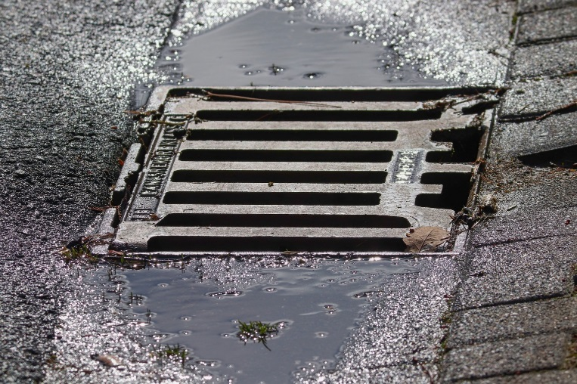Main Sources listed below. Each plastic piece could have more than one source.

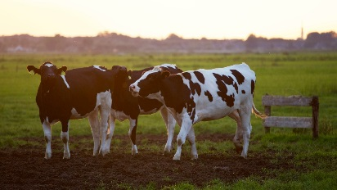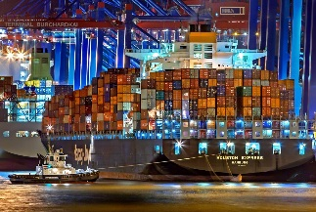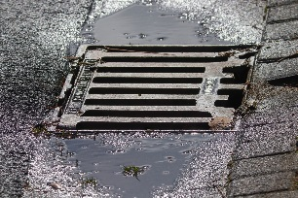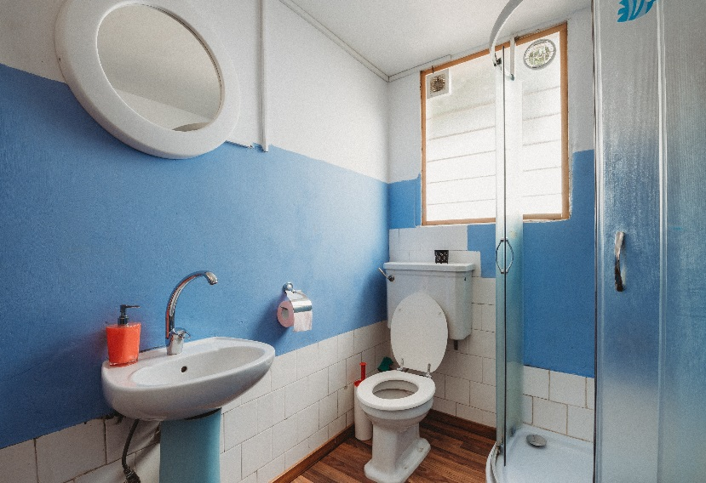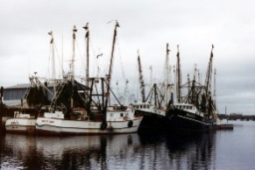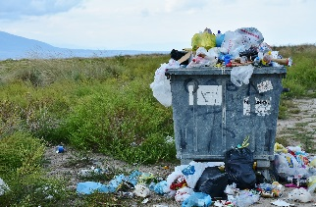

Objects:

|  |  |
| --- | --- |
| A) Wetwipe | J) Kinder egg |
| B) Cotton Ear bud (cotton rotted but plastic left) | K) Cable tie/Zip-tie |
| C) Lighter | L) Silage Wrap (used to make silage for cattle) |
| D) Plastic Bottle | M) Clothes Peg |
| E) Nurdles (plastic pellets melted to form plastic objects) | N) Plastic straw and cutlery |
| F) Polystyrene | O) Fishing Net |
| G) Coffee Cup Lid | P) Coffee Cup |
| H) Fishing line/gear | Q) Plastic bottle |
| I) Lego Piece | R) Food packaging |

Main: R, Q, P, N, J, I, F,C, D.

Also accept: A, M.

Main: R, C, G, J, K, N.

Also Accept: Q, P.

Main: H and O

Also accept: D, F, Q, K, R.

Main: L

Also accept: F, K, Q, R.

Main: E and I

Also accept: C, D, F, K, M, N, R.

Main: A and B

1. Can you think of any ways that we could reduce the flow of plastics into the natural world?

Facilitate ideas around reduce, reuse and recycle.

How can we avoid our reliance on single use plastics..