Beach Detectives
Time: 20 minutes

Aims: Students can identify the common sources and pathways of plastic pollution.

Beach Detectives is an activity designed to engage students in the origins and pathways of plastic pollution from source to sea.

- Give out catchment map and plastic items/picture cards.
- Allow student/s to discuss the origin of each of these plastics.
- Give out worksheet/s, and give students 5-10 minutes to complete worksheets (use answer page to facilitate).
- Spend 10 minutes going through the answers together
You will need (per group)
- One A3 print out of ‘Beach Detectives catchment’
- One worksheet
- One set of picture cards – do bring in physical plastics if you have them!
Answers:

Q1. Ask students to give answers for each source 1 to 6. Click the slide to reveal the answer, and explain the source/pathway if needed.

Some of the plastic pieces have more obvious sources than others. Some stories of interest are:

- The Lego piece: A container filled with millions of Lego pieces fell into the sea off Cornwall in 1997. But instead of remaining at the bottom of the ocean, they are still washing up on Cornish beaches today - offering an insight into the mysterious world of oceans and tides.

Q2. How can we avoid our reliance on single use plastics?

Facilitate ideas around reduce, reuse and recycle.

Answers

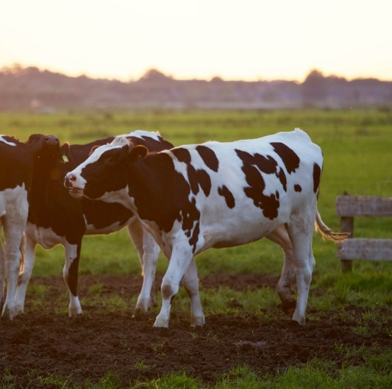
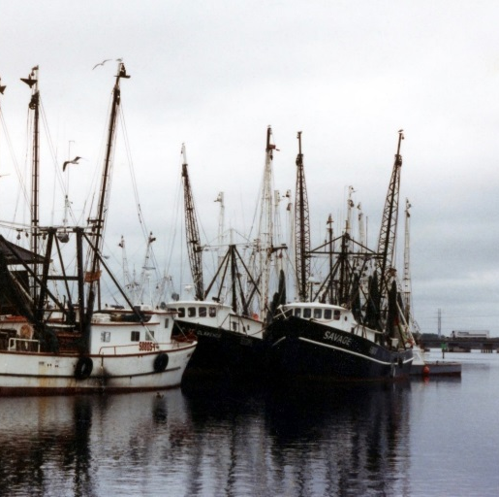
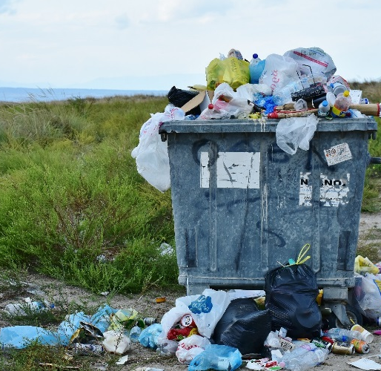
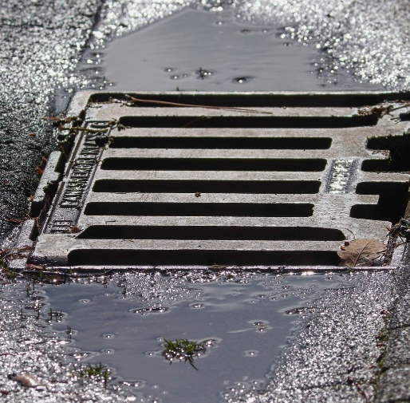
Main Sources listed below. Each plastic piece could have more than one source.
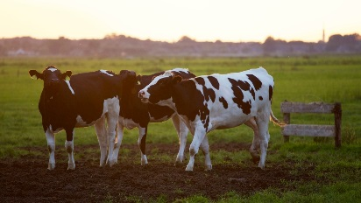
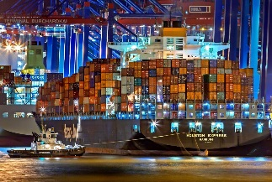
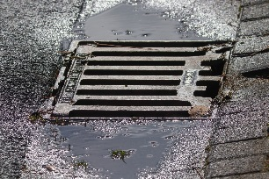
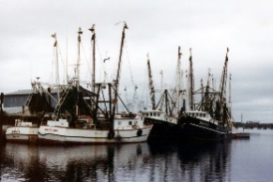
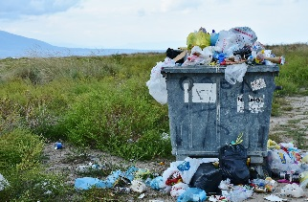

Main: E and I

Also accept: C, D, F, K, M, N, R.

Main: L

Also accept: F, K, Q, R.

Main: R, C, G, J, K, N.

Also Accept: Q, P, D

Main: H and O

Also accept: D, F, Q, K, R.

Main: A and B

Same for outfall (waste water) pipe

Main: R, Q, P, N, J, I, F,C, D.

Also accept: A, M.

Objects:

A) Wetwipe | J) Kinder egg
B) Cotton Ear bud (cotton rotted but plastic left) | K) Cable tie/Zip-tie
C) Lighter | L) Silage Wrap (used to make silage for cattle)
D) Plastic Bottle | M) Clothes Peg
E) Nurdles (plastic pellets melted to form plastic objects) | N) Plastic straw and cutlery
F) Polystyrene | O) Fishing Net
G) Coffee Cup Lid | P) Coffee Cup
H) Fishing line/gear | Q) Plastic bottle
I) Lego Piece | R) Food packaging

