YOUR ESTEEM PAVILION REPORT TEMPLATE

Welcome to your virtual work experience week!

You should by now have received a copy of your Class of Your Own Student Team Brief, Class of Your Own Student Guide pack and Industrial Cadets pack. Please do use your student guide alongside the completion of this Written Project Report as this will guide you through the day to day tasks of your work experience project.

At the back of this template, in Appendix 5, you will a checklist to help keep you on track. You will also notice the ‘time to reflect’ page within your guide. Please complete this and either include within this portfolio at the back or complete online using the QR code. At the end of your working week, you will be asked to submit your work to your teacher by close of business Friday.

You will receive a link to complete an evaluation form from Industrial Cadets please ensure you complete this questionnaire before you finish your working day.

Your work will be assessed by Class of Your Own and moderated by Industrial Cadets in order to qualify for your Industrial Cadets Silver Award.

Good luck! Let’s get designing

Note:
- This report template has been created to help you focus on the key features of your Esteem Pavilion design. You may wish to use it or prefer to create your own.
- Do remember to delete hints and tips as you input your own work and remember, there’s lot more to think about!
- We’ve provided you with just a small number of the issues you might explore….don’t forget to refer to your Student Brief and Student Guide documents - you’ll get even more ideas when you watch the Learn Live sessions where professionals are also on hand to answer your questions!
- You must include information about the Esteem Pavilion - including your concept design - in no more than 6 A4 size pages. This page, along with the Appendices, are NOT included in the 6 pages.
- You should include floor plans, elevations and a site plan in an Appendix at the end of your report. Don’t forget labelling and dimensions!

Page 1

ESTEEM PAVILION REPORT

Name:

School:

PROJECT INTRODUCTION

Describe the project brief, main objectives and key considerations.

PROJECT TEAM

Outline who contributes towards the design, engineering and construction of the Esteem Pavilion and their key responsibilities.

Page 2

END USERS

Describe who will use your Pavilion.
Describe what they will learn and the different ways you intend to teach them.
Do any of your end users have difficulties or face specific challenges? How have you overcome this?
Anything else?

SITE and LOCATION

Where is the site?
How big is the site?
Describe the terrain.
Outline the key challenges you face and how you overcame them.
Don’t forget to add your site plan drawing to the appendix.

Page 3

The CONCEPT DESIGN and its DEVELOPMENT

Remember – sustainability is key!
Use diagrams, charts and tables if helpful.

Describe rooms and spaces and the method you used to plan them.
How does your design cater for people with specific needs?
Outline the materials you have chosen and why.
How is your Pavilion powered?
How is it heated and cooled?
How is the Pavilion lit?
Did you consider what might happen to the building when it’s no longer needed?
Anything else?
Page 4

MOOD BOARD

Arrange images and text that outline your interior design ideas.

Page 5

YOUR DIGITAL/PHYSICAL MODEL

Describe what software program you chose and why.
If you haven’t made a digital model, describe how you created your physical model.
Describe key features.
How does your building fit in with the natural environment?
How sustainable is it?
What challenges did you face?
Is your building inclusive and accessible?
How do you think people will feel inside your building?
Anything else?
Include renders and photographs.
Don’t forget to append your site plan, floor plan and elevations!

Page 6

EVALUATION and REFLECTION

Summarising and reflecting honestly on your performance are really important skills and will help you develop and improve.

Each day you have Review and Reflect sessions when you can consider:

What did I learn each day and how did that co tribute to my overall project?
What would I do differently or like to explore further if I had more time?
Which element of the project did I enjoy the most?
What went really well?
What was the most challenging?
How might I improve?
Anything else?

Don’t forget to include floor plans, elevations and a site plan in an Appendix at the end of your report. Have you included labelling and dimensions?
Appendix 1: Floor Plans

Appendix 2: Site Plan

Appendix 3: Elevations

Appendix 4: Time to Reflect

Please complete this form below, or complete the online form using the QR code provided:

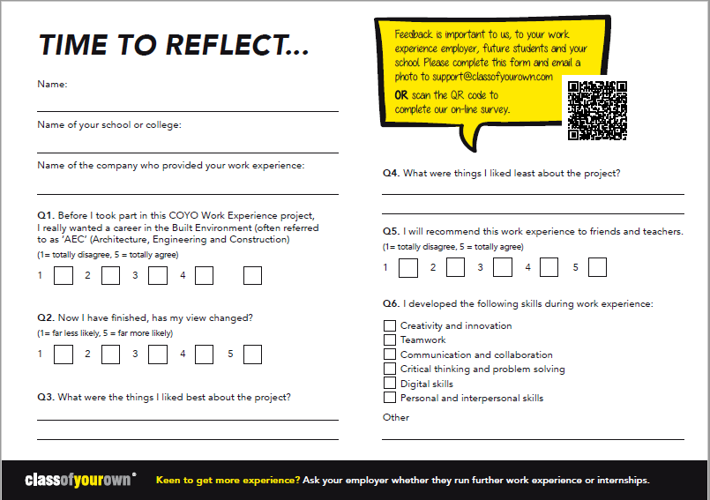
Appendix 5: Student Checklist

Accreditation Criteria | Completed* and submitted Y/N | Student Signature
MONDAY
Completed GoConstruct
Questionnaire and attended all meetings
TUESDAY
Attended all the LearnLive
sessions and team meetings

WEDNESDAY
Attended all the LearnLive
sessions and team meetings

THURSDAY
Attended both team meetings

FRIDAY
Attended all the LearnLive
sessions and team meetings

FRIDAY
Digital Concept Model
3D renders of final design
included in final report
FRIDAY
Floor Plans
Suitable scale used, and
dimensions included
FRIDAY
Site Plan
Suitable scale used, and
dimensions included
FRIDAY
Elevations
North, South, East
and West views
FRIDAY
Written Project Report
maximum six pages incl.
key features of project
FRIDAY
Time to Reflect Evaluation

*To the best of your ability

